A CONDENSED CW CONTESTER’S GUIDE TO THE ELECRAFT K3
W9NJY 11/06/2012

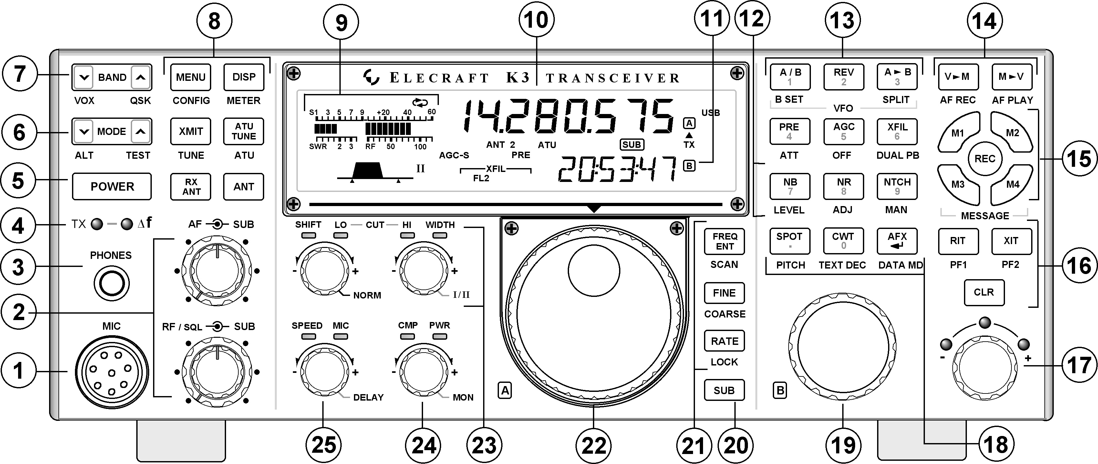

The most helpful hint of all: Avoid using any buttons or knobs except as described below. The K3 works as is out of the box. Pushing an unknown button or knob may invoke an undesired function or parameter. It may be hard to figure out how to go backwards. Please stay out of the menus.

All buttons and many knobs have two functions. The first is listed on the button and is achieved by a tap. The second function is listed underneath the button and is invoked by a press and hold.

POWER ON-OFF Button 5 Tap – ON Tap – OFF Turn the radio off using this button rather than switching off the power supply. It’s similar to exiting Windows before turning the power off on a computer. Please leave the K3’s on for the entire week. It prevents normal thermal cycling and condensation of salty moisture in the radios. Same is true for the power supplies for these radios. If you want to disable a radio’s transmit function, press and hold TEST (6). This will prevent a radio from destroying itself if is accidentally keyed by a computer, etc. through the nights before the contest. If you find a radio has no power out, it is still in TEST mode. Press and hold TEST to get it back to NORMAL mode.

AUDIO GAIN – Main receiver is INNER KNOB at 2 “AF” The outer knob adjusts the audio of the subreceiver.

RF GAIN – Main receiver is INNER KNOB at 2 “RF/SQL” The outer knob is the RF gain of the second receiver.

Page 2

VFO A for the main receiver is knob 22.

VFO B for the second receiver is knob 19. The frequency of radios equipped with a second receiver is indicated on the LCD at position 11. (Time display is selected for this illustration only.)

BAND SELECT – Button 7 Tap the UP or DOWN chevrons.

MODE SELECT – Button 6 Tap the UP or DOWN chevrons until the desired mode appears on the display

ATU TUNE – near button 6 - Tap to tune internal tuner. You do not need to touch this button. It is not used when tuning an amplifier. (Note: If you do accidentally hold this button, it enables or bypasses the tuner. We want the tuner bypassed since we are driving a linear.)

TUNE is enabled by pressing and holding XMIT. This is the button needed for tuning an amplifier. The tune power is menu enabled. Let the K3 owner know if you want this changed. Most of the radios will be set between 10 and 20 watts of tune power.

TRANSMIT POWER is adjusted by KNOB 24. If the PWR LED is not illuminated, tap the knob. Then adjust power.

SIDETONE ADJUST – Press and hold KNOB 24, and then release. Rotate to the preferred sidetone level. NOTE: If this knob is not pressed, held, and released before it is turned, it will be changing the transmit power or speech compression. Tap the knob to exit this function.

VOX – Button 7 “DOWN” – Press and hold – The VOX needs to be ON for CW to be sent.

RECEIVE PREAMP – Tap PRE (16) – to toggle on and off. The K3 preamp is typically not needed on 40 meters and below as it typically just makes band noise louder. With the extremely high incoming RF levels we experience at Signal Point, it may not be needed on higher bands.

RECEIVE ANTENNA - Tap RX ANT next to the power button to toggle. When the separate receive antenna is turned on “RX” appears in the display. If you are not hearing signals, the RX ANT is probably selected without an attached Beverage.

RECEIVE BANDWIDTH is adjusted using the knob with the designations HI and WIDTH. If the HI LED is on, tap the knob to change it to WIDTH. This knob changes both the DSP bandwidth and invokes the correct roofing filter.

Page 3

RIT Tap RIT (16) to toggle on off. Turn RIT control (17) as desired.

XIT Tap XIT (16) to toggle on off. Adjust XIT (17) as desired.

DIFFERENT XMIT & RX FREQUENCIES: Whenever the K3 transmit and receive frequencies are different, a warning yellow (delta icon) LED comes on at (4). To make XMIT & RX the same, turn off (tap) RIT, XIT, or SPLIT (13).

SECOND RECEIVER is turned by a tap of SUB Button 20. Holding this button LINKS the frequencies of the two radios by the distance apart they are set before punching the button. If you want the receivers on the same frequency, tap A>B in button cluster 13 first, and then hold SUB. NOTE: Even experienced ops will sometimes tap the SUB button by fumbling fingers when using the VFO A knob. If you suddenly hear two different audio streams in the phones and don’t know why, the second receiver has been turned on.

AGC is toggled between fast or slow by tapping the button so labeled. It is turned off by hold. If the AGC characteristics do not meet your preferences, contact a K3 owner and they can be adjusted to anything you prefer. The factory default may have more audible dynamic range in the Signal Point environment than what some ops desire.

QSK – Button 7 UP – Press and hold to select QSK on or off. When switched on the QSK designation appears in the LCD. We want QSK OFF since we are driving linears with slow relays.

IF THE SWR IS CONSISTENTLY ABOVE 2.0, and you are sure you selected the correct Signal Point antenna, most likely the wrong antenna output on the K3 has been selected. We will be running all radios on ANT 1. See the indication of the selection of ANT 2 on the LCD above. Tap the ANT button to the left of the LCD to toggle ANT 1/2.

