 | Signals From The Point  Official Newsletter of the Caribbean Contesting Consortium
Volume 1, Issue 5 September, 2001

Signal Point Activity
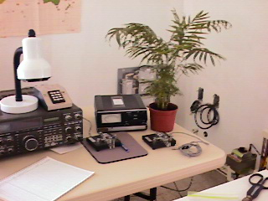

As you know, we've been renting Signal Point for contest events in which nobody from CCC is interested. This was part of our club philosophy from the beginning. It provides extra revenue that benefits the club and also heightens our visibility within the contesting community.

For example, G3XSV and 8 other operators from the Bristol contest group spent two weeks at the station in July, operated the IOTA contest and generally had a blast with casual operating and beach and food time at Sunset Waters. If you heard them on the air, you know that they were perpetually overwhelmed with pileups all hours, all bands. There's the best proof possible that the improved station is playing well. They were so impressed that they've already booked to return for IOTA next year.

The revenue from this and other rentals has picked up a substantial part of the tab for new bedroom furniture, landscaping, the irrigation system, the security system, as well as covering the usual utility and other operating costs. A portion of those revenues (the station support dollars) have been forwarded to K4LT to disperse for PJ2T station needs. For example, I'm pleased to be able to report that the original $2100 debt on the AL-1200 has been reduced to $750, and our $400 debt to N7BG for Heliax is now down to only $100.

In August KD4D, his XYL and another friend spent two weeks and operated the WAE CW contest. Our feedback from them about the QTH and about the island generally was all positive. Please help spread the word to all of your own radio friends that the place is available for many minor contests and just casual operating rentals. The more of these we can generate the better the house and the station will be for all of us when we want to contest.

Speaking of CCC contesting, the drama begins! NW0L and his friend AE9B will, by the time you read this, have completed their RTTY operation in the first week of September. In addition to running the contest, Marty is taking advantage of this trip to make dramatic improvements in the PJ2T computer situation. More about that below. N8VW, KU8E, WC4E, K8NZ and W0CG will attempt to put the QTH on the map (as PJ2Z) in the year's biggest contest, CQWW SSB. Toward that end, the station committee is working frantically to try and improve the technology in time for this and for CQWW CW in November. Other upcoming CCC operations include: W9VA, W9EFL and W9JUV for the December 10 meter contest; NW0L and his xyl for an RTTY contest the first week in January; N7BG, who will operate the FOC Marathon in January; and of course our club favorite the ARRL DX CW in February. The February operation will involve, by far, the largest number of CCC ops we've had together at one time. More drama in March -- N8BJQ, who of course is the director of the WPX contest, is going to operate the WPX contest (SSB version - sorry Goose,) with N8NR and both xyls in residence. ARRL SSB and WPX CW have been rebooked by last year's non-CCCers for repeat engagements.

Station Improvements

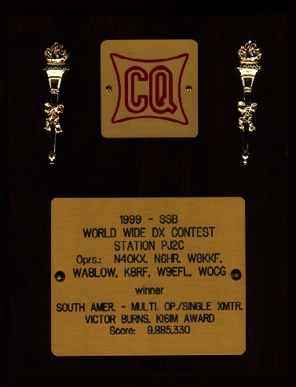
It's hard to believe that just last November we won a CQ WW plaque with a station that, two weeks prior, didn't even exist. With shoestring antennas and tremendously unreliable equipment, we were able to post a great score. Now, one year later for CQ WW, we'll have a full-up effort with four KW stations, band pass filters and rejection stubs everywhere, automatic antenna switching on the run station, four Pentium computers connected by Ethernet and serious stacked monobanders, all fed with Heliax and controlled by WX0B stack boxes. To get there, NW0L and W0CG have been exchanging emails busily in an effort to coordinate on the computer improvements. There is one Pentium in place now at the station. On Marty's September trip he took all the boards and components to assemble two additional network Pentiums, purchasing power supplies and many tower cases from PJ2BR after arriving on the island. On Geoff's next trip he'll take Pentium #4 and a newly purchased 15 inch flat screen monitor for the run station, and KP2L will bag drag a very heavy 17 inch monitor to the station from St. John. (Thanks, Jim!)
Add in Marty's network hub, a backup network hub in case of disaster, and much luscious ham radio software gathered and installed by Marty, and we'll have a dynamite network. The plan is to be able to log using CT, NA, TRLog, or WriteLog. Marty was able to arrange the great discount deal on WriteLog wherein the club will pay $30 a year for a perpetually renewable license.

As you've seen in the emails, the coax switching system is also a current hot project. The design philosophy is for Station #1 (run) to have access to all the antennas on the lot. The six primary contest antennas for the six bands will be automatically switched using a top ten devices band switch driven by a band decoder which will pick band change data from the run station computer. The other antennas accessible at the run station will be manually switched using a rotary panel below and to the right of the run operator. Station #2 will focus on low band multiplier chasing and thus will have access to the multiplier tri-bander, the Europe monobander, and secondarily, all the WARC antennas -- the 12/17 Yagi and 30 meter V. Station #3 will specialize on the low bands and will have access to all the obvious antennas and will be equipped with the LK800 amplifier so that the low band mult chaser will have lots and lots of watts. For now, Station #4 will serve only as a multiplier listening station with access to a vertical and a long wire using the W8TK TS-440. Over time we'll add an amplifier and more antenna access to this position. The manual coax switches needed for the switching unit have all been ordered and will supplement the coax switches that were donated this summer and are already at the station. W8AV has volunteered to make up the 35 odd coax jumpers needed indoors using cable donated from N8BJQ's barn and connectors that Goose hopes to pick up at the Findlay Hamfest. Special thanks to W9EFL for the tutorial he gave Geoff in August of the switching matrix at Noel's station that he designed together with KC1XX. This design was substantially cloned for the PJ2 station.

Antenna work is far from finished. The WARC Yagi, the US/JA 10 and 20 meter Yagis, and the 6 meter beam are still on the ground awaiting time and labor to be installed. All feed lines and rotors are in place, however, so the installations should go fairly quickly. The 15 meter beams for US/JA will require much more work as both need considerable re-work and assembly, and all the US/JA beams will require overhead and lateral boom trusses as well as boom wind braces. W0CG has invested lots of time and effort at acquiring all the aluminum, steel and Phillystran, and is fabricating all the truss kits in preparation for the next trip south. Low band antennas are still woefully inadequate. The 160 inverted L transmits beautifully and we get great reports on that antenna, but we need to install a permanent system of radials and a permanent feedline before that antenna is complete. For 80 we'll build the W8AV designed steerable vertical array, and there's already a 75 meter V at 75 feet, feedline complete. Operators worldwide tell us we're deaf on 80 and 160, and two attempts on past trips to toss out temporary beverages have failed.In one case we used non-insulated wire draped across 700 feet of shrubbery and it rained like mad both nights of the contest. In another case K6RO strung a beverage but it was interfered with by foot traffic and provided him no functionality. Thus our plan on the beverages is to turn to the top of the ridge and install two 800 foot wires, one for Europe and one for US in a permanent configuration where there is almost zero chance of foot traffic. We'll use insulated wire, terminating posts cemented in the ground, and proper terminations at both ends and keep our fingers crossed. Installing these may be a near-death experience for W0CG and anybody crazy enough to assist because the slope is steep and the cactus and Wabi are not to be believed. Getting feedline to the beverages will also be a major challenge as it's about a 600 foot run, a portion of which needs to cross an asphalt road in front of the house. We obviously can't dig up the asphalt, so the only feasible solution is to rig connectors on both sides of the road and plug in a jumper across the road which can be removed when we're not there, and if destroyed by a vehicle, can be easily replaced. These beverages will obviously not be on Signal Point property, but will be complete unobtrusive. If they're damaged, we'll simply have to fix them.

When we completed installation of the Yagis on the Europe tower (100 feet of Rohn 55) we were dumbfounded at the torsional motion induced at the top of this tower by the wind. We knew the seaside winds were fierce and unceasing from our experiences on the PJ9JT tower, but nothing prepared us for the winds at one hundred feet. The 20, 15, and 10 Europe monobanders are attached to two legs of the tower, against a flat side, but in spite of this secure attachment, the tower twists fearsomely in the wind. N8NR and I are both highly experienced riggers, and even we were both terrified. What's worse is that there is so much motion in the booms that we're very concerned that metal fatigue will quickly claim the 20 and 15 meter antennas. There's no particular concern about the tower itself coming down, but the antennas are highly vulnerable. Suggestions are welcome here, but after much head scratching, it appears that the best fix, other than shortening the tower and shrinking the antennas (ham anathema) is to attach stabilizing guys to the booms about six feet out from the tower on both sides, make these from light-weight Phillystran and run them to the ground guy perpendicular to the booms. We think that if we apply quite a bit of tension, using ground turnbuckles, that this will greatly stabilize the torsional motion of that tower before we have a disaster. W0CG has acquired most of the pieces/parts to do this, all stainless or galvanized of course, and is pre-assembling the kits right now. In addition to remedial boom guys on the Europe tower we will pre-install boom guys for the big 20 and 15 Yagis for the US/JA tower before those antennas even go up. Again, everything will be done with lightweight Phillystran so that we don't foul up the patterns of the low band antennas.

All of the above has been about work and more work, but it will result in fun and even more fun! For example, the run operator will have the ability on 15 meters to select a five element 38-foot monobander at 85 feet on Europe, a six element 42-foot monobander at 67 feet on US/JA, a four element 22-foot monobander at 42 feet on US/JA, or any combination of these three antennas, automatically matched using the WX0B stacked box. Ditto on ten meters, except for the obvious differences in antennas, and on 20 the operator has the choice of the Europe Yagi, the US/JA Yagi, or both. In addition, the run operator can quickly flip to a tri-bander at 45 feet fixed on South America for all those LUs on 10 and 15.At Station #2 the multiplier operator will have an IC-765 and W8TK Centaur linear together with the PJ9JT legacy Classic 33 tribander fully rotatable at 85 feet. Station #3 will be able to chase low-band mults but will also have the flexibility to access high-band antennas when needed. All stations will have tuned stubs that can be selected manually using an Ameritron RCS-8V switchbox.

House shaping up!

Incredibly, it's a pretty nice place to spend time now! The smell is gone, the uglies are gone, the electricity, water and appliances all work (mostly) and I think it's fair to say that the first pass on the interior renovations is complete. Both bedrooms have decent furniture-- we bought a beautiful bedroom suite for the east bedroom in June, added drapes and bedspreads and art on the walls, and our daughter Amy painted a beautiful 6x12 foot mural featuring Caribbean scenes on the closet doors in that bedroom. There's still much to do inside: the kitchen works and Cindy and Mary have created some incredible meals, and all the basic appliances/utensils are there, but it sure is ugly - not to mention dangerous when you get hit in the head with a cabinet door. (Cindy is waiting for all new kitchen cabinets!) Thus the longer term plan is to remove and completely replace all the kitchen cabinetry, counter, and sink with more attractive and more functional stuff. We might even put in a garbage disposal that works, get rid of the dime-store lighting fixtures, and best of all, eliminate the old tile. Bathroom makeovers and new floor tile throughout are also part of the long-term plan.

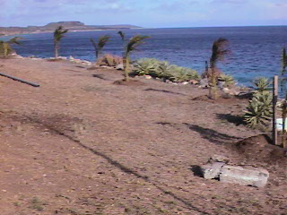
With the house interior and the station relatively well in hand, we can now turn to badly needed exterior improvements and upgrades to the grounds. Some of this is already underway as all the rotted soffit panels have been replaced. Geoff will put a fresh coat of white paint on them next trip, and a substantial start has been made in the planting of palm trees and flowering shrubs, all supported by a computer-controlled irrigation system.

The next priority will be a coat of exterior paint on the house and trim, followed by extensive fence replacement and repair. Much of the fence is more rust than metal. We're also looking at possibly building some permanent concrete walls around the perimeter rather than wasting money on metal fencing, building a gazebo on the ocean side, putting in some poured patios and steps and eventually putting a gate and driveway on the property. John Thompson used the vacant lot next door for parking and a driveway for over thirty years, but there are indications that the property will be sold for development by the hotel and we'll need to quit using that space. (Who wants to buy the adjacent vacant lot? You could put your retirement bungalow on it, hook into the PJ2T antennas, and in the process, protect Signal Point from a potential hostile neighbor.)

What’s Verona?

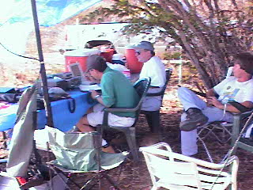
PJ2A Field Day Operation at
Signal Point, June, 2001

Verona is to us an incomprehensible acronym for the Dutch name of the Curaco ham radio club. W0CG became a member in June and was lucky enough to attend two meetings this summer and will be back for many more. Our good friend Brett (PJ2BR) is president of the club and is providing dynamite leadership in teaching this group the emergency services side of amateur radio and each meeting is attended by twenty or so hams. The group is like any ham club anywhere on the planet -- they made me feel immediately welcome, offered immediate assistance in construction of the station, loaned us equipment, welcomed us to their 2-meter repeater, and even conducted their PJ2A Field Day operation from the back yard of Signal Point. As a case in point, Fernando Ferrara, PJ2FF, got wind of the fact that the house lacked a security system and that we had a control panel donated by W9EFL but nothing else. Fernando is a certified security system technician and quickly dashed off and acquired all the other components we needed for the system and then spent the better part of Sunday - his day off - installing the system at Signal Point with lots of tool-handing from Geoff and Bob. Presto - the house is even more secure, thanks to Fernando's generosity. We look forward to involving as many of the Verona crew as are interested in our contest ops. And PJ2BR has keys to the QTH in case of contingencies. One very special thrill in connection with our July trip is that Brett and Nena had a new son on the next-to-the-last day we were on the island and we were on Brett's short list for calls right after the baby was born. Cindy has made a baby blanket for baby Caleb, and we're sure Brett's already teaching him CW. Their nearly five-year old Joshua is already interested in ham radio and has "played" at making calls on dad's rig as other little kids play at making phone calls!

State of the Club

Thanks to everyone who has renewed thus far for second year membership. The club was able to keep its pledge not to raise dues and the Signal Point operation is turning out to be absolutely financially viable with the present fee schedule. Thanks for your support. We will continue to solicit new members as we lose existing people and it's apparent from our first year of experience that our new members must possess some combination of key attributes. These include: the ability to climb and rig; world-class operating skills; specialized mechanical or metal-working abilities; willingness to do extensive volunteerism (QSL management, for example); have the freedom to travel frequently for contest operations and work parties; have the ability to support the station financially; possess a wide range of handyman skills; or be a pretty competent electronics wizard and equipment repair technician. If each of our new members fits one of these descriptions, our club as a group will possess fantastic capabilities.

K4LT as treasurer for PJ2T has posted financial statements on the website. As you'll see, we're about nine grand in the hole, and while this is certainly not a crisis, it impedes our desires to upgrade the station equipment and provides no money for on-going maintenance, repairs and so forth. One of our members has offered a 1 for 1 matching grant to help pay off the debt. The way it would work is that every dollar contributed to PJ2T would be matched by another dollar up to a maximum of $4500 which, with the matching funds, would pay off the whole debt. That fund drive is not underway yet, but you'll be hearing about that from President W8TK sometime in the future.

You all have copies of the PJ2T QSL card now and several thousand of these have already been sent out via the bureaus and direct, heightening our club's visibility and providing the ultimate courtesy of each QSO. Remember, CG has only about 14,000 cards left, so get your requests in now for your own supply. You can use these cards to QSL your PJT/xxxxx contacts from Curacao and they're “free” – (you've already paid for them with the $40 card contributions).

Article Set for NCJ

Your editor, W8TK, has written an article for National Contest Journal titled, “Resuscitation of a Caribbean DX Legend.” (That would be a QTH, not an operator) The article should appear in the next issue, and should bring CCC and Signal Point to the forefront of contesting locations. After the article appears, contesters will beat a path to our door to join the club and rent Signal Point. Manufacturers will beg us to showcase their equipment to the active, affluent, and beautiful people who operate from there. Stay tuned.

From the Editor, W8TK

As your new editor, I have taken the liberty of changing the format of the newsletter. Type is larger, column format is gone, and maybe the look is less “professional.” I think it is easier to read this way. Let me know whether you agree or not. Also, I’m trying to figure out Word XP, which has tremendous capability that far exceeds mine. Future issues will include more photographs, providing someone submits them. There are plenty of those on the website for the verbally impaired.
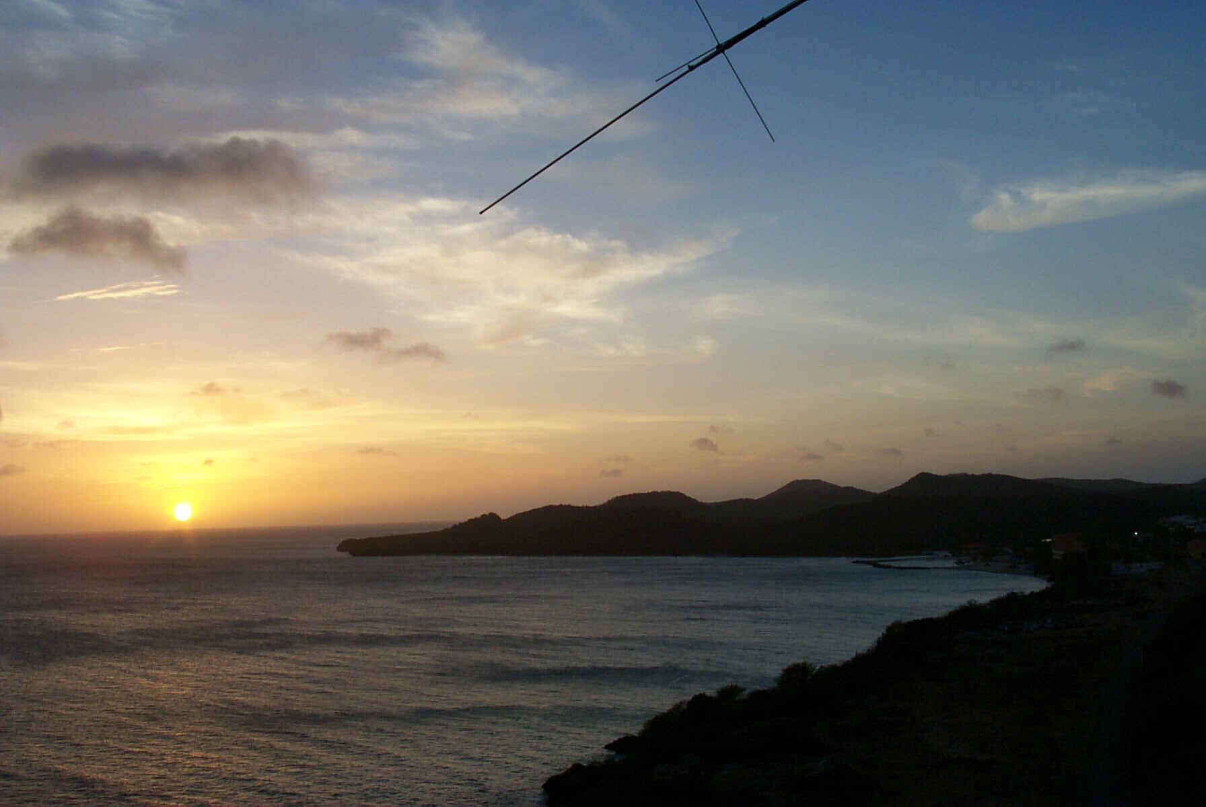
Shot Toward the US from the 40 Meter Yagi

I’m counting on YOU to submit info for the newsletter. I hope to include biographical info on a member with each issue, but so far the response to requests for such articles has been underwhelming. I may resort to fabricating fictional biographies and appending the name and call of members chosen at random. Count on them to be steamy and sordid.

I’m also amenable to printing CCC members’ classified ads for equipment or solicitation of operators for upcoming contests. No charge, just e-mail to me at tkravec@columbus.rr.com

Got comments on the newsletter, club, or anything else? Let ‘em fly. Same address.

