THE PJ2T TWO ELEMENT 80 METER WIRE YAGI
by K6AM 2/15/15

In 2013, we added a reflector to the existing 80-meter inverted vee on the US/JA tower. The goal was to improve our signal to the US by over 4 dB. We mounted a 39-foot long boom at the 80-foot height, just above the 20 meter yagi. We placed an inverted vee at each end of the boom..

Modeling indicates the antenna will be resonant at about 3.5, 11, 18 and 25 MHz. Thus, it is nearly invisible to the nearby 10, 15 and 20 meter monoband yagis, and the Classic 33 tribander at the top of the tower.

PREDICTED GAIN AND BANDWIDTH

Gain is entirely a function of the resonant frequency of the reflector. You would have the same gain if the driven element showed a 3 to 1 SWR as when it was perfectly matched. High SWR only results in increased line loss and problems tuning the amplifiers, not reduced gain.

According to the EZNEC model of the antenna, the maximum gain will be 4.4 dB at 80 kHz above the resonant frequency of the reflector. The gain falls off rapidly below this frequency as the reflector begins acting like a director. However, it falls off gradually as we go up in frequency. If we tune the reflector for 3440, maximum gain occurs at 3520 (see Figure 1), but is at least 3.5 dB from 3500 to 3580, giving us an 80 kHz pattern bandwidth.

The model indicates that the impedance measured at the center of the driven element at resonance will be about 25 ohms resulting in a minimum SWR of 2 to 1. When we add a “hairpin” matching coil across the center insulator to match this impedance, the 2 to 1 SWR bandwidth becomes fairly narrow, on the order of 40 – 50 kHz.

MECHANICAL

The boom is made of seven telescoping 6 ft. lengths of .120” wall aluminum tubing. It has stainless steel through bolts at each junction and pulleys at each end. It is mounted to one face of the Rohn 45 tower pointing to the US at approximately 310 degrees true. It is U-bolted to an aluminum plate which is then U-bolted to the tower legs with saddles to stand it slightly off the tower face. The ends of the boom are supported by 3/16” black Dacron rope tied to the tower just below the top plate.

Both inverted vee’s are suspended on the pulleys with 3/16” black Dacron rope to allow raising and lowering. Both ropes are tied off near where the boom attaches to the tower. The driven element is fed with RG-8X coax through a current balun mounted on the center insulator. There are # 10 screw terminals on the center insulator to allow us to mount a coil if necessary.

TUNING AND TESTING

We have good gain over about 80 kHz (see above). To get full coverage of the contest portions of the band, we will center this window on 3540 for CW and 3780 for phone. This places the resonant frequency of the reflector at 3440 for CW and 3680 for phone. The driven element will be tuned for the center frequencies. We initially tune it for the CW band, then retune for the phone. The exact length the ends are shortened is then marked on the wires with tape and put on a label on the 80 meter antenna switch for future quick mode changes.

The reflector may be tuned by measuring its SWR. You first must detune the driven element by untying its ends, coiling them up and walking them in to the tower. Then temporarily replace the jumper across the center insulator of the reflector with a balun and a length of coax. With the reflector at full height, resonance is indicated when the SWR at the feed point of the temporary coax is minimum. Adjust the lengths of the wires by wrapping the ends back on themselves until the SWR dips at the desired frequency. For fine-tuning and changing the antenna from the CW to the phone band, it is only necessary to adjust one end. The imbalance is not enough to cause a problem. Don’t forget to replace the jumper when finished.

Once the reflector is tuned, you may tune the driven element. Uncoil the ends and re-attach them. Adjust the wire lengths as you did with the reflector for minimum SWR at the desired frequency. If the minimum SWR is too high, the impedance of the antenna is too low. It may be raised by placing a coil across the output of the balun at the center of the antenna. Start with 6 turns of #10 solid wire 3” in diameter and 3” long.

If you need to adjust the coil, adjust the length and number of turns until the SWR is brought down to 1.2 to 1 or less. This will change the resonant frequency, so re-adjust the lengths of the wires to bring the SWR minimum back to the desired frequency. If the coil adjustment changes when you tune for the phone band, set it halfway between the two adjustments.

Actual gain may be measured by stationing someone with a handie talkie and an MFJ analyzer and 10-20 ft of wire about a quarter mile in front of the antenna. He uses the analyzer to send a test signal into the wire, which is attached to a point above the ground.
The guy in the shack with the base radio listens on the receiver in the CW mode with the AGC turned off. He connects an analog AC VOM to the headphone output. He tunes in the test signal and adjusts the audio gain for a reference voltage somewhere around 0 dBm. The level of the audio signal is now proportional to the received signal level and can be measured to within 1/10th of a dB. Audio level measurements may also be made using the audio level meter built into the Elecraft K3.

The team makes a set of measurements over about 100 kHz with the reflector lowered to the ground. These measurements are repeated with the reflector in place. The difference in the readings is the gain of the antenna in dBd at each measured frequency. If maximum gain does not occur 80 kHz above the resonate frequency of the reflector, adjust the reflector accordingly and use the new offset frequency as determined by actual field testing to tune the array in the future.

RESULTS

Measurements of the as-built antenna indicate a good match without the need for a coil. This resulted in an SWR bandwidth that exceeds 100 kHz.

The gain was measured to be about 3.5 dBd at about ¼ mile. However, modeling indicates that this gain at 0 degrees elevation would equate to 4.5 to 5 dB at 15 – 25 degrees elevation.

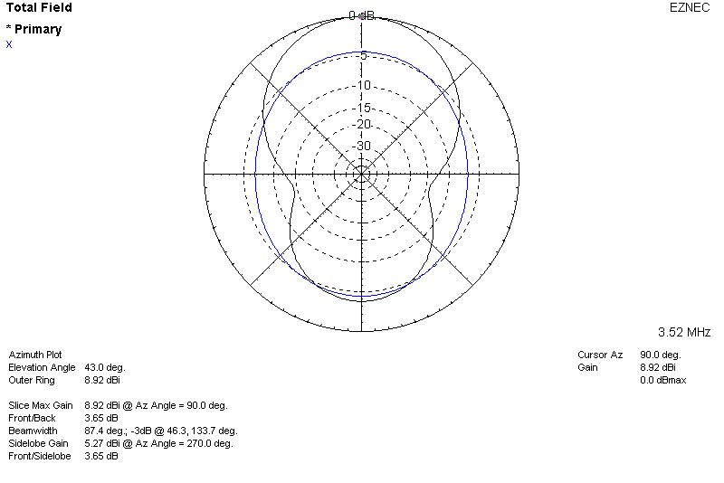

FIGURE 1

PJ2T 80 METER WIRE BEAM
AZMUTH PATTERN AT 43 DEG ELEVATION
(original inverted vee shown in blue)
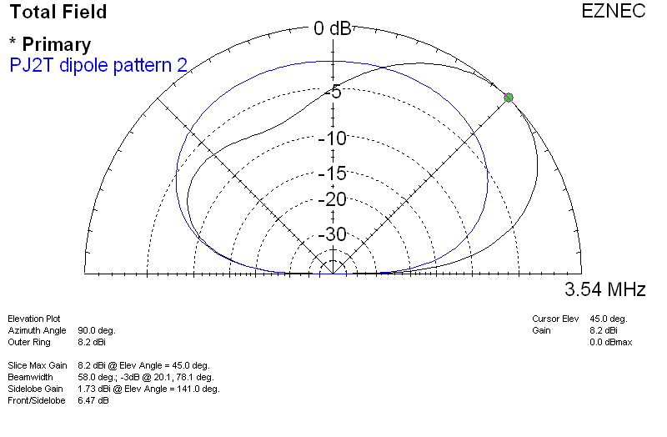

FIGURE 2

PJ2T 80 METER WIRE BEAM
ELEVATION PATTERN
(original inverted vee shown in blue)

