// PRESS RELEASE 3 //
July 6, 2017

The Curacao Half-Century CQWW Celebration
PJ3CC / PJ2T 50 Years

The Caribbean Contesting Consortium, club of the PJ2T contest station, announces the November 2017 Curacao Half-Century CQWW Celebration.
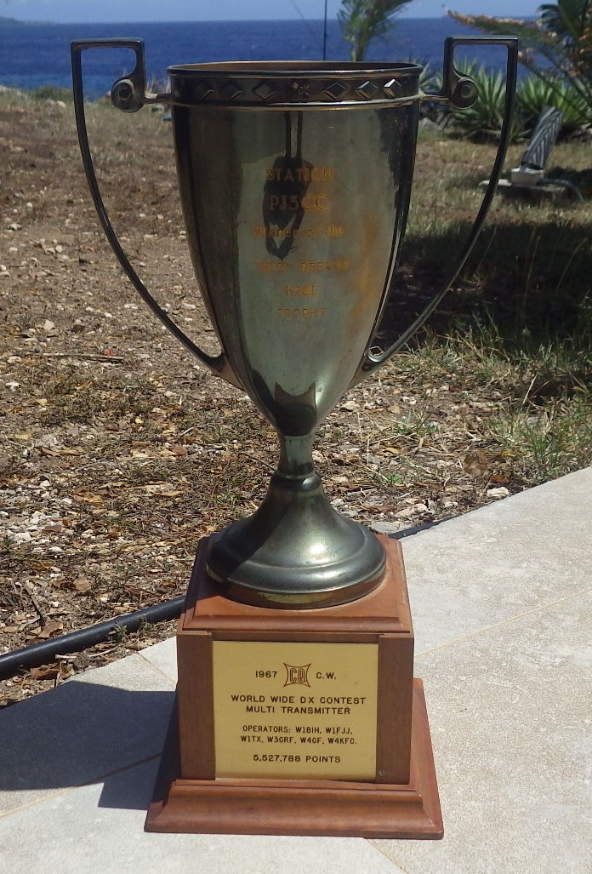
November 2017 will be the exact 50th anniversary of the PJ3CC CQWW CW contest operation from Curacao’s Coral Cliff neighborhood. Manned by legendary contest operators W1BIH, W1FJJ, W1TX, W3GRF, W4GF, and W4KFC, this station won the CQWW M/M world championship trophy pictured here. This was the first organized contest operation from the Coral Cliff area, and since then the Coral Cliff neighborhood of Curacao has been the most active contest location in the world. For half a century teams operating from the Curacao homes of John Thompson (W1BIH/PJ9JT), of Chester Brandon (PJ9EE), from the Coral Cliff Hotel including the famous Radioteam Finland operations, and since 2000 from the PJ2T contest station have made literally millions of contest contacts. The incredible propagation conditions from this locale are now legendary.

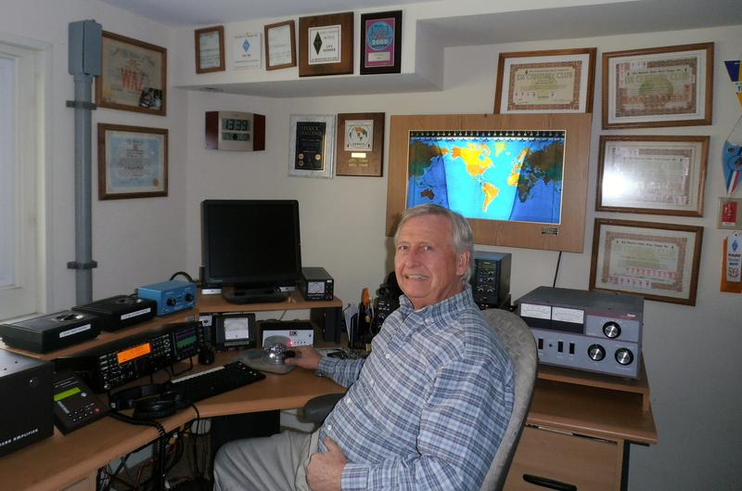
PJ2T will operate CQWW CW as a Multi/Multi entry in November 2017 to commemorate this fabulous milestone, to honor the six operators who started it all, and to celebrate the long history of operations from contesting’s “mecca,” Curacao’s Coral Cliff neighborhood. Our planned VIP Guest of Honor for the operation is Al Rousseau, W1FJ, the only surviving member of the 1967 operation.

Planning is underway now. Here are some of the proposed features of the celebration.

* W1FJ plans to attend and operate. Al is the only surviving member of the 1967 PJ3CC team.

* PJ2T will QSL the contest 100% with a special commemorative card sponsored by PVRC. Three of the six PJ3CC ops were PVRC members.

* Everyone who is in PJ2T’s contest log will be eligible to purchase a special Half Century commemorative coffee mug.

* CQWW Contest Director W5OV has tentatively committed to be on the team. Director W4PA will also make a visit to the QTH to commemorate this great competition and honor the six original operators.

* K2MGA, publisher of “CQ Magazine” and CQ’s editor W2VU have been invited as honored operator guests.

* Anyone who has ever operated from the Coral Cliff location in this past half century is welcome to attend the event as spectators and/or as guest operators. If this turns out to be a large number of people operating time will obviously be limited, but everyone is welcome. We could potentially be honored by having a large and historic operator list for this year’s CQWW CW. There is plenty of hotel space on Curacao.

* Dignitaries from Bureau Telecommunicatie, Curacao’s “FCC” will visit the operation.

* Press coverage by local Curacao broadcast and print media will occur.

* All members of Curacao’s local ham radio club, VERONA, will be invited to participate.

* On Wednesday night before the contest we will have a special dinner at a Curacao restaurant or hotel to celebrate the anniversary.

Watch for subsequent press releases about this event and for additional publicity in amateur radio media.

Released by Geoff Howard (W0CG, PJ2DX) ghoward@kent.edu 208.676.8766

