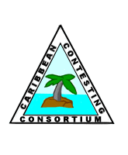 | Signals From The Point  Official Newsletter of the Caribbean Contesting Consortium  Editor: W0CG
Volume 19, Number 5 May 12, 2019

Dayton Hamvention

CCC Annual Meeting: Friday, May 17 at 3PM at the Crowne Plaza Hotel, Wilbur Room, top floor.

President’s Message de N5OT

I got a look at the great polo shirts Geoff has produced for our club and they are fantastic! I'm looking forward to wearing mine to the festivities in Dayton. Speaking of Dayton, we'll see you all, or as many of you as can make it, at the meeting Friday afternoon in the Penthouse of the Crowne Plaza hotel. 3pm in the Wilbur Room. Be there! “Cliffhangers for everyone! On the house!”

Looking to the future, there are a couple key issues in the balance. First is to find a way to configure what we do so all the routine tower work down there is not so dependent on Geoff. The officers have produced a plan for how we can make this happen. We look forward to getting you, the membership, up to speed at the meeting, and we ask that you agree it is the right thing at the right time.

Another challenge is to broaden our success base to consistently include all six of the major contests. Our operations in contests these days are at an all time high, but there is still some room for improvement. We should be putting in world-class efforts for both modes in all three: CQ Worldwide, CQ WPX, and ARRL DX. After 20 years of diligent efforts, it's time for us to maximize our contest entries.

Of course part of that goal involves continuing to identify and raise up new operators who have penchants for CQ WPX and for phone operating. Imagine having a robust stream of new operators flowing through our program. By so doing we can identify the best candidates for new members, and put up our best scores in all the majors. Building this base of operators and members will be what carries our club and our contests to new heights.

Kathy and I will be leaving for Dayton in only a couple more days. We look forward to seeing you there!

73 – Mark N5OT

Old Time PJ2T: Station 1 September 2002

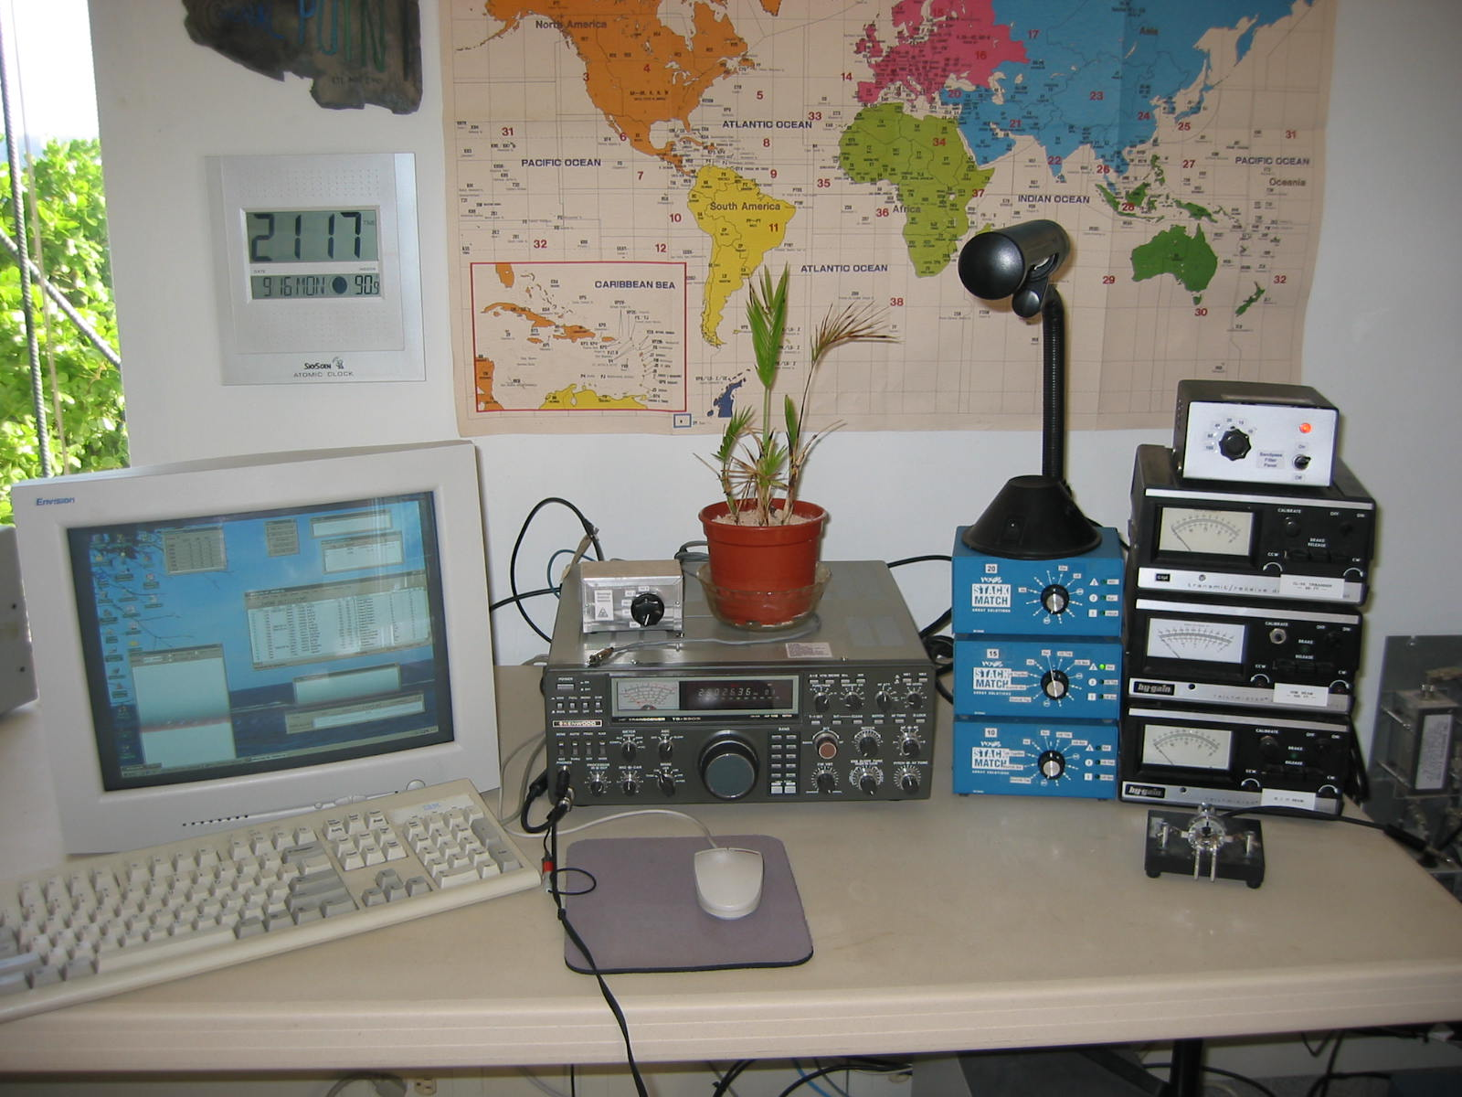
This TS-930 donated by W9VA was our only transceiver, the computer monitor weighed 50 pounds, and the antenna switching system was a couple of B&W cans on the floor. We’ve come a long way since then!

Financial Snapshot

As of May 1 the balance is at $6628.62. Thanks Treasurer W8WTS.
About the Coral Cliff Title Foundation

CCTF is our neighborhood homeowners’ association for the 13 homes at our dead end of the road. This group is led by Prof. Albert Koers, who is pretty much the only person who has been in the neighborhood longer than I have been. Albert is a brilliant and eloquent Dutch attorney, and he provides excellent leadership for our group.

Over the years the HOA has been a bit on again off again, but now with the new hotel coming we have become much more formalized. Last month the HOA began assessing annual dues of NAfl 600 per house, which I paid promptly. Our upcoming big project will be to install a controlled-access gate across the road at the northwest corner of the Signal Point property. The gate is on order, to be shipped from Holland, and the drive mechanism and electronics will be installed once the gate arrives on the island. Access may require a key code, a key card, or a remote control code transmitter, the details of which are still fluid. Most probably Signal Point will supply the electricity to run the gate because of our proximity. I’ll keep you posted as this project unfolds. Nothing is foolproof, but the gate will be one more component in enhancing the security of the neighborhood.

Health Check on the US/JA Tower

The US/JA tower was built in June of 2001 using mostly sections donated by Bob, N8NR. Those sections were in like-new condition, having been in his barn, protected from the weather. That 80 foot Rohn 45 US/JA tower is still in acceptable condition. I’ve maintained it very aggressively. Where rust has appeared I’ve power-brushed and/or sanded it, and then applied coats of epoxy primer and finish paint. Over the years we’ve discovered several holes in the legs, almost always hidden under tape wraps, and have put on splints provided by WB9Z. Those steps have kept the tower safe. Here’s an example of a hole in a leg at the 25 foot level, on December 4, 2016.

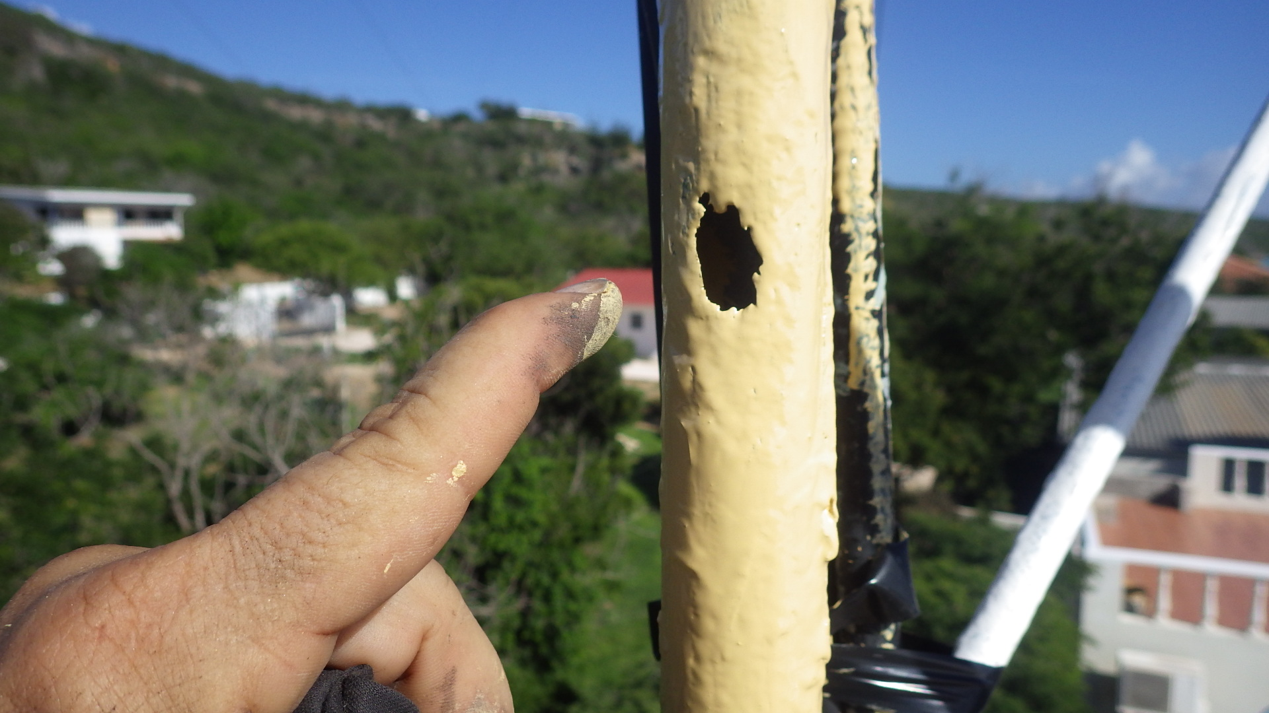

This was underneath a wrap of tape that was holding up feedlines. We have now learned not to use tape on tower legs, and it has nearly all been removed. This hole is not as heinous as it looks, because tubing is still very strong with this small proportion of its circumference lost. As you see, this hole has a coat of epoxy primer. The next day I coated it with epoxy paint and the day following installed a leg splint. There is no need for concern, as this will hold up for many years.

In the most recent two years, almost all attention was understandably directed toward the Europe tower. With the new tower now in place I was able finally to devote several days to the US tower this February. I found and fixed considerable rust, mostly above the 20 meter beam, but found nothing that was particularly alarming or structurally threatening. This tower will continue to require careful maintenance, hopefully from NR0X, but I have little doubt that it will continue to serve well for many more years.

The obvious question is why is this tower still OK when the Europe tower deteriorated so badly that it needed to be replaced. I have two theories, neither of which I can prove scientifically.

Theory 1 is that the metallurgy of the tubing Rohn used for our 45G sections differs markedly from the tubing in the Rohn 55 Europe tower. The 55 leg material reacted much more rapidly over the years to the damp salt slurry blown onto it from the ocean. The legs in the Europe tower seemed to turn into a rusty mush much faster and more severely than the US/JA tower. The Rohn 45 does definitely rust in the presence of salt, sure, but the leg material seems much harder and its corrosion much less profound.

Theory 2 is that our site geometry protects the US/JA tower better. This seems counterintuitive because the US tower is closer to the ocean. But the cliff and the house present blocking angles to the windborne salty moisture in a way that protects this tower better than the Europe tower.

In a future issue I’ll review the status of our WARC tower. Preview: it’s in good condition, and a little maintenance will go a long way there.

Remembering Noel, W9EFL (SK)

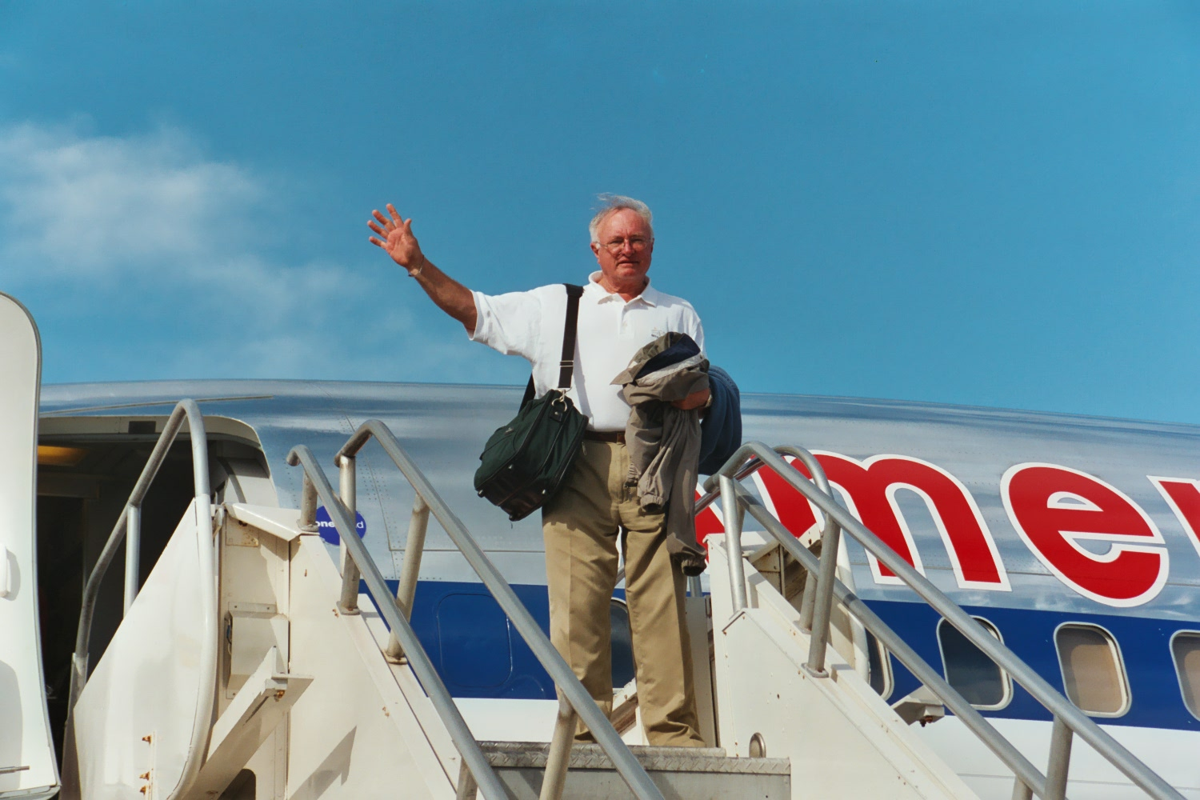

Noel Kindt was a charter member of CCC and was instrumental in helping to get Signal Point on the air. He operated several times with the CCC gang from VP5 and KP2 in the 1990s, and after the hard work of those field day style operations he fully supported the idea that the club should try to establish a permanent, owned station somewhere in the Caribbean.

Noel was on the October 1999 CQWW SSB PJ9C operation from Kadushi Cliffs Hotel at Westpunt. After taking a look at the PJ9JT QTH, which was on the resale market, we decided to get serious about a purchase, and Curacao looked like a good bet for many reasons. After I bought the house in October of 2000 Noel was instrumental in cleaning it up and helping to get a modest signal on the air in WW CW 2000, our first PJ2T operation. Noel was more than willing to do the dirty work of hauling out trash, cleaning, sanding, and painting the ugly, abandoned old home.

In real life Noel was retired from his hugely successful electronics manufacturers’ rep business, was on the Board of Directors of Ten-Tec, and had a magnificent giant station and car collection in Marcellus, Michigan. He was a rabid fan of the Fighting Irish and had his engineering degree from Notre Dame. He contested with us in Curacao for many years, and we still miss his smile, his “yip yip” can-do attitude, and his scientific lectures about femptoseconds.

More Legacy PJ2T Photos: November 2002

Here are my XYL Cindy and Jim Livengood (W0NB) having breakfast on the site of the Ocean Pavilion. I put the breakfast table out by the ocean one morning to see what it would be like to have an eating area that close to the cliff edge. Jim and Cindy squawked that morning about having to eat with no shade, but the spot felt right and led to the construction of our Signal Point Ocean Pavilion in late 2003. The small sea grape tree behind Jim’s seat is the same one that is now about 15 feet high. 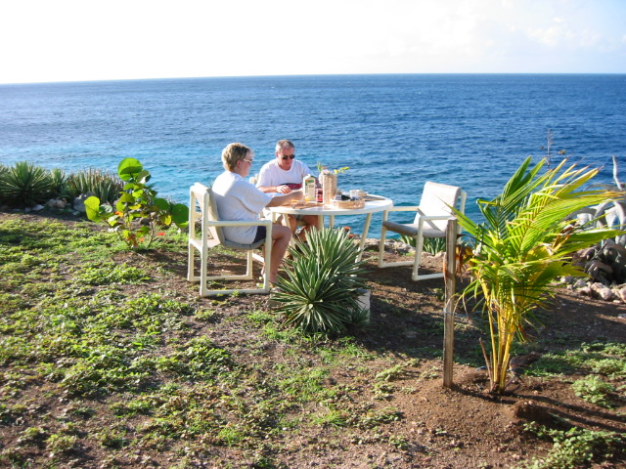

Here below is Joeke, PA0VDV operating Station 1. He’s a frequent visitor to the island, and was good friends with John Thompson, W1BIH/PJ9JT. After this visit Joeke reported to John that we had a framed PJ9JT QSL card on the wall (visible in the photo) and that got us a smile and nod of approval from W1BIH via E-mail.

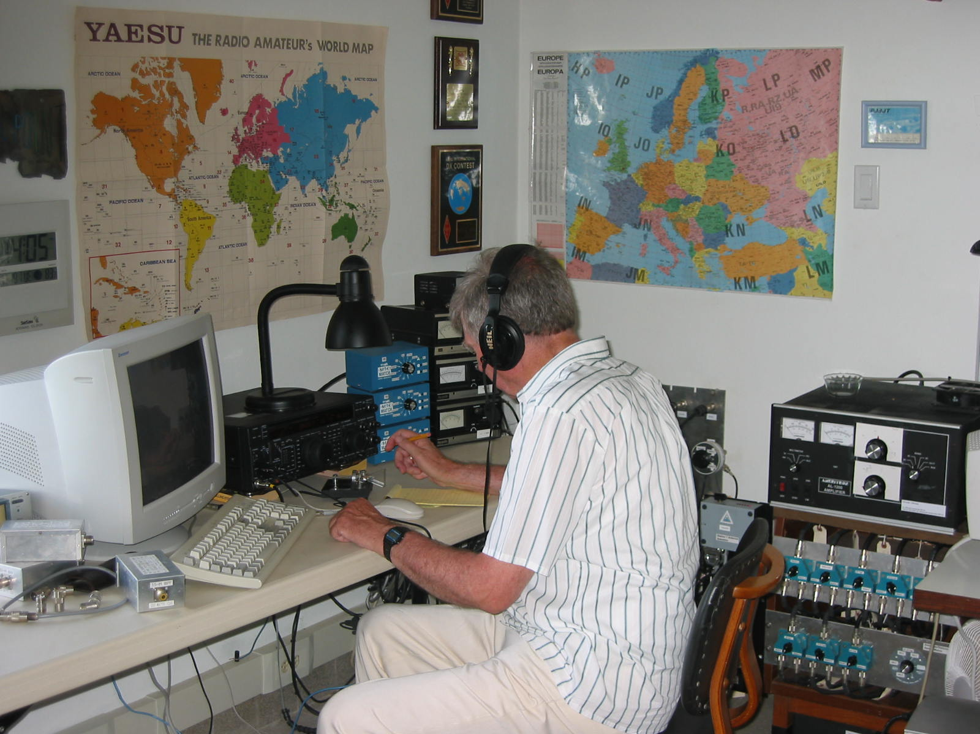

PJ2T’s Wish List

We are in very good shape on equipment and antennas, but there’s always something on the wish list. What would you add to this list? What might you be able to help with?

* Monster high power simple amp
* One more K3, subreceiver not needed
* SSB contest operator members
* RTTY contest operator members
* Tower-climbing members
* 275 feet of LDF4-50A ½ inch Heliax hardline,
* Three new operating chairs (buy on island)
* Larger monitor for Station 3 (buy on island)
Thanks to VE3CX and VA3OJ the wish for Heliax hardline has been granted. Also, I greyed the operating chairs and large monitor off the list because we will simply buy those on the island when we’re there next.

Europe Tower Photos Revisited

If you missed the album of tower photos from last December, here’s the link.

http://www.pj2t.org/ccc/PJ2TTowerReplacementAlbum/pj2t.new.europe.tower

Station Technical Tips

Tip 1: Signal Point has four permanent stations. Each station has its own dedicated 12 volt DC supply under its desk. Nothing will work at your station until you bend down and flip on the DC supply for that station. The supply runs the K3 transceiver if it’s installed, and all of the low voltage DC accessories at your station.

Tip 2: Station 1’s under-desk DC supply also runs the entire shack antenna switching system. Nothing will work anywhere in the room until that Station 1 supply is turned on.

Tip 3: N0YY designed and installed absolutely beautiful undershelf LED tape lighting at each station. It’s a 12 volt system, so the DC power supply for that station has to be turned on. To light up the LEDs, use the small toggle switch at the far left end of each station, just below the amplifier trestle shelf.

Thanks again to Mal, NP2L for major funding for the new desks we got in 2015.

What’s “Tribanders Direct” ?!?

N7IR has prepared a superb tutorial on how to use our antenna switching system, referenced below.

http://www.pj2t.org/ccc/Antenna.switching.102.N7IR2.pdf

But some of you are still puzzled about the button at the top right of each station’s antenna selection control. It’s labeled “Tribander” in this older photo but now is labeled “Tribanders Direct.”

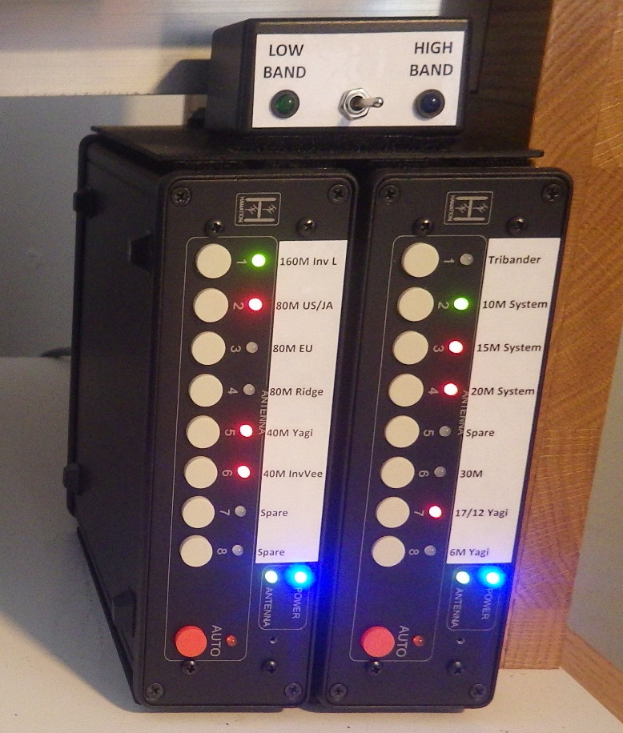
.
When you push this button you have immediate access to our four triband beams without having to use the 20, 15, or 10 meter system boxes (pictured below).

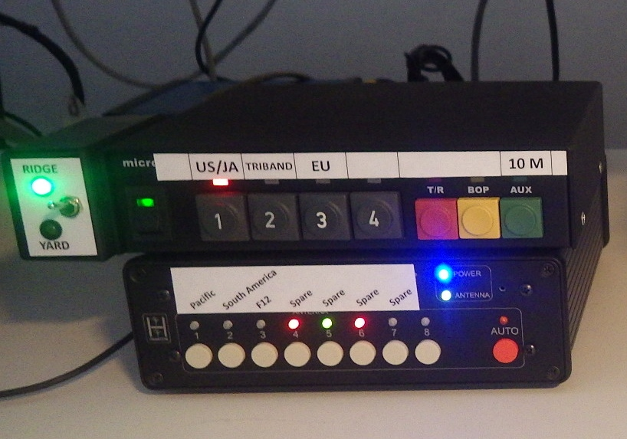

When you pushed that “Tribanders Direct” button you completely bypassed these three boxes and went, well, direct to the tribanders.

Now, which tribander do you want? There is just one box in the whole shack where you select the tribander you want via direct. That box is at the right side of Station 2. Go over there and stab the button for Force 12, South America, Pacific, or Bencher Europe Yard, and you’re on the air with the tribander you want.

SSB Audio Setup by KB7Q

After doing a few SSB contests with various M/M teams at Signal Point I realized that we’re not getting the most performance out of our Elecraft K3 radios. I did some Internet sleuthing and compiled the results.
On receive the trick with the 2.1 KHz filter and narrower is using the IF shift control and moving the IF center frequency DOWN a bit to increase intelligibility. The Hi-Cut and Low-Cut adjustments can then be lightly used to try and knock out adjacent QRM.

If you totally mess up your settings you can restore things to the nominal 2.7 KHz filter with a centered IF by pressing and holding the knob with the yellow label “NORM” for 2 seconds.

Our K3 radios are usually run with AGC settings of AGC SLP = 0 and AGC THR = 10 for maximum dynamic range to enhance picking signals out of a pile-up.

K3 radios achieve maximum performance when you protect the front end from signal overload. Reduce the RF gain or use the attenuator, especially on the low bands.

In transmit, set the 8 channel transmit audio equalizer as follows, realizing that your voice characteristics might require some adjustment. Use the monitor function to see what you sound like.

Channel Setting
1 -16
2 -16
3 -16
4 -6
5 0
6 0
7 +3
8 +3

To properly set the audio TX gain on a K3 turn the compression (CMP) to zero first, then adjust the MIC GAIN until the fifth to seventh ALC bar is flickering on voice peaks. Only then bring in your compression, no more than 10db on the compression meter is warranted… ever. We don’t want PJ2T associated with crap audio.

The full text about using the K3 in SSB is at:

http://www.pj2t.org/ccc/ssb.setup.for.K3.by.kb7q.pdf
Check Out PJ2T on Google Maps

Following this link will take you to a photo from the road at Signal Point’s front gate.

https://www.google.com/maps/@12.2614644,-69.1232797,3a,75y,166.28h,70.17t/data=!3m6!1e1!3m4!1sdANVbNRNs_WLkkhwaFvjzg!2e0!7i13312!8i6656

Within this December, 2017 image you can click to “walk” up and down the road and to turn left and right to look into the station’s front yard. Use the red and white compass icon at the bottom right to change direction.

Member Spotlight

Bill Smith, W9VA

Bill is the second longest still active CCC member. (WA9S is the longest.) – Ed.
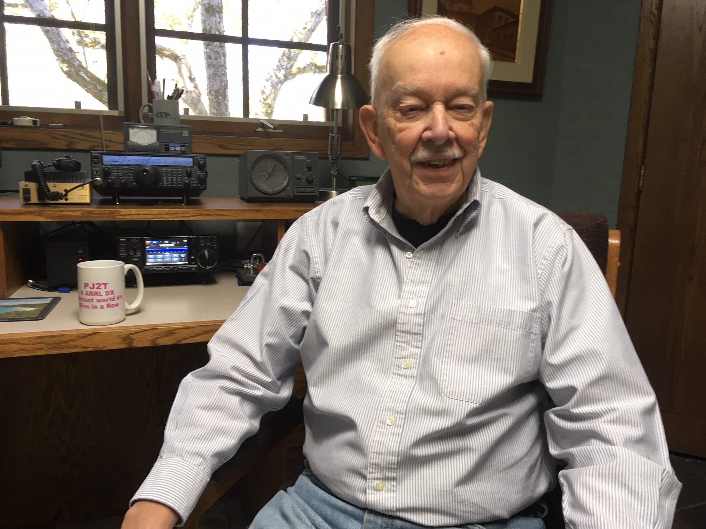

Like many from that era, I became interested in radio in high school and was licensed in 1952 at age 15. A friend helped get an antenna on the roof of our apartment building, and I was on the way. My first DX was a KL7 on 40 followed by such memorable calls as KV4AA and KH6IJ. I dragged a radio to college – Miami University in Oxford, Ohio. A previous guy in my fraternity had established a ham shack on the top floor of the fraternity house – very convenient for me to move in. This was during the peak of sunspot cycle 19 – the best ever – and DX was so easy. Later on, got married, bought a house, and moved on to some good equipment and contesting.

The serious contesting from the DX side began in 1980 – the first business trip to Brazil – meeting the Rio contesting and DX group, including Hal Harris PY1ZAE (SK), Rolf Rasp PY1RO (SK), and others. I was invited to a nice contest station about 25 miles out in the country. Hal really helped me learn contesting from the DX side. I did quite well in various contests using my first Brazilian call – PY1ZFO. Through Rolf I met Andre Sampaio PY0FF. I visited Andre on the island of Fernando de Noronha in March 1988. I happened to be there for the ARRL phone DX contest. Keeping in mind that Noronha is a separate country from Brazil for DX and contesting, and having very limited activity, I got my first real exposure to huge pile-ups. But once experienced, the pile-up hunger is never satisfied. I went back to Noronha 11 times, mostly in February for the ARRL CW contest. In February 2003 fortunate enough to win the Single Band 10 plaque and set a new continental record for South America. A 7 over 7 and Alpha does wonders. The last time to Noronha was 2009 – a multi-op venture in the ARRL phone DX contest. Unfortunately Andre has moved off the island and that opportunity is no longer available.

But before that window closed another opened. Geoff was looking for operators for the 1999 ARRL CW contest from Providenciales – and I was quick to volunteer. Being part of the VP5CW team and meeting Geoff, Keith and others was a life changing experience. It was there that Geoff decided he had had enough of dragging stuff around, and began planning for a permanent station in the Caribbean. Not long after the John Thompson station PJ9JT on Curacao became available – the rest is history. At that time the house had been unoccupied by humans for several years. The animals and the tropics had done much damage to the house, but Geoff had the vision to see what it could become. After months of cleaning up the house became habitable – things were looking great for my first visit for ARRL CW in February 2001. Soon after I led groups for the ARRL 10 Meter contests of 2001 and 2002. Later we began a series of non-contest visits with Joe W9JUV (SK) and our wives.

But the most memorable was the 10-10-10 celebration of Curacao’s independence (sort of) from the Netherlands. In October 2010 the four Dutch Caribbean island groups were added to the ARRL DXCC countries list – probably the first time ever that DX’ers throughout the world had a shot at four ATNO’s (All Time New One) at the same time. Groups went to Bonaire, Dutch St Martin, and Saba to satisfy the demand. Jeff K8ND and I catered to the multitude from Signal Point – I had been on the receiving end of some humongous pile-ups, but nothing quite like that one. Our friend Bob Allphin K4UEE actually came up with a 10-10-10 band plan so the four simultaneous pile-ups would not overlap. I wrote an article about it that appeared in the March/April 2011 issue of The DX Magazine. Now in my twilight years of contesting, I love the annual February visit to PJ2T for the ARRL CW contest. Looks like another M/M win for 2019. Living in Illinois, just being somewhere warm in February is most welcome, but the friendships and camaraderie at Signal Point are very special.

Another good experience was the opportunity to be Chairman over a ten year period of the W9DXCC convention. This is an annual event held near Chicago going back to 1953. A great opportunity to meet the “Movers and Shakers” in the DX and Contesting community, which of course included our own Geoff Howard, who told the PJ2T story at W9DXCC 2005.

I also have a life outside of amateur radio. My business career spanned forty years and included some interesting assignments. I spent a few years in nuclear insurance - which brought the dubious honor of being one of the first at Three Mile Island following the “incident” of March 28, 1979. Several international assignments – in addition to Brazil – work in Canada, Bermuda, Belgium, and Puerto Rico. The Belgium trip allowed a day with ON4UN in Ghent and ON4DE in Antwerp. In San Juan, our base was the Caribe Hilton Hotel. Security not so tight then in the 70’s – ask me about putting up dipoles on the roof of the hotel. Since retirement, I have been active in the National Stuttering Association, doing financial work for our church, and playing bridge.

None of the above would have been possible without the support and encouragement of my wife Jane. As mentioned above, Jane has been to Signal Point several times. College sweethearts - next year will be our 60th anniversary – been a wonderful journey.

