 | Signals From The Point  Official Newsletter of the Caribbean Contesting Consortium  Editor: W0CG
Volume 19, Number 4 April 15, 2019

CCC Job Roles

President: Mark Beckwith (N5OT)
Vice-President: Gene Shea (KB7Q)
Treasurer: Jim Galm (W8WTS)

Station Equipment Lead: Gary Hembree (N7IR)
Computer Operations Lead: Gene Shea (KB7Q)
Outside Maintenance Lead: Geoff (W0CG)
Remote Operations Lead: Gene (KB7Q)
Strategic Planning Lead: Jeff Maass (K8ND)
Newsletter Editor: Geoff (W0CG)
PJ2A CW Skimmer Lead: Jeff (K8ND)

Annual Meeting at Dayton Hamvention

CCC’s Annual Meeting will be Friday, May 17 at 3PM at the Crowne Plaza Hotel, Wilbur Room. Unlike recent years, the meeting will be on the top floor. Thanks to N5OT for arranging this. See the details below. We will have the usual drawing among those present for a $200 kickback on your next visit to Signal Point. Be careful: if you’re not there, you may be elected or appointed to something!

President’s Message by N5OT

Greetings to you all. I should start by reiterating all the kudos to everyone who has seen our club and our station through to the level where we find ourselves. It is unprecedented! I'm honored to be president of such a fantastic group in this time and place.

We have our big annual meeting coming up in Dayton. I hope to see as many of you there as can possibly make it to the meeting. We managed to secure the Crowne penthouse, and I look forward to the nosebleed elevator ride. I bet some of you do, too. Nowadays it's called "The Wilbur Room." Sounds like the Wright move. Rumor has it, there will be Legacy N4RV-certified Cliffhangers again this year for all Brave Souls.

We are at a crossroads. Our club is coming into a new generation where it will likely see a number of us OTs age out of playing radio. Those same OTs (hey, OT is my middle name) are hoping to leave a legacy for a future generation of radio operations that will outlive some or all of us. Geoff has strategically planned for the station to remain in the hands of the club. We have upgraded the biggest tower on the site. Now it remains for us to consider the issue of our “perceived accessibility.”

I put it like that, because I have talked to a lot of contesters about their perception of PJ2T. Thanks to our undying effort to make sure our great station is on the air for all major DX contests, there are many who tune across PJ2T wishing they might some day be on our end of the pileup. Yet a number of potential members conclude we are simply beyond their reach. They have no idea how easy it might be to join the action from the Coral Cliff. There are also misconceptions that we are elitist. A number of people who could be joining in our operations have inaccurate ideas about what we do and how we do it.

That said, during the next year, my goal is to break the ice and have the conversations with some new blood who could become real assets to our club. I suggest we all think about ways to increase our membership base, and how to welcome into our fold other serious contest operators who are cut from this peculiar cloth we know so well.

I look forward to seeing you in Dayton!

73 – Mark N5OT
President, Caribbean Contesting Consortium

Elecraft K3 Acquisitions and Upgrades by N7IR
The CCC now owns four Elecraft K3 100 Watt transceivers. Through a process of donations and purchase with station operation funds we have updated all four to the latest hardware configuration available for the “plain” K3. We have two single receiver and two dual receiver K3 transceivers, whose configurations are given in the following linked file.

http://www.pj2t.org/ccc/K3.hardware.configurations.n7ir.jan.2019.pdf

The most significant improvement in the K3, since it was first sold in 2007, has been the new synthesizer board that was introduced with the K3S in 2015. All of our K3 transceivers have this upgrade for each of their receivers. This upgrade not only improves the phase noise performance of the receiver but also improves the QSK performance of the entire radio, especially in split frequency operation. The following link will download an article that outlines these improvements.
https://ftp.elecraft.com/K3S/Manuals%20Downloads/KSYN3A%20FAQ-ver-D.pdf
Spearheaded by the efforts of member Pete Gladysz K8PGJ, digital voice recorders and narrow SSB roofing filters have been added to each of the club K3 transceivers. These additions have already enhanced the operation of these radios in our SSB contesting efforts. KB7Q has written an excellent article outlining their setup and operation with N1MM Logger+ in sideband contests.

http://www.pj2t.org/ccc/ssb.setup.for.K3.by.kb7q.pdf

Finally, for our low band aficionados we have full diversity receive capability on two of our K3 transceivers. Each of our dual receiver radios has an “Auxiliary Antenna Port”, labeled AUX RF on the rear panel, which is connected directly to the 2nd receiver. This hardware enables connection of a separate antenna to that receiver, independent of the main receiver antenna. K8ND has posted a portion of the Fred Cady K3 manual that covers the connections and setup of the radio for diversity reception, which is linked below. He and Jim W8WTS have used this capability extensively in their “letter mining” operations in the 160 meter contests. They also upgraded one of the dual receiver radios with 250 Hz roofing filters before the 2019 CQ WW 160 contest. Thanks to Jeff for donation of the two filters.

http://www.pj2t.org/ccc/Elecraft_k3_Cady_ver2o_Diversity.pdf

Financial Snapshot

As of April 1 the Station Support Fund is at $6326.82. The Europe Tower Fund is at zero because that project is finished and fully paid for.

K8ND: Hyperactive on the Air

Jeff’s recent numbers:

Total PJ2/K8ND QSOs: 61958 since 20 Nov 2002
Total PJ2ND QSOs: 23070 since 20 Jan 2017
TOTAL PJ2 QSOs: 85028
Remote PJ2 QSOs: 13094 since 9 Feb 2017
Total Days on Curacao: 423 since Nov 2002
35 total trips to the island

Congratulations to Jeff and thanks to him for helping to keep the profile of our club station very high.

PJ2T Contest Season – Major Efforts Summary

CQWW SSB October
7407 588 12,582,612 7th World M/M

CQWW CW November
11929 777 27,256,383 2nd World M/M (Winner was in Zone 33.)

CQ 160 CW January
1359 131 1,766,797 2nd World DX Multi-HP

ARRL DX CW February
8052 300 7.209,900 #1 World M/M (Most QSOs in the world, any location, any category.)

ARRL SSB March
7729 290 6,713,790 #1 World M/M (But PJ4G made 9856 QSOs with only two transmitters.)

Stew Perry Topband December
460 4.206 SOHP (Remote), KB7Q, 3rd DX Side

CQ WPX SSB March
4832 955 19,373,130 5th World M/M

WinKeyer PTT Protocol for PJ2T by N7IR and KB7Q

We use the WinKeyer USB made by K1EL to handle our CW sending and PTT sequencing. The logging program off-loads CW messages in the form of ASCII characters to the WinKeyer, which takes care of converting them to perfect rig keying. In addition, a PTT control signal is generated with the correct amount of lead and tail time for our amplifiers' slow relays. Using the WinKeyer to generate the PTT signal from N1MM+ allows close control over the timing of the amp TR relay closure versus RF generation from the exciter. This control is independent of mode and can be used with SSB and RTTY in addition to CW on any radio. Using the WinKeyer relieves Windows OS from the overhead of producing quality CW keying and accurate PTT directly. This is now standard operating procedure at PJ2T.

The following link will bring up a pdf of the WinKeyer setup instructions appropriate for our Elecraft K3 radios. Similar settings and connections will undoubtedly work with our Yaesu FT-2000 radios when they are run in pure PTT mode; not VOX, QSK or semi-QSK.

http://www.pj2t.org/ccc/winkeyer.and.n1mm.engineering.notes.pdf
To send with paddles without N1MM+ you will need to make sure the WinKeyer is programmed in stand alone mode with the same PTT lead, tail and hang time settings as in N1MM+. This task is accomplished by using the Winkeyer 3 Tools Utility, which is installed on all of the station computers. In addition to setting the correct timing, be certain that the “Output Config” drop-down menu is set to “Port1, PTT”. These settings are required so that the correct PTT behavior will be followed if N1MM+ crashes and you want to complete a QSO manually. The following image (next page) illustrates how to change the stand alone settings. Note the “Read WK” and “Write WK” buttons in the bottom left. Those are used to find out what parameters are loaded and to load new parameters respectively.

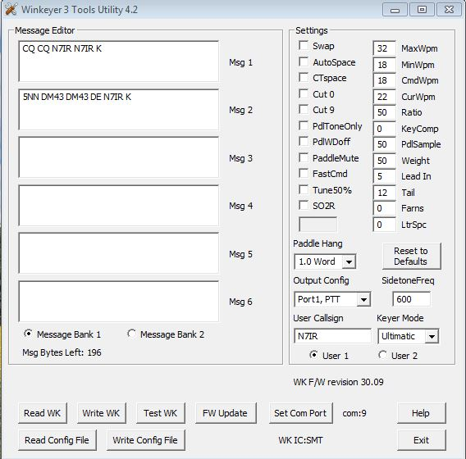
AL-1200 Problem Solved

We’ve have heard it for a couple of years: an occasional loud crack coming from several of the AL-1200 amps. What else could it be except bad electrolytics in the HV chains, right? But in several cases replacing those capacitors did not cure the
problem…! This seemed nuts, but we finally discovered that the problem was NOT the caps, but the resistors, the 50K 7W voltage equalizing resistors on the HV string. We found that some of these had gone open or nearly so, while others had very low values. Obviously this was placing much higher than the rated voltage on the caps and taking them out. So we bought a pile of replacement resistors and N7IR did the work in November. The photo shows Gary in the most awkward of all work situations, doing surgery on several of the amps in the East Bedroom before and after CQWW CW. This did the trick, all AL-1200 HV supplies are now completely healthy, and we have a good stock of spare caps and resistors. Thanks N7IR, KB7Q, W8WTS, and W0CG for this fix.

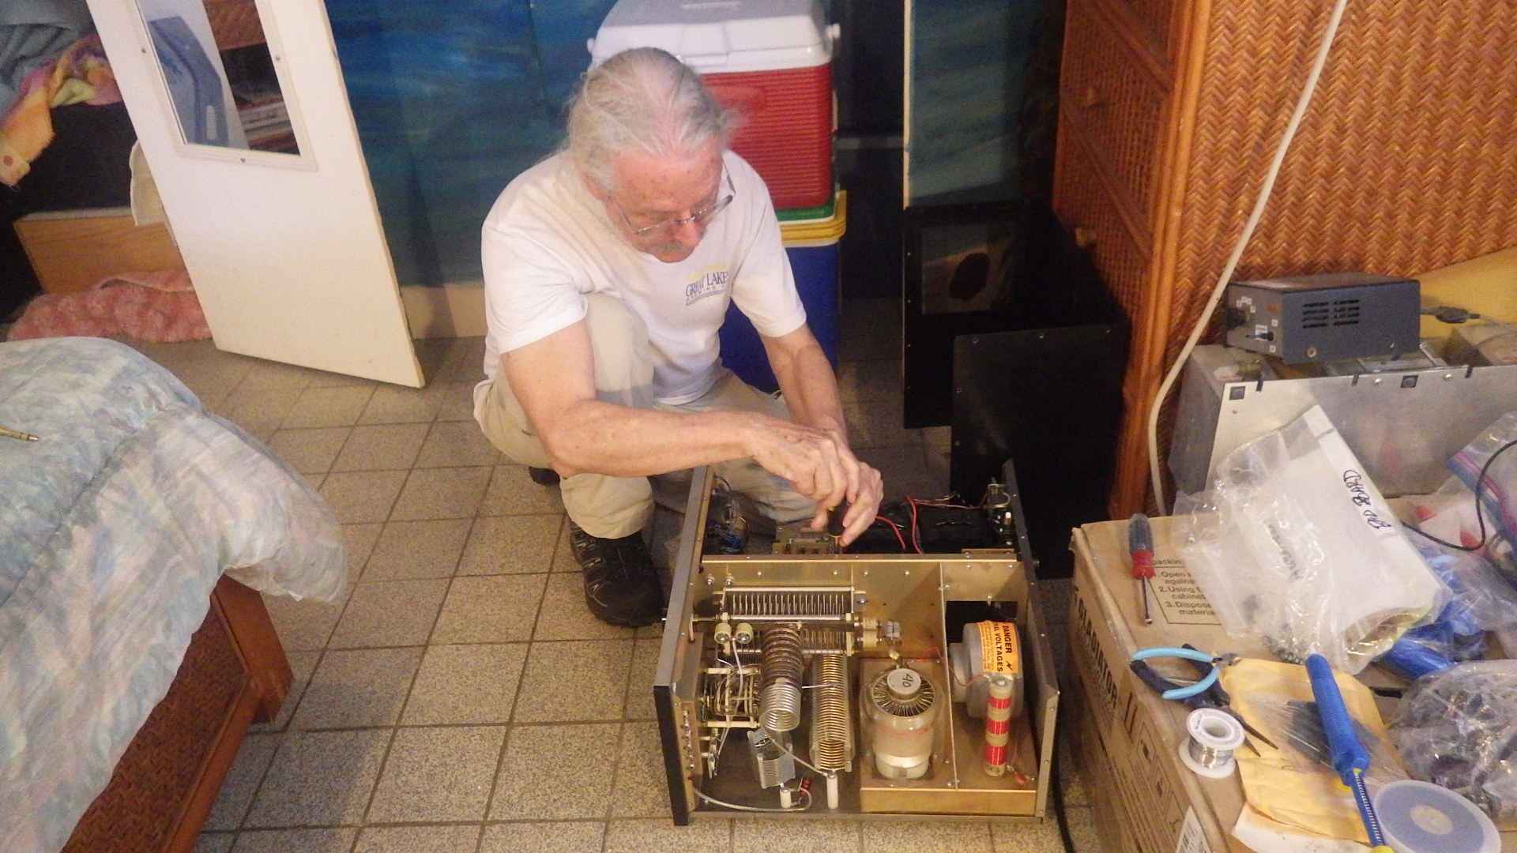

The Historic Origins of PJ2T

If you’re curious about how CCC and PJ2T came about, our origins date back to the mid-1990s. See this DX Engineering W0CG interview for an outline of some of that history.
https://www.youtube.com/watch?v=5yHJqa_Tk50

The “Lost” Rotor Is Found

I took the old Tailtwister out of the Europe tower and brought it back to Idaho in December. As we’ve done so many times, I shipped it to CATS for a total rebuild, whereupon it disappeared!! The shipment never, ever showed up anywhere in the FedEx tracking system. Also, I never received any delivery confirmation that it had reached CATS in Kentucky. The manager of the local FedEx office worked patiently with me for two days because she had no record whatsoever that it had ever been tendered for shipment. What’s worse, all of my phone calls and E-mails to CATS went unanswered, and I was about ready to write it off as a loss.

Miraculously, I got an E-mail a couple of weeks ago from CATS that the rotor was finished and had been shipped to the address I specified in Ohio. He apologized for disappearing for a couple of months and assured me he was now fully back in business. But the FedEx mystery was never solved. Obviously their system has some serious holes.

I’ll get the repaired rotor back to Curacao this fall season. Also, I’m trying to buy three Tailtwisters from an estate sale in Seattle. Cross your fingers.

Rebuild of Our 30 Meter Vee

The 30 meter vee had been inop with high SWR for months, but that “for fun only” antenna was low priority. Finally on December 10, the week after we got the new Europe tower in the air, I got some time, and lowered that antenna to the ground. It’s no mystery from the photo in the next column why it was not working.

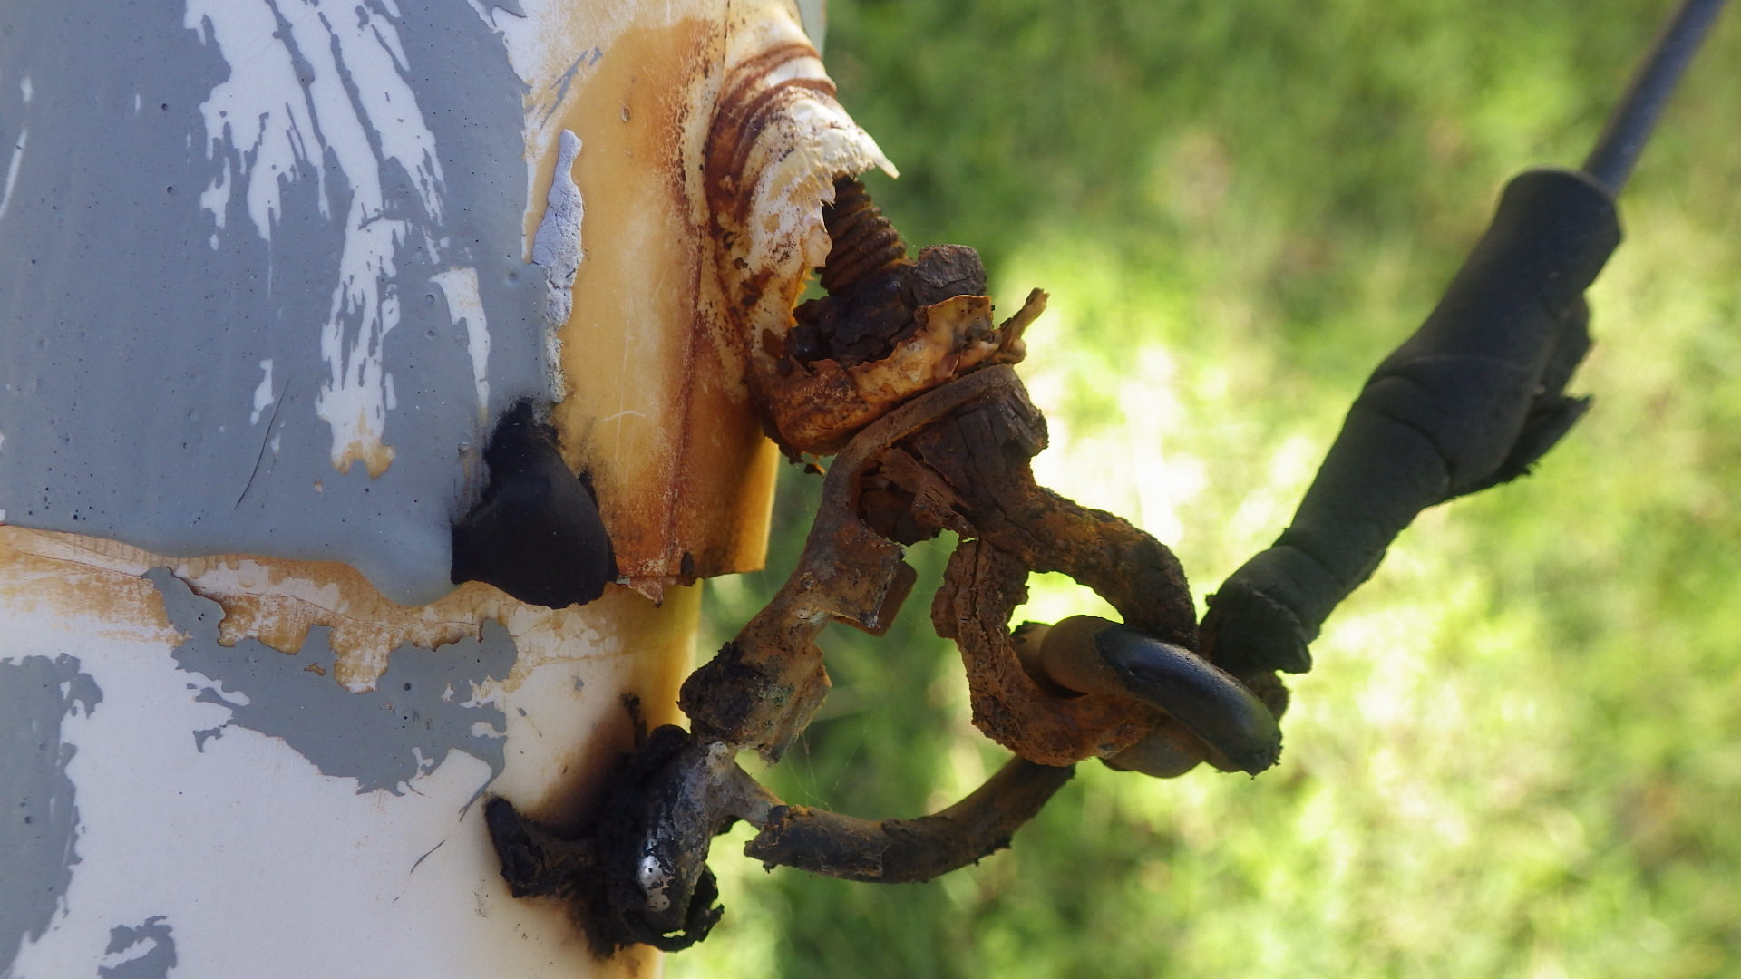

It showed a DC open at the feedpoint. I vaguely remember that a good Samaritan, identity unknown, had taken this antenna down and repaired some time back. But obviously it did not get weatherproofed after the repair, and this in the photo was the result. Please, please, at PJ2T when we fix something our goal is to fix it in such a way that it will require absolute minimum maintenance for years to come. Otherwise the next guy to come along (that was me in this case) is left with a lot of work to do.

I found a new balun (thanks W8WTS for the donation) and rebuilt the antenna, even replacing the wires, and weatherproofed it with a ton of duct seal putty and tape.

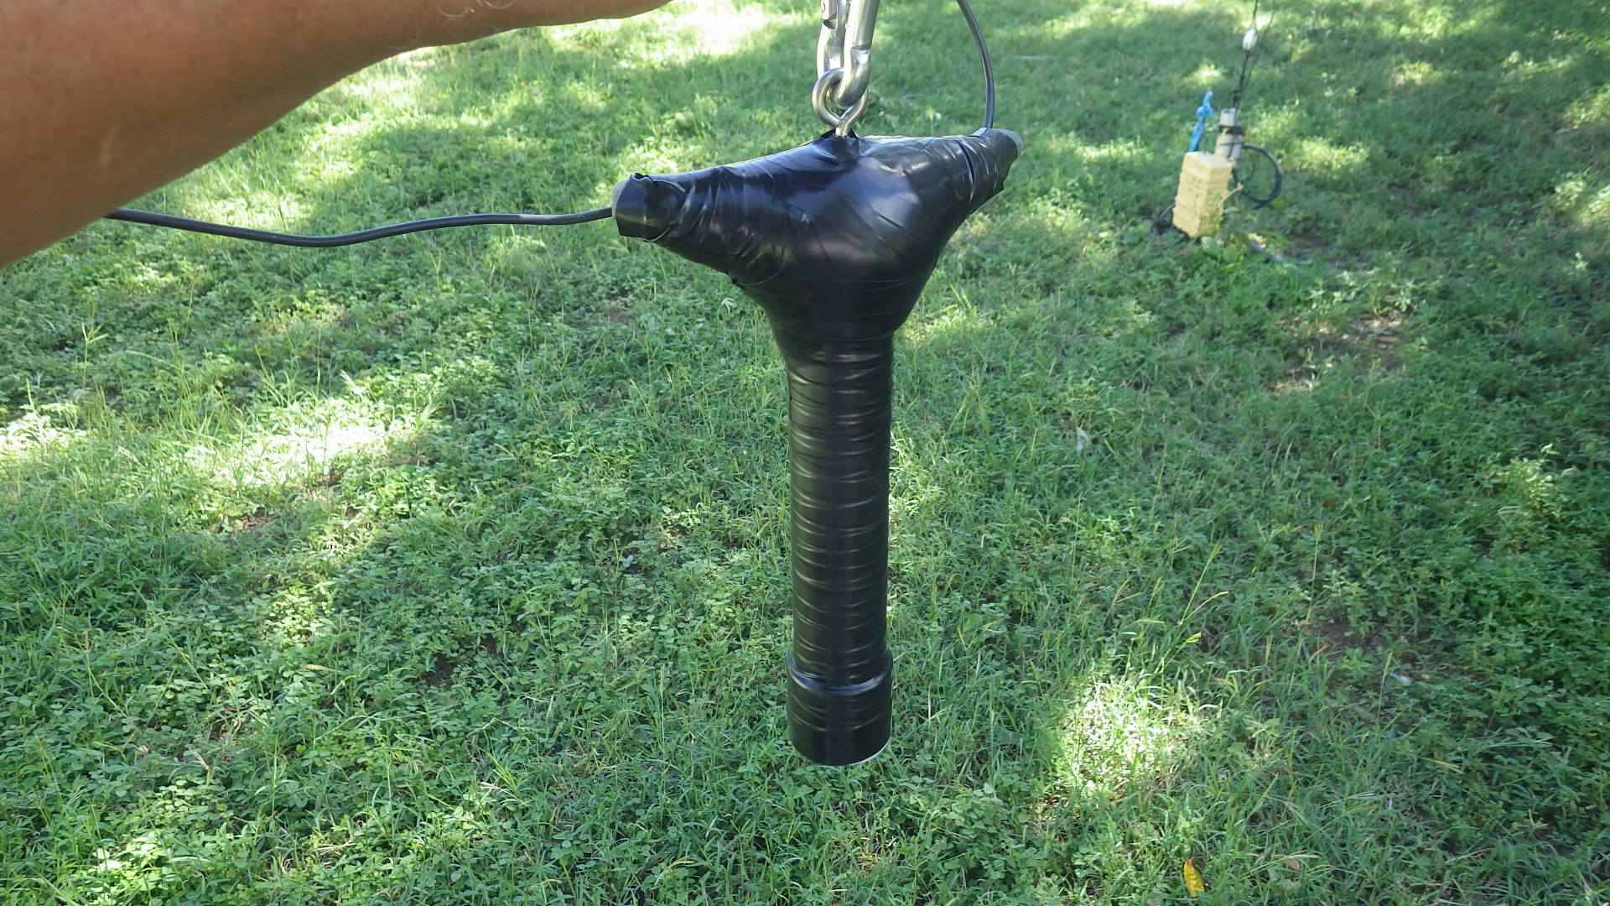

I know this looks goofy, but with the putty and tape and stainless hardware it will last nearly forever. After about five hours of effort I got the new antenna back in the air and pruned the trees around the new vee wires, a critical step if this thing is to last. The antenna is now working perfectly and I’ve made many QSOs on it from the remote here in Idaho. It should be good for many years.

Ancient PJ2T Photos

Here’s Rensel (Zoom’s brother) with a pneumatic jack hammer pounding away at the limestone and coral, making the hole for the “ocean” guy anchor for the US/JA tower in June, 2001. Note that this is before the construction of the perimeter wall, patios, and ocean pavilion. This was very hard material and it took a couple days of hot, hard work just to make this one hole. Nowadays there’s a planter on top of this guy anchor.

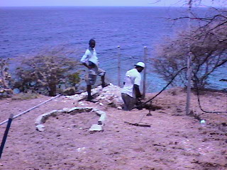

This next photo shows one of Zoom’s cousins digging the hole for the “wall” guy anchor for the Europe tower. This was long before there was a perimeter wall, back when the house was still pink and green, ick.

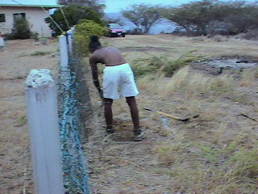

I’ll have some additional old photos for you in upcoming newsletters.

PJ2T’s Wish List

We are in very good shape on equipment and antennas, but there’s always something on the wish list. What would you add to this list? What might you be able to help with?

* 275 feet of LDF4-50A ½ inch Heliax hardline (VE3CX may have this….)
* Three new operating chairs (buy on island)
* Monster high power and very simple amp (below)
* Larger monitor for Station 3 (buy on island)
* One more K3, subreceiver not needed
* SSB contest operator members
* RTTY contest operator members
* Tower-climbing members

Dreaming of a Monster Amplifier

We are lusting for an amplifier for Station 1 that is super high power so it will run very easily and cool at 1500 watts output, that has no microcircuitry that is failure prone and hard to work on, and for which replacement tubes are affordable and available.

This pretty much translates to a homebrew amplifier, possibly a pair of 3CX1200A7s, or to a vintage amp such as an Alpha 77DX. Please keep an eye out for something like this in your locale and radio clubs. Or who would like to accept the challenge to build one for PJ2T?!

Muffin Fans and Amplifier Conservation

The supplemental cooling muffin fans on top of the amplifiers are important - they help control the temperatures in the tube compartments. The built-in fans are not all quite 100% healthy, and they are challenged to keep the amps cool in our high ambient shack temperatures at Signal Point.

Regrettably, we still see many instances where even our own experienced members forget to turn on these muffin fans. (The automatic thermostatic control on the muffin fans quit working reliably years ago.)

Also, we try to go easy on our amps and run them at around 700 to 800 watts of output for everyday non-contest operation. Sometimes, however, we see our own members unnecessarily pushing the amps to maximum available output for general everyday use. (For contests, we press harder and run them at about 80% rated power.)

Please, please let amplifiers cool for about 10 minutes before turning them off. It’s an unwelcome shock to the tube seals when they suddenly go from very high operating temperatures to off.

Please be vigilant and protect our amplifiers. They are very difficult to transport back and forth if repairs are needed, and the tubes are extremely expensive and difficult to find. Gary, Gene and I thank you for using the amps conservatively because we’re the ones who have to fix them. ☺

Sunset Waters Beach Resort

The hotel died in July of 2009. It was a wonderful convenience to PJ2T because our operators slept at the hotel and most opted to eat in the restaurant. Since the loss of this place we have had to scramble to rent houses for our teams and set up difficult arrangements to feed everyone.

The place now has new owners, and we have high confidence that there will be a completely new hotel. We’re told that work will begin this June to tear down everything and start anew. Initial plans are for a 200 room hotel and a new marina, with further expansion planned over a period of 10 years. This will enhance our security at Signal Point and will provide a nice facility for meals and lodging. It’s not all good, though, in that we can expect electrical noise from the northwest and are likely to lose the use of the flats and storage building. Also, there is a threat that the road may be relocated in a way that we will not welcome.

See http://curacaochronicle.com/main/government-signs-agreement-for-the-development-of-coral-cliff-at-santa-martha/ .

Our New Outside Maintenance Lead: NR0X

I need to greatly cut back on my tower climbing. We’ve seen too many instances of our older ham radio brothers losing their lives in tower accidents. While these accidents have various contributing causes, one is aging. I’ll be 70 very soon, and while it is tempting for me to try to show off and cowboy my way forward and try to keep up the present pace, that’s not prudent. Also, I’m losing my effectiveness. I have been very lucky with good health, but inevitably I can feel my shoulders and knees weakening. I’m also paying heavily for injuries from my 15 foot fall from an extension ladder in Ohio about eight years ago. Additionally, I’m aware that my mental focus is not quite as sharp as it should be for such a dangerous activity. It’s time for new, stronger, safer blood.

Jason Joens, NR0X, has been to Signal Point several times, most recently to help with the removal of the antennas and feedlines from the old Europe tower this past November. Jason is a highly accomplished climber, and is young and very strong and an incredibly skilled rigger. He’s careful, thoughtful, has all the best equipment, and absolutely loves coming to Curacao. He has agreed to take over as our tower and antenna guy. The photo shows him with one of the old Europe tower braces that broke under his weight last November.

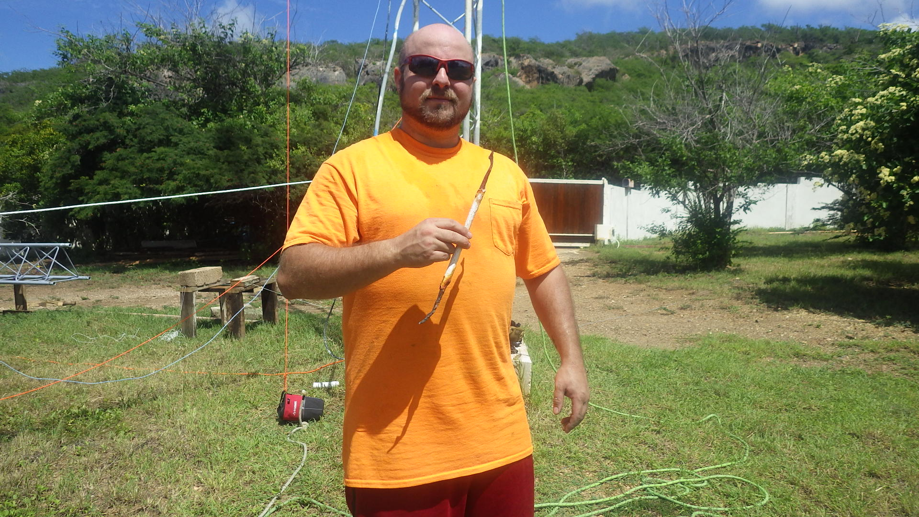

He’s willing to make two trips annually to the island, one week each. Over the next year or so I will climb with him and train him to a point where he will have a full understanding of all of our towers, antennas, and feedlines and will be able to take over most maintenance on his own. After that I will still climb, but much less.

Since Jason is young he works full time, and when he is in Curacao he loses income. We will need to provide his airfare and also about $1500/week for his lost income. Each trip, then will be about 2.5K including airfare. How to cover this?

For starters, we for many years have collected a $175 “outside maintenance surcharge” for each major contest operation. Seven of these in a typical year yield $1225. In addition, the funds for our Station Support Fund come from annual dues and the $75/operator/week contribution from each operating visitor to the station. A portion of these can justifiably be used to cover Jason because he is, after all, supporting the station when he does tower work. But there will still be a bit of a shortfall, so there is presently some discussion underway about a modest dues increase. This would likely be on the order of less than 100 bucks per year, and won’t be done without member approval. Stand by for those discussions from our officers.

Two trips per year may seem excessive, but take it from me there is always something broken that needs attention. For example, the rotor in the US/JA tower has just failed, the rotor plate in the WARC tower needs a stiffener plate installed and a new rotor, the WARC yagi needs to come down for trap cap and center insulator replacement, and there will soon be a need for additional coating and corrosion control work on the 80 foot tower. We will also be installing new feedlines to two of the antennas on the Europe tower.

Our station and club are VERY healthy. We’re in great shape on radios, computers, amps, spares, and accessories. We have the new Europe tower. We have Rick’s fabulous antenna switching system and desks. We are out of debt. Our antennas are mostly in great condition. But it’s critical to have Jason in order to be able to stay on the air going forward. We have been unable to recruit tower-climbing members, so NR0X is very much needed.

Happy 80th to N1ZZ

March 3 was Sunday of the ARRL DX SSB contest but, more significantly, it was Dan Gravereaux’s 80th birthday. It’s very flattering to CCC that he chose to spend it with us rather than in the States with family. Here’s the crude birthday surprise we concocted for him after he blew out the eight giant flames. The whole crew sang for him! Dan has been a CCC member for a great many years, and in real life is the inventor of the RigBlaster and many other wonderful products as the founder and original owner of West Mountain Radio.

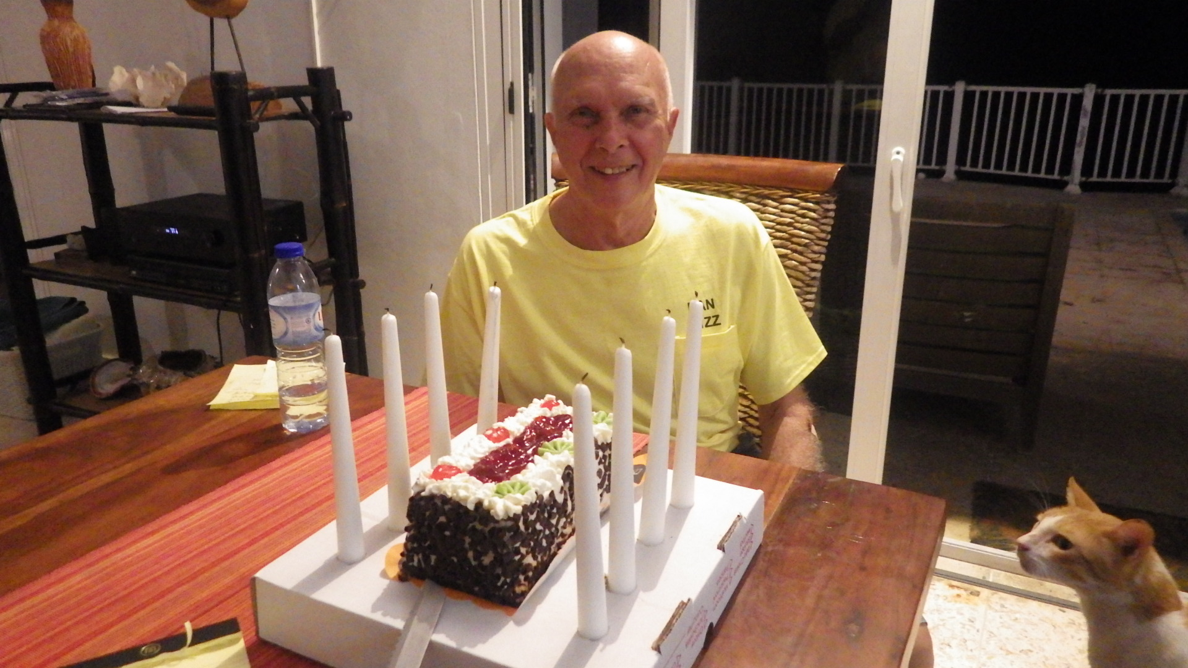

Station Technical Tips

Tip 1: AC power outages happen frequently in Curacao. The house has a three phase service. Occasionally only one or two phases will go down. This can be puzzling because some things will still work normally, some at a diminished level, and some not at all. If you experience any kind of power failure, the best thing to do is to turn off the master switches in the laundry room because the restarts are possibly accompanied by damaging surges, and because things like refrigerators are very unhappy running undervolt.

Tip 2: At Station 2 there are six W3NQN bandpass filters that are automatically switched to the correct band. The IBS-1 controller is velcroed to the bottom of the desk directly under the transceiver. If Station 2 is not working right, one of the first things to check is to get on your hands and knees and look up at the IBS-1 under the desk and be sure it is indicating the same band as the radio is selected to. The IBS-1 follows the main VFO on the transceiver.

Member Spotlight

Egon Behle, KF4DX and DK8FZ
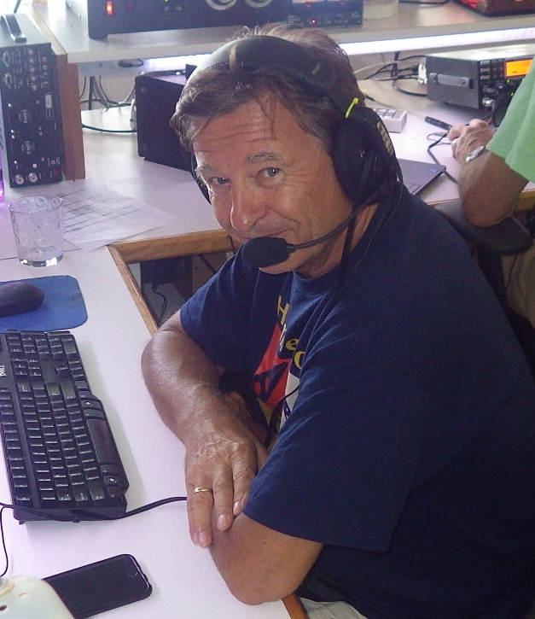

I was born and raised in a small town close to Frankfurt, Germany, as the eldest of three sons living in a nicely uphill located single family house my parents had built and from which they never moved away again. It was a great radio location! I got my ham radio license at the age of 15 and hold my German call sign DK8FZ since then. It was my dad, DK3FQ, who supported me in the licensing preparation after I had been an active SWL for some 3 years. I was thrilled to then be able to use our Mosley MP33 at 55ft and the Drake TR4 which my dad from that day on had little chance to operate.

Soon I started pushing for an amplifier and we built one together using two 813s grounded grid. My focus ever since was 80-10m sideband only and I started working contests. With band conditions in those days and my setup I was competitive and I ended up with a number of 1st in Germany and among top 10 in Europe. I worked my 5 band DXCC within 2 years but never did the paperwork to apply for the award. Making friends around the world and looking for Caribbean Islands on 20 m into the early morning hours was fascinating for me. Once in my life I wanted to visit these places and PJ9JT’s QSL card was on my wall.

Even prior to ham radio I started flying gliders and did my first solo still at the age of 14 receiving top honors as one of the youngest glider pilots in Germany. I added my powered gliders rating when I turned 18 and finally also had my driver’s license (earliest in Germany at that time). I worked on collecting my first flying awards on gliders for distance and duration of flight. Flying and ham radio were filling my free time to the largest extent. Instead of serving in the military I took the more demanding alternative and joined the border police for 2 years. For the second year after going through all trainings I successfully applied for a position as bodyguard for a German politician and top manager. (In those days there still were people in politics in Germany who knew how to make money).

This was a very exciting period of my life that largely shaped my professional goals. When turning 21 I started my studies as engineer for aviation and space technology at the University of Stuttgart after I had given up on any career as commercial pilot with Lufthansa or any other airline following some long discussions with my parents and others. Still today I am happy for that decision. I upgraded my pilot’s license to single engined aircraft and enjoy powered flying since then.

Real life finally hit me after graduating as Dipl.- Engineer and getting my first job at Bosch in Stuttgart. Ham radio was pushed into the background of my life as I continued to have no space or permission to install any antenna. My time window for flying was limited to the weekends and my fiance, Gabi, was not interested in any of my technical hobbies. However she was thrilled by my proposal to do our first trip to the United States. It was in November 1984 that we landed in Tampa FL and took a rental car south. I had FAA-validated my German pilot license in Frankfurt and read a lot about flying in Florida so I was well prepared. We ended up in Naples, and I could easily rent a Cessna 150, did a checkflight, and the aircraft was mine for the next week. We explored Florida by air from Key West to Jacksonville, visited the Space Center and did some boating in the Naples canals. I did not know at that time how much this experience seeing Florida has turned a page in my life.

Fate hit us a year later when Gabi got the diagnosis of cancer at the age of 25. She passed away 3 months later and I had to learn how fragile life can be. At the same time I took a new job as sales director at Dornier, a company in aviation and space technology. I deeply dived into this job which made me travel a lot to the USA and distracted me from my private disaster. About a year later I realized that life had to go on and happened to meet Simone. We married and my son Patrick was born.

Meantime we had moved to Augsburg in Bavaria as I took a new position with Renk AG, a company in the MAN group. As the new Vice President I was supposed to build up a new business for test systems and using my background we expanded into automotive and aviation. After taking a turnaround job as CEO in Stuttgart for 2 years, ZF Friedrichshafen at Lake Constance called me and I could not resist this new challenge at my most desirable place to live. I bought our first house in 1998 at a beautiful uphill location overlooking the lake, put up an antenna and was back on the air after many years of QRT. I also joined the local flying club having Cessna 172, Piper PA 28, Mooney and Robin aircraft available. Life was great and I was traveling the world for business from the US to Asia.

In 2002 ZF promoted me to become the CEO of the 50/50 joint venture they had with Bosch for steering systems. This multi billion dollar company with some 10,000 people around the world was at a 10% loss situation, and I was supposed to fix that. I was extremely excited about this big opportunity and the trust Bosch and ZF had put into me but had to learn from day one that this was a really tough job ahead. At the same time Simone disclosed that she wanted a divorce. She had met someone she thought to better get along with. Obviously I was away too much and did not realize what happened between us. One of the most difficult periods of my life started and ham radio and flying were switched off. Instead I was creating new daughter companies in China and the USA, pushed my people for process improvements and used our huge growth to return the company to profitability.

A year later I met Elke, a famous dentist in Stuttgart. She had gone through a divorce like me and had a daughter same age as my son. We started building up a new family and some time later we found out that we both love Naples. What a coincidence! We spent one of the first family holidays in Naples and agreed that this is our place to be. Being afraid of marriage we both had postponed it from year to year but finally took the decision in 2007. We married on the island of Santorini as Elke wanted a romantic very special marriage. At the same time I was offered the CEO position at MTU Aero Engines AG in Munich, a company listed on the stock market for just 3 years. ZF steering was back to a good profit margin and I was again excited for a new challenge. The family moved to Munich and Elke commuted to her dental practice in Stuttgart daily. My international travels got even more intense, and flying in a club was no option anymore. In 2008 I bought my first aircraft, a Cirrus SR20 and Elke loved to join me for weekend trips if we did not go to Lake Constance where a 40ft Flybridge Yacht was my toy on the water. MTU was developing great and my business connections to GE had paid off. The stock price was increasing from year to year and the market and the media were excited about this new pearl of German technology. MTU and the CEO were honored as the most innovative company and management.

In 2012 we took advantage of the real estate crash in the US and bought our first house in Naples. It was supposed to be a holiday home, but whenever we had to leave back to Germany we almost cried and we decided that longer stays have to be the future. We thought about a visa for 6 months and to spend the German winter in Florida after retirement. 2013 then was the turning point for Elke and myself. Elke was fed up by the increasing regulation in Germany and so was I in my business. I denied another 5 year contract as CEO and as the stock price had increased from 12Euro when I took over to 75Euro I decided it is time to sell and retire.

Leaving to Naples forever came into our mind and we explored our options. With my business background our US lawyer saw good chances for a Green Card and we put the application on the way in 2014. I restarted ham radio as W4/DK8FZ but finally got my Extra Class license and my KF4DX callsign. RexAir in Naples had Cirrus aircraft for rent and I had bought a boat plus boat dock. What a great life away from Germany. It took until spring 2017 to finally get the Green Card approval and we immediately sold everything in Germany, the real estate, the Cirrus, the yacht and all cars. On July 1st 2017 we left the country and arrived in Naples with big relief. When the German government had opened the borders for unlimited immigration of millions of Muslim economic refugees from Middle East and Africa into the German social welfare system in 2015, I knew this will kill the country in some years time. I bought a place in Austria where we put the remaining stuff from Germany and where we may spend one or two months in summer and meet family and friends in Europe.

Not a single day did we ever regret our decision and we look forward to applying for US citizenship in 2 years time. I am still on some boards and do some consulting to private equity and M&A. As a member of Naples Greater Leadership I am happy to support some nonprofit organizations with my know-how bettering Collier County and giving back to the country that has become our new home. Joining CCC was another of my boy’s dreams to come true: operating ham radio from the Caribbean and contesting. I love to be a part of it.

