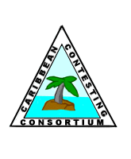 | Signals From The Point  Official Newsletter of the Caribbean Contesting Consortium  Editor: W0CG
Volume 19, Number 3 March 15, 2019

About this “New” Newsletter

Since 2000 our club newsletter has been sporadic at best. With President N5OT’s concurrence, we’re starting again, and I’ll put out a newsletter at the middle of each month, some brief and some longer as needed. The volume and number of this issue pretends that the newsletters have gone on continuously since they were started (and cleverly named) by Jeff, KU8E. The content will be flexible, and we’ll keep it brief and informal, yet hopefully extremely informative.

Our New Europe Tower: A Health Check

I went to the top a few weeks ago to replace some galvanized hardware and to carefully inspect how things looked after nine weeks in the air. As always, most of the tower was saturated in a gooey salt-saturated film, but there were no signs of rust or corrosion yet. We’re hoping that it will be a very long time before it needs a fresh coat of paint. It is a fact of life that the paint will oxidize and rust will begin to appear, but this will happen much, much more slowly than on the original tower, which was put up unpainted, bare galvanized. The photo below contrasts life for the old tower versus the new one.

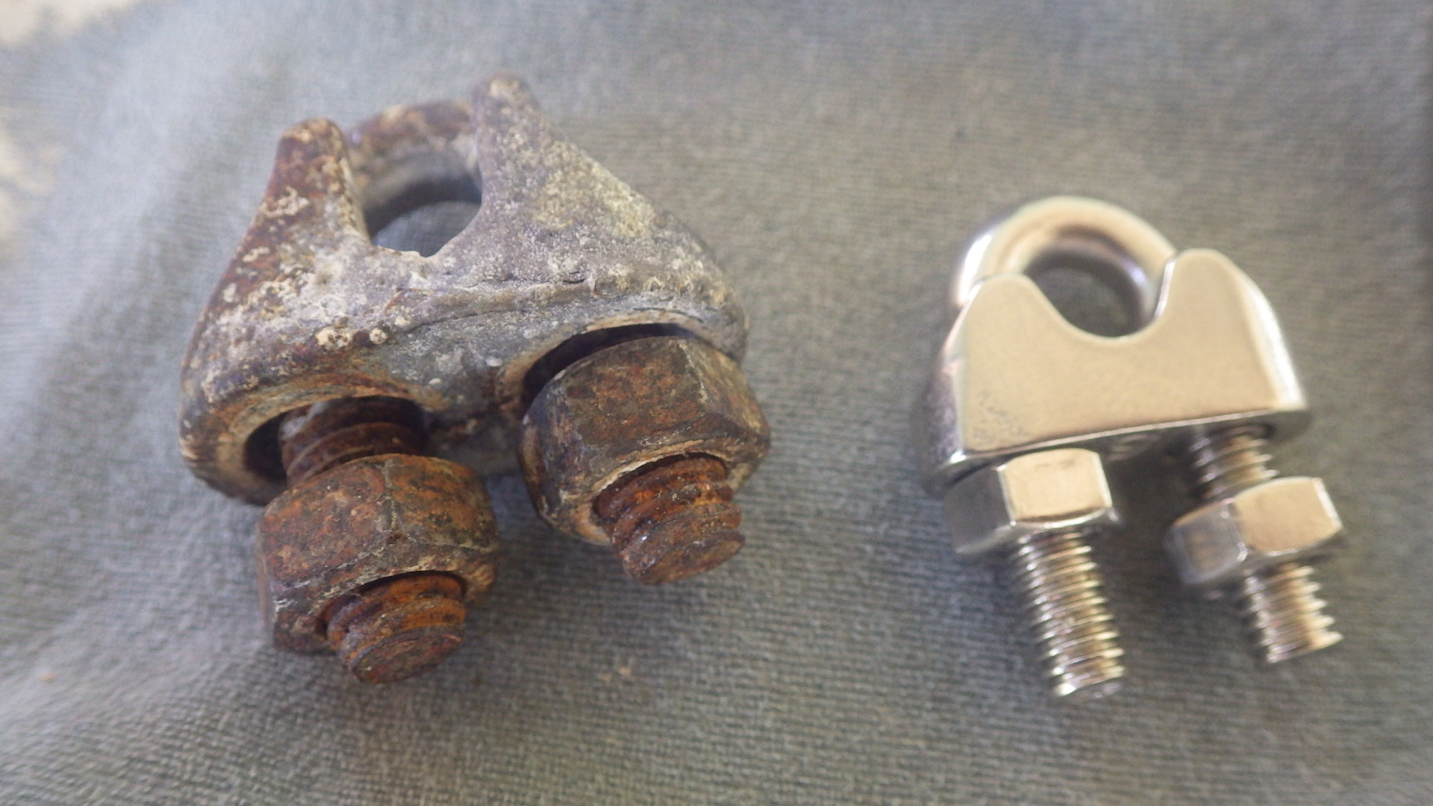

We installed up the clamp on the left on December 5 because I was short six stainless clamps. It was new, shiny zinc. This was for the overhead boom truss on the Bencher Europe Yard antenna. After nine weeks this is what it looked like, in contrast to the stainless steel clamp on the right. The original 2001 tower turned brown in very few weeks just the same as this clamp did.

The new tower applies all the lessons we have learned about corrosion. All steel is covered. Parts are all either aluminum or stainless steel, and there is nothing on the legs. The worst rust on the old tower developed under the tape wraps that supported the feedlines. Who would have thought?

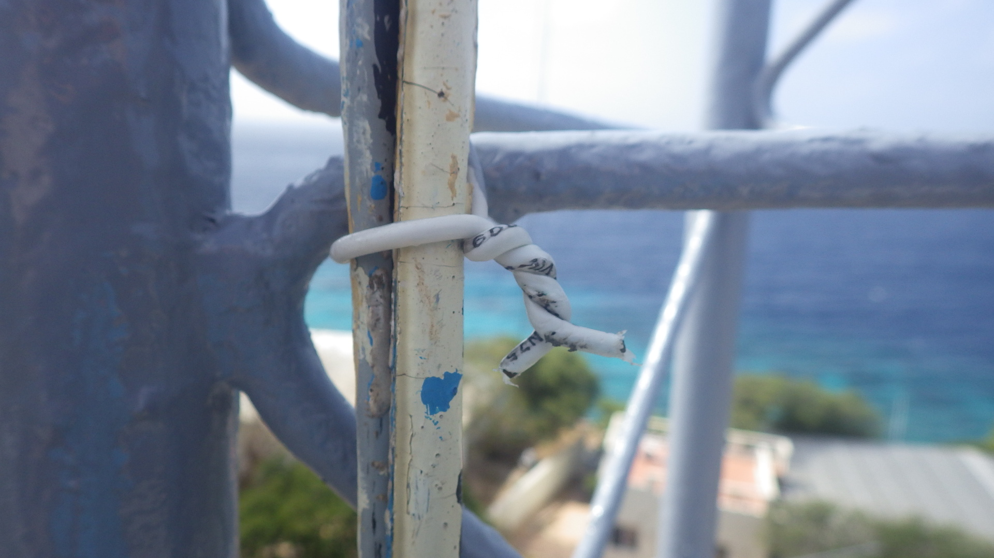
Instead of taping to the legs, all feedlines are fastened to the bracing pieces – not the legs -- with a wrap of insulated #12 solid copper wire. This will never corrode, and it minimizes contact with the tower.

The photo on the next page shows the condition of our homemade side mount fixture for the Pacific tribander. The tiny amounts of surface browning are normal for stainless, but you can see that the aluminum plate, the stainless steel stabilizing rod, and the stainless U-bolts are corrosion free after nine weeks in the air. This will still look this good after a decade.
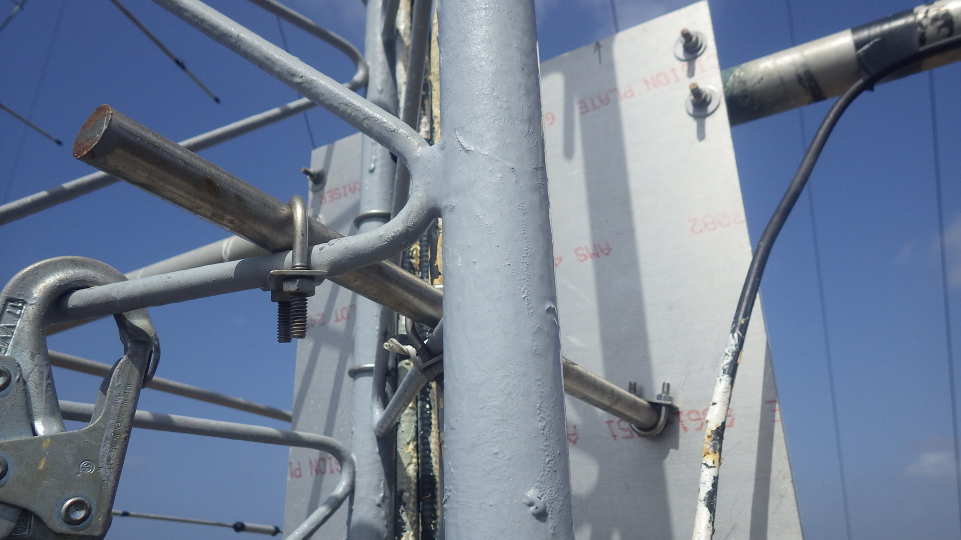
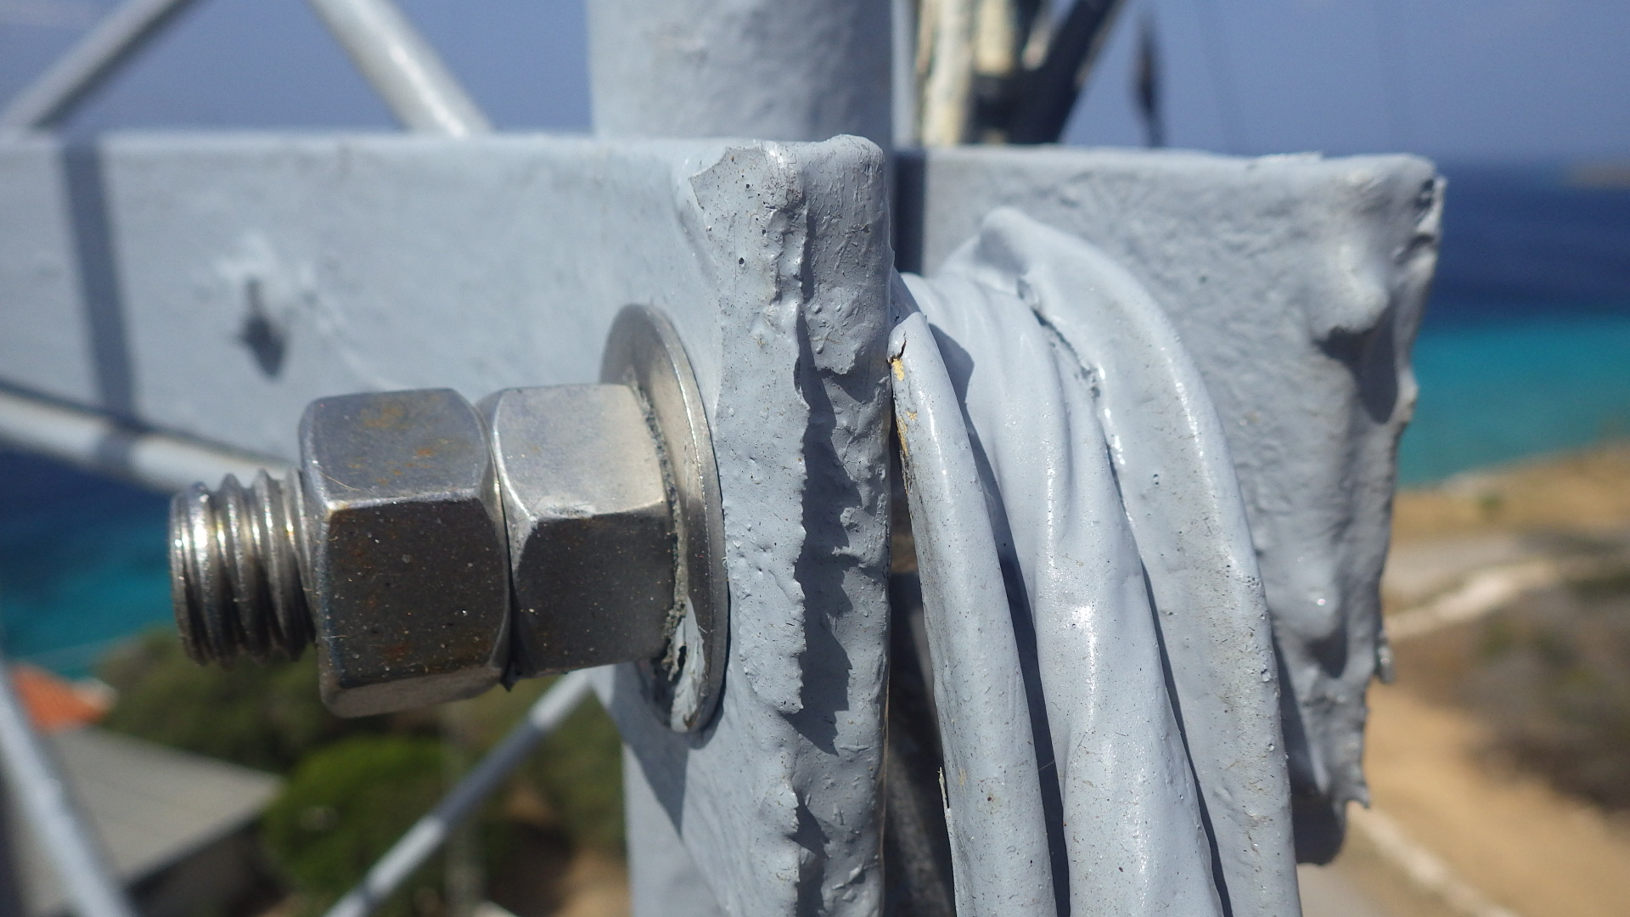

One of the most unique aspects of the new tower is the stainless steel thrust bearings that were obtained by N0YY. Two of these have served well on the US tower for four years, and two more are now installed on the Europe tower. Also pictured (right) are the stainless hardware on one of the guy brackets and the stainless cable thimble (painted grey).
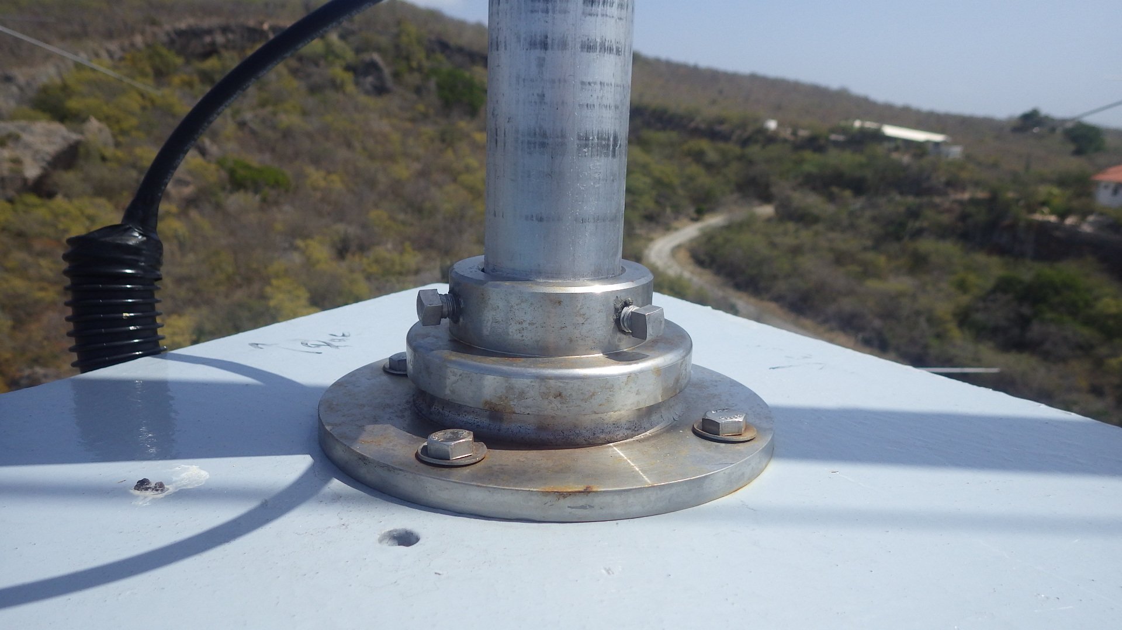

As you see, the bearing and the very thick-wall aluminum mast at the top of the 100 footer are in excellent condition at nine weeks. I’ll update you on other design features of the new tower in future issues. We can be very proud of the design, engineering, and construction of this great new PJ2T asset.

CCC Recruiting and Contest Staffing

Our present membership seems to be biased toward CW. As a result, we often have difficulty staffing SSB contest operations. Thus, to fill out SSB teams we have been happy to welcome many non-members to PJ2T for, as examples, WPX SSB 2018 and 2019, CQWW SSB 2018, and ARRL SSB 2019. These teams have been anchored by one or two CCC members, but most of the other operators have been new to high-rate contesting on the DX side. In every case, our central objective of having fun has been attained, but there are sometimes vivid contrasts between the CW and SSB score outcomes. N5OT has quite correctly suggested that we focus fairly intensely on recruiting about 10 highly proficient DX SSB contesters into the club.
Alongside this effort, we are looking for five or so multi-mode members, with a particular need for tower climbers. Please help us recruit, and refer potential members to me or to any of the officers.

Dayton Contest Dinner Table

K2PLF bought a table for the dinner and as of this writing has filled all the seats. We’ll have an excellent CCC presence, and maybe someone will be as lucky as I was two years ago, winning the grand prize, a Geochron wall clock.

Amplifiers

We are in a very strong position here. We’re continuing with our philosophy of trying to wring out every ounce of life from the vintage amps on site before retiring them in favor of the younger AL-1200s. The Titan 425 and LK-800 worked great at the 20 and 40 meter positions for this entire contest season. We now have six AL-1200s on site, and K2PLF is donating a seventh, which we’ll get at Dayton and I’ll then prep for transportation to the island from my Ohio QTH. We’re careful to practice crop rotation on the AL-1200s so that all six (soon seven) are used roughly equally. The Titan III is still down, and we did not have time this season to tackle it, but I’ll be making a maintenance trip this summer and will do all possible to figure out what’s wrong. When it works, the Titan III is superb.

Welcome to PCARS

Our member N1ZZ invited five of his friends from the Platinum Coast Amateur Radio Society to join him and me and K8PGJ and KB7Q for ARRL SSB. These gentlemen had a delightful eight days at the station, one of them even telling me that he can now cross this major item off his bucket list. We helped introduce these guys to high-rate contesting and posted a score that is presently at the top of the 3830 M/M listings for DX-side stations. That said, our M/2 friends on Bonaire made over 2000 more QSOs than we did, with only two transmitters, so our PCARS friends now understand about the need for rate. Here’s our K8PGJ shooting the PCARS group photo. L-R: Walter (WB5ZGA), Alan (W1BQ), Don (AF4Z), Dan (N1ZZ), Jim (W4EE) and Greg (N4EN). These are super gentlemen, and we much appreciated the opportunity to make new friends for PJ2T.

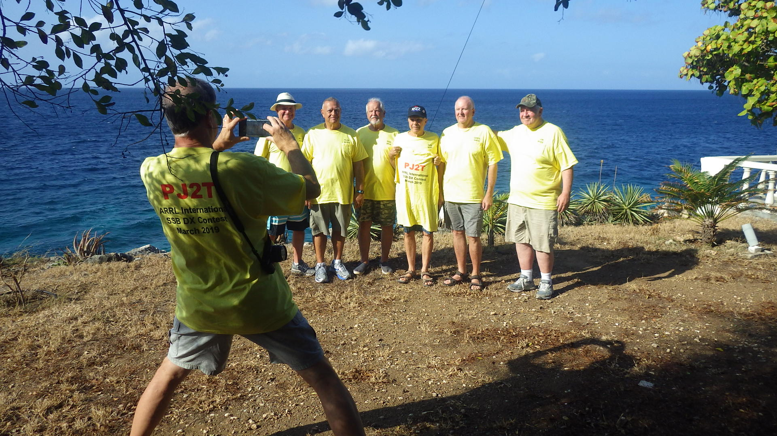

KB7Q: PJ2T’s Winter Caretaker

As you’re aware, Gene and his XYL Joyce are presently making a long stay at Signal Point for the second year. This benefits CCC immensely. On my side, I can go home six weeks earlier than I used to so I can be with Dorothy. On the club side, Gene does a magnificent job of supporting the station and real estate, supports the remote operation, and hosts visiting teams. Our member K1ZN will arrive later this month with his Georgia team for WPX SSB. As for Gene and Joyce, this is an opportunity to spend time in a welcoming and warm place. What they do is very hard work, but they are enjoying most aspects of it. During their stay, they of course pay zero rent, Gene does not participate financially in paying a cut when teams run contests, and they receive a 50% subsidy on metered utility usage (outside of contests) and a 33% subsidy on the cost of the rental vehicle. He also receives the usual 50% airfare subsidy that any member can obtain when going for mainly working on the station for one week or more. We hope the Sheas will continue to want to do this in coming years, and at other times of the calendar year this caretaking opportunity is available to everyone in CCC. The QTH is always better off when someone is on site.

Maintenance Matters

A quick partial summary. Dorothy and I painted much of the exterior of the perimeter wall, ocean pavilion, roof terrace, and East Sunroom. I re-varnished the mahogany front gate. I took out the failing splints on the WARC tower and replaced them with solid aluminum rod and stainless pipe clamps. I replaced one of the 13 A/B relay boxes on the antenna switching panel when it became intermittent at Station 2. N7IR has it now for assessment. We took 71 tiles off the wall in the West Bedroom after they had separated. Glue fails after 50 years. We cleaned up the wall with a power brush and replaced and re-grouted those tiles. The toilet in the West Bathroom was replaced when the old one broke at the anchor hole on the base. I repainted the light blue band board at the side of the roof, both front and back. I checked all 76 irrigation heads and replaced, cleaned, and rebalanced many of them. I final-tensioned the Europe Tower guys and plumbed the tower. Then I re-potted the three ground guy anchors of the Europe tower, re-installed the safety cables, and painted everything, thus completing the very last step on the Europe tower work plan. The six zinc Bencher boom truss clamps were replaced with stainless steel clamps. We assessed the bad Pacific and South America tribander feedlines, discovering that the SA one was almost completely unserviceable. Gene and I used our new wattmeter and even installed a 350 foot scab coax line to verify what was going on. We are taking steps now to replace those old RG-8 type cables with ½ inch Heliax. In January A1 Pest Control bombed the QTH inside and out with the result that we were pretty much bug free for weeks afterward. I did the full length maintenance on the Europe Beverage on the Ridge, clearing vines and deadfall and getting the antenna back in its correct position. Gene and I rebuilt the failed 40 meter inverted vee and reinstalled it with all new parts, a large multi-day project. I replaced four dead trees and bought a pot for the patio palm, carefully connecting irrigation to all new plants. Gene is replacing bad PL-259s in the shack. That’s just a partial summary of the work that goes on seemingly endlessly to keep the station viable.

Curacao Challenges

My job is to manage the real estate, and I don’t say much about that, quietly going forward. But you would not believe some of the challenges. Aqualectra switched to an “improved” billing system in November of 2017. The system failed, with the result that no utility bills were generated for 13 months. Thankfully, SM4KYN was able to physically snag the meter reader when he came through the neighborhood in January 2019, providing the first real readings for over a year. In the meantime, they were posting estimated usage each month which was much too high, even though they could not collect bills. Finally in January they got things working, and I was able to establish an account online with the utility company and pay an almost 7000 guilder bill. For 17 years billing was automatic and payments were deducted electronically from my Curacao bank account. Now, with the “improved” system, I have to pay the bill manually every month.

Similar story with UTS, the government PTT from whom we get our phone and Internet service. Their “new” system was unable to accept payments for over a year. Once they finally fixed that and I made a giant payment to catch up, my former automatic billing ended and now I have to pay that manually also. This is a pain each month. Even worse, a big payment I made in December is lost from their system, and I am fighting with them trying to get that $350 credited, but they claim to have no record of that payment. I have documents from the bank that prove payment, but they still can’t find the money. I am paying over and above that amount so that we don’t get the DSL turned off until this problem is fixed.

Selikor, the trash pickup agency, has not billed for over a year and there is presently no way for me to pay that, not even in person.

Last week I received a collection letter from Guardian Insurance claiming that our homeowner’s premium was overdue since last September 3. I sent them documents proving that I made that payment in August, well ahead of the due date. Yesterday they acknowledged their error, apologized, and posted the payment correctly. But there went several hours of work.

Last July I received a letter in Idaho in Dutch from the Curacao income tax authority. I painstakingly deciphered it using Google Translate, determining that they needed me to file a Curacao income tax return for CY 2017. This was a first. Turns out that they are pushing a new initiative to catch people. I went through the months-long painstaking process of establishing on-line access to the tax portal and getting that confirmed by paper mail from the island. Finally, when I was ready to file my null return showing no Curacao-derived income, I discovered that the promised English language tax return form was not available. All 11 pages of it were in Dutch. After much phone calling and nervousness, I found a professional tax adviser who would help me. I met with her at her office a few weeks ago and now, finally that income tax return is filed. She said that after about three more years of null returns they may leave me alone.

There’s more, but you have the idea. I spend many, many hours at my desk here in Idaho and on the island dealing with bad-functioning agencies and companies in Curacao who do not know how to execute business processes. This so that we can walk in, sit down, call CQ, and have things more or less working. There’s tremendous value for our club in having owned real estate for the station, but it is never, ever easy.

Cruise Shippers and Other Visitors

On February 7 we hosted Mary Ellen and Mark Munroe, who were on the island for a quick cruise ship stop. This was traumatic for two reasons. One is that Mary Ellen was, in my high school in Poland, Ohio, about 63 rungs above me in social status and hot-factor and, second, because Mark is Chairman of the Republican Party in Youngstown, Ohio. That’s scary, because I was pretty sure we would not even be able to agree that the sky was blue.

In fact, all worked out fine. Mary Ellen treated me as more less an equal instead of the homecoming queen vs. total nerd deal we had in high school, and to my astonishment Mark turned out to be a licensed ham. He got on the air, we toured around here and there, had lunch at the house, and overall had a good time. I’ve probably done this cruise ship thing over a 100 times, and it is always fun to bring old and new friends to the station. After they got home, Mark figured out the rules and got on and worked PJ2T in the ARRL CW contest.

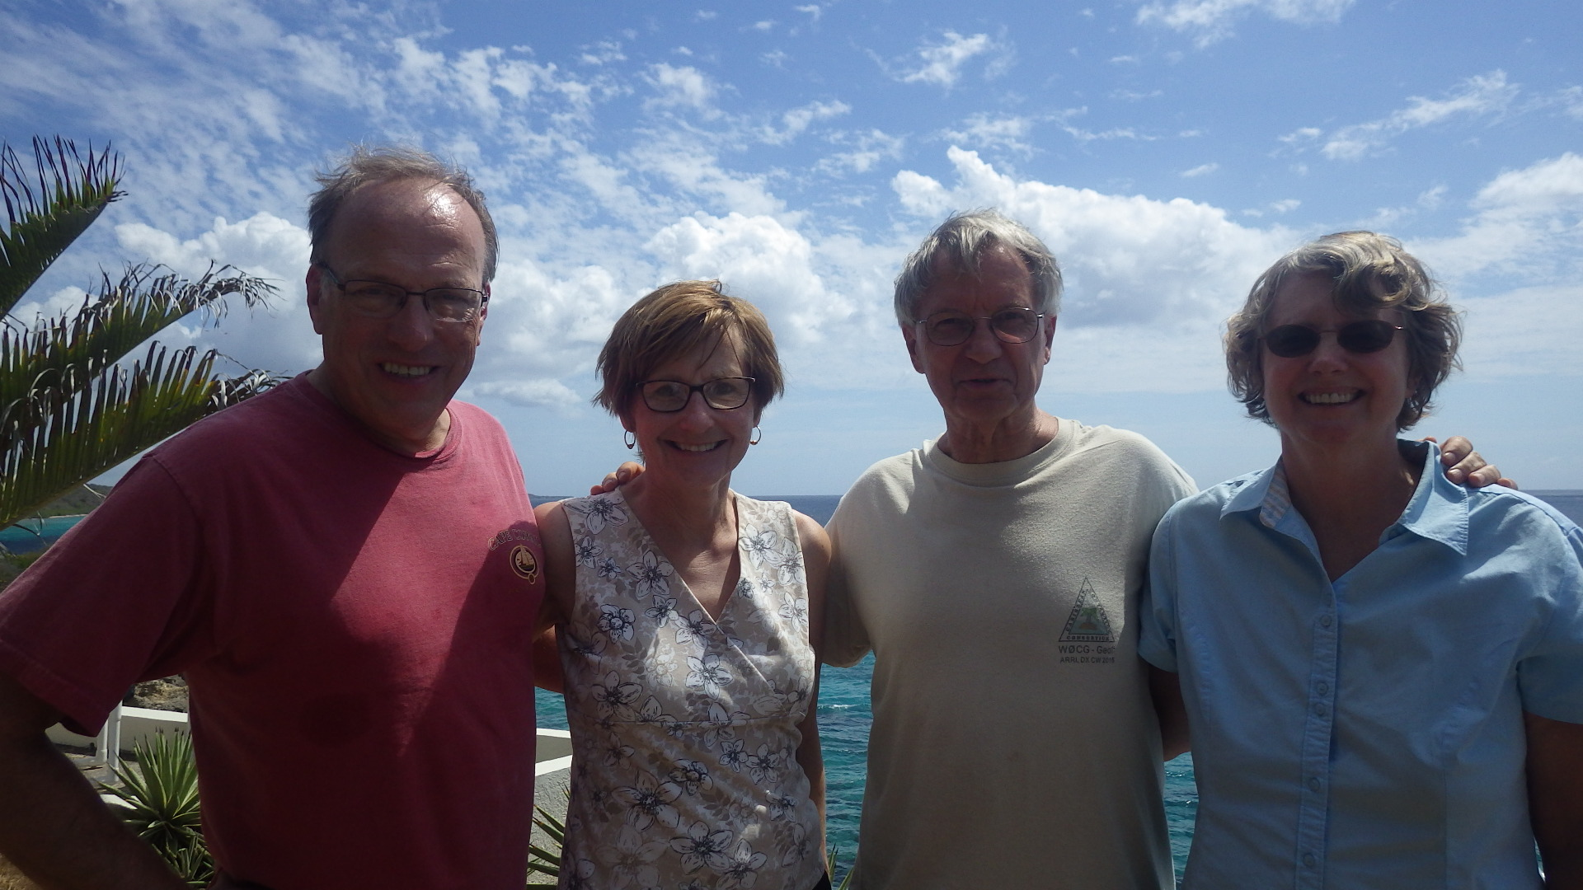

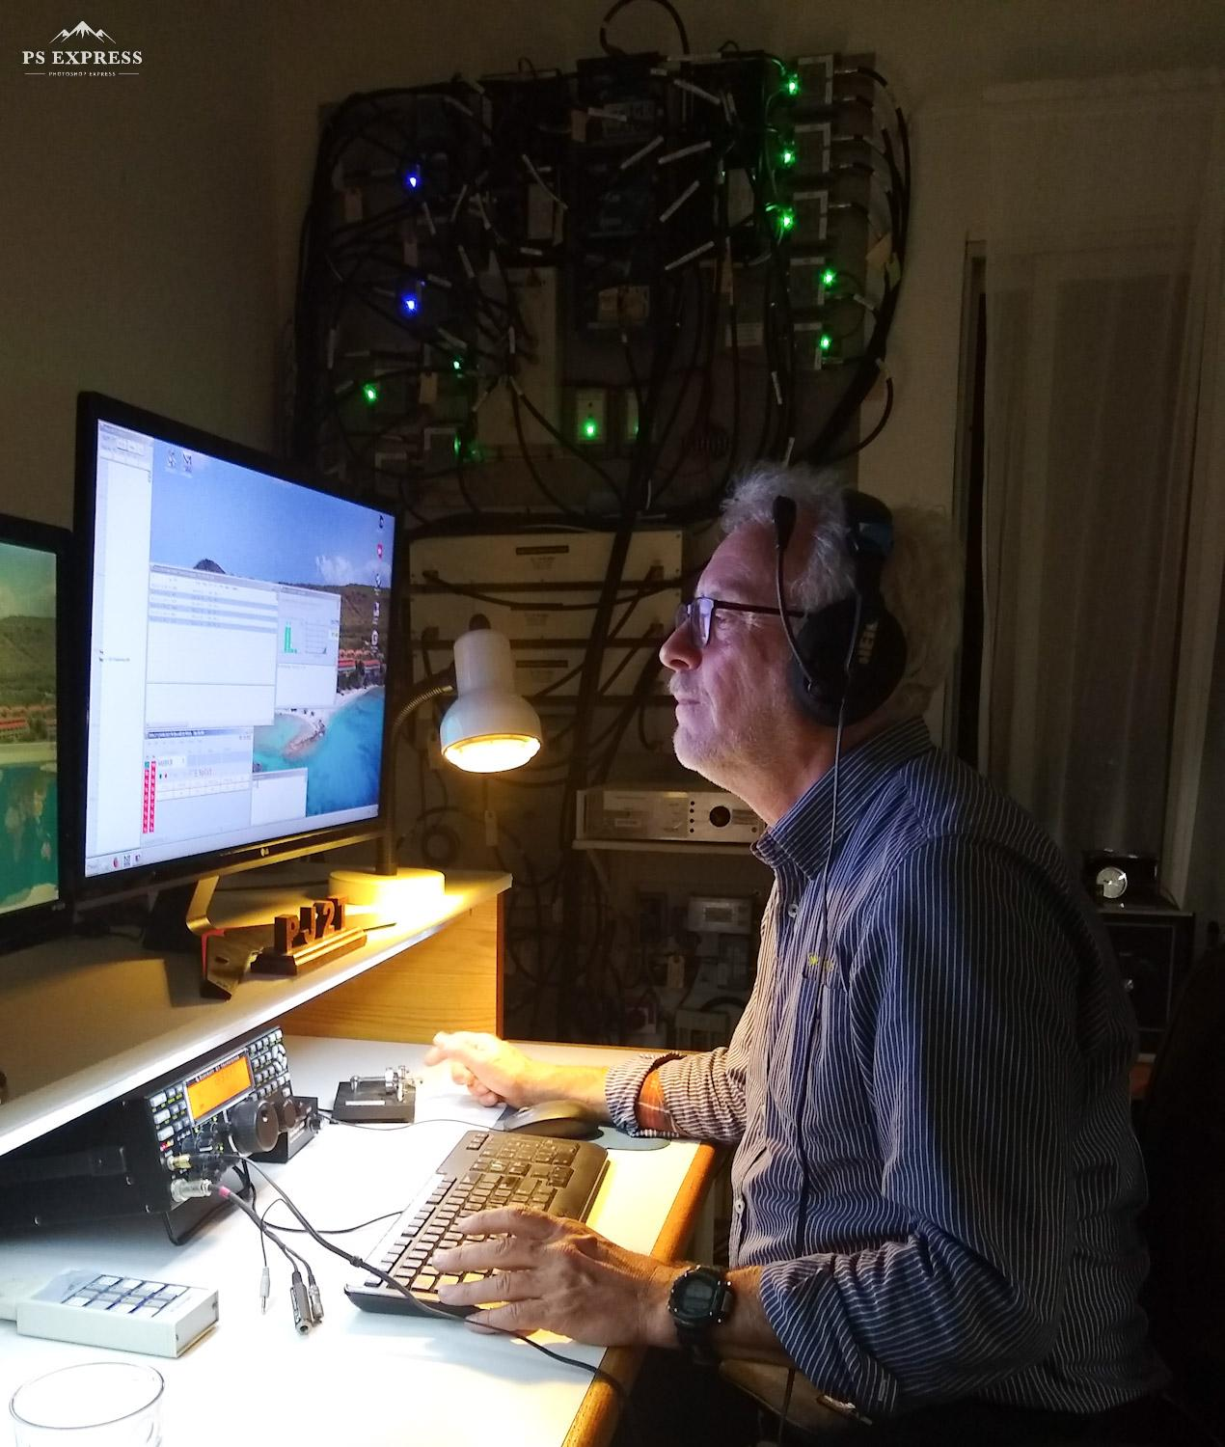

This is DK7PE, for whom Gene and Jeff were kind enough to coordinate a 160 meter visit. He is globe-trotting collecting countries, and he made about 250 Qs from Signal Point, promising to send a courtesy donation when he gets back home. Your club station is much in the public eye, and we try very hard to be completely welcoming to everyone.

ARRL DX CW 2019

We can be very proud that we made more QSOs from our shack at Signal Point than any other shack in the world! This will bring us another M/M World #1 plaque. Here’s the team that did it, fueling up with pizza at Sol Food a few hours before the contest.

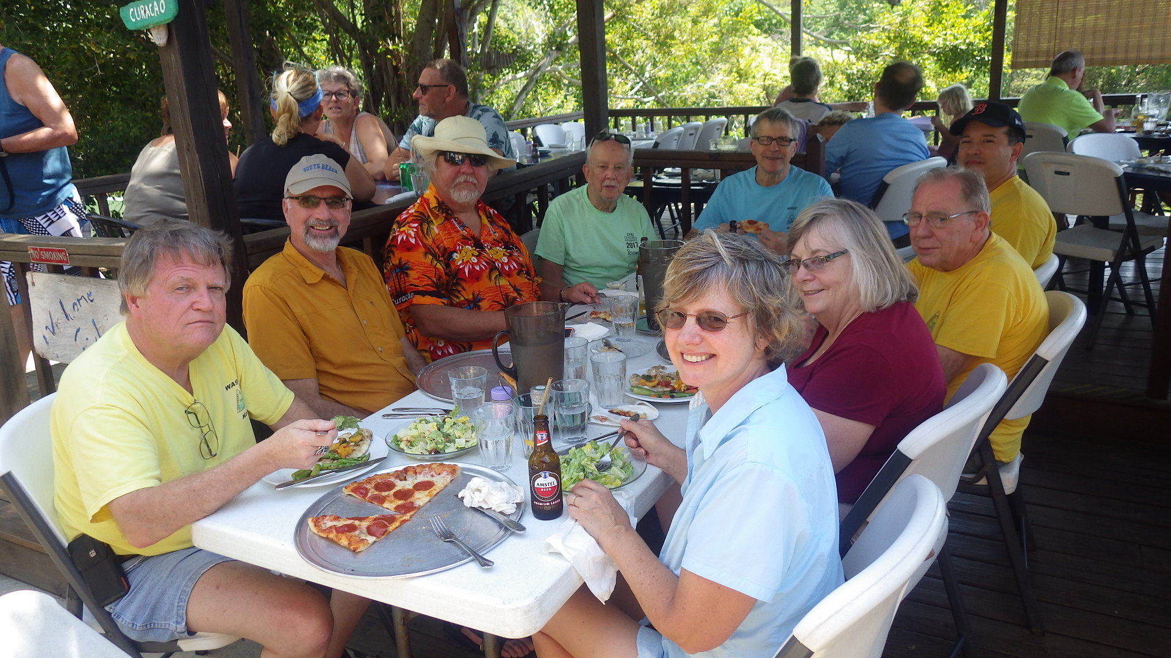

Station Technical Notes

Our “Europe 20 Yard” antenna no longer exists because the corroded and broken elements on this old Hy-Gain 205-BAS were not easily repairable. Thus, the “Ridge Eur / Yard Eur” toggle switch that was velcroed onto the left end of the 20 Meter System box has been permanently removed. When you push the “EU” button for 20, you will automatically get the Ridge antenna. No need for a toggle switch.

Instead of that old 20 Europe Yard monobander we now have a Bencher tribander installed in exactly the same place at the top of the tower.

See the example photo of the “10 Meter System” box below. To use this new Bencher from any of the 10, 15, or 20 meter system boxes you press “TRIBAND” and then look down and select the “BENCHER EUROPE YARD” button. Because this is a tribander, this works on 10, 15, and 20. This expands our operational capability and versatility.

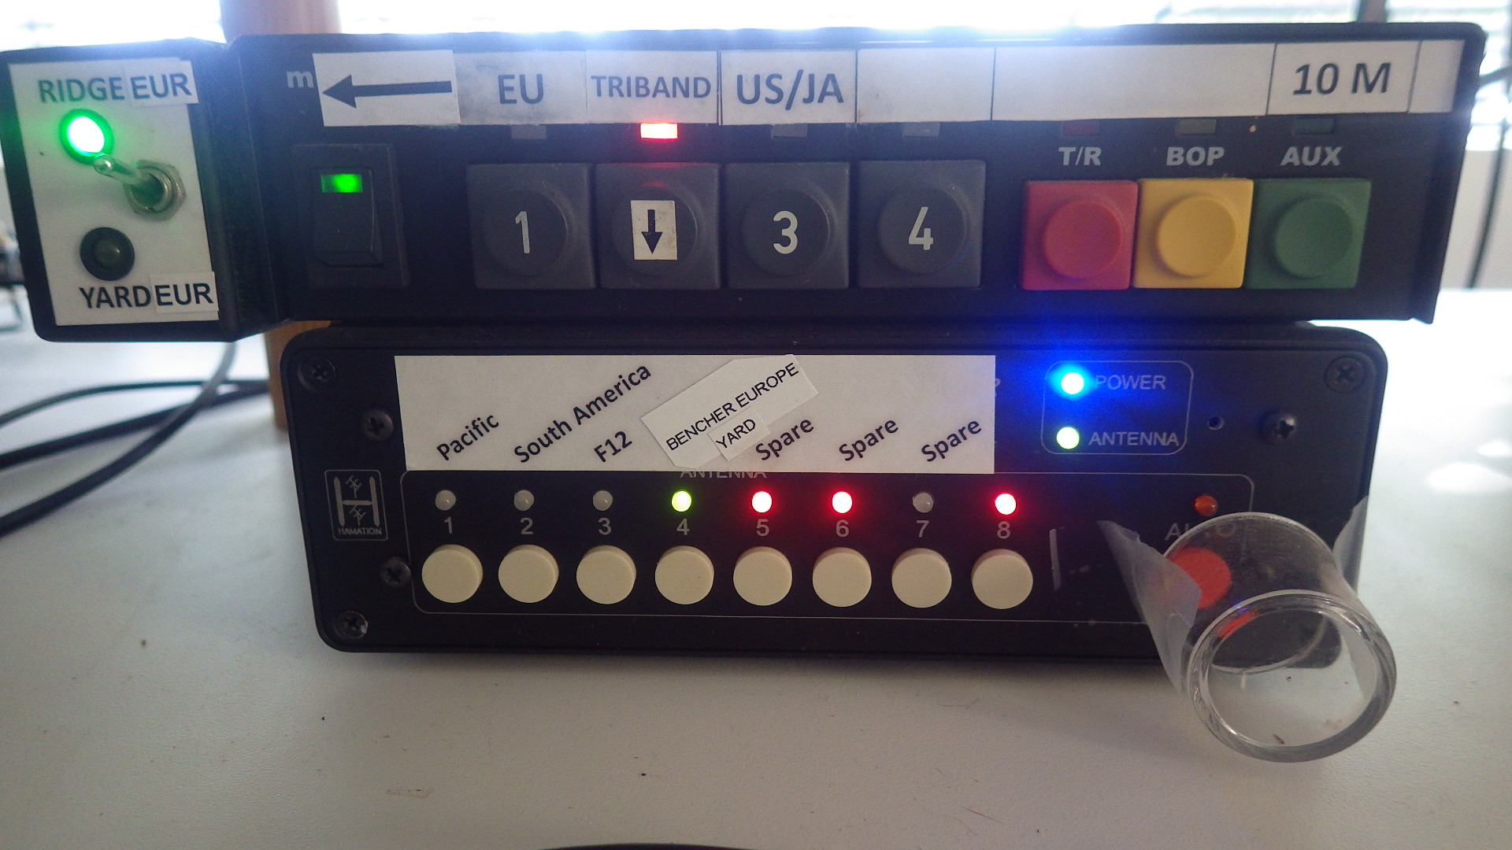

The new Bencher Europe Yard antenna can also be easily accessed using the “Triband Direct” feature of our switching system, a topic for a future newsletter.

Computer Corner by Gene, KB7Q

Our computer updates keep happening. As many of you know Anders, SM4KYN has donated several computers to Signal Point over the past few years. It turns out the Dell Optiplex 7040 units he supplied us with are perfect for our needs. They are small, fast and reliable. We have four, one at each operating position, and last month the club purchased a fifth unit as a spare for a great price from a system refurbisher.
Three of the five computers are running Windows 10, the others Window 7. I’ve put either “Classic Shell” or “Start10” on all the Windows 10 machines so they look and act like Windows 7 that we’re all used to. Microsoft is phasing out security and performance updates for WIN7 early next year, so we’ve started our migration to Windows 10. So far it has been a very smooth transition.

These computers have both HDMI and Display Port video outputs available, so we can run dual monitors, and they interface with the latest, highest resolution, and brightest monitors. VGA is long dead! Operating positions #1 and #2 each have a brand new 27 inch displays which got rave reviews in the last two contests from Signal Point.

I hope you get the sense that we’ve been carefully, but continuously upgrading the computer side of things at PJ2T to make sitting in the chair and banging contacts into the log during a contest as pleasant and stress free as possible.

Member Spotlight

We’ll do this in each newsletter because not everyone in the club knows everyone as well as we’d like. We tend to know each other in our radio worlds but not so much in the real world. I’ll start as an example.

I’m Geoff, W0CG, licensed at age 13 in 1963 in Wheeling, West Virginia as WN8KUW. I didn’t have an Elmer, so I figured it all out by reading “Popular Electronics,” taught myself CW, and then found a local, W8LBI, to give me the test. I lived with my grandparents, and grandpa was terrified of lightning. Thus, I was never allowed to put up much more than a very low dipole, and that was at the bottom of a deep valley. I was very active in the traffic nets but unfortunately was known for my puny weak signals.

I ended up at the University of Cincinnati to get an EE degree, and had pretty much zero time or opportunity for ham radio or romance or much of anything fun in those years. That was followed by an MBA at Pitt. After the MBA I married Conni LaRue. I had no parent help, so the Air Force was my only route to be able to go to college. Thus I served four years of active duty as a NAVAIDS engineer to repay my commitment. I finally got on the air in 1976 after building a home while serving in Kansas and grabbing the W0CG callsign in the vanity system. In that time I was extremely active as a flight instructor and charter pilot, all of which was a ton of fun, so radio took a back seat.

After the Air Force I joined the FAA as a facilities engineer and helped build flight service stations and control towers in Nebraska and Missouri. After Conni and I had a friendly divorce in 1979 I moved to Youngstown, Ohio and took up with Cindy Smith. We had been friends in high school, she had been recently divorced, and we got married in mid-1979. I struggled to get my work life established after the Air Force, finally taking a position as a systems analyst at Youngstown State University. That involved design of large business systems in a PL/1 and mainframe environment, and while there I began teaching college courses in systems analysis at night part time. I discovered to my vast surprise that I dearly loved teaching and the academic life, and was naturally good at it. After the birth of Adam and a year or so at YSU I began to thirst for more academic challenges and started taking Ph.D. level systems coursework at Kent State University at night. With Cindy’s enthusiastic concurrence I quit my YSU job for a graduate assistantship at Kent State. To make ends meet I re-joined the Air Force as a reservist, Cindy worked as a part-time church musician, and I troughed VA education benefits.

I finished the Ph.D. in record time in 1984 and joined the faculty at Idaho State University. We immediately did not like Pocatello and it was far from Cindy’s family, so after only six months we returned to Kent State, which had made an incredibly lucrative offer to me to return as tenure-track faculty. Amy was born right after we returned to Kent. I designed and hand-built a wonderful home on an eight acre hilltop in 1985 and finally, after decades of frustration, up went the towers and aluminum. Cindy settled into a church music director job in Kent, I was moving up the ranks at the airbase, and the antennas got bigger and better.

We prospered. I loved the academic world and was very successful, winning awards year after year as a top researcher and classroom teacher, and at the airbase I eventually found myself serving as commander of a large Civil Engineering squadron. That was weekend work, so contesting took a back seat as I juggled two very demanding careers. I eventually rose to Full Professor rank at Kent and became a Colonel and the ranking traditional reservist at the base in Youngstown. We had 16 C-130s, and I traveled the world in that job. I left the Air Force in 2002 at the mandatory retirement age, and scored a lucrative three year early retirement from Kent in 2004.

We had bought the Curacao place in 2000 for retirement, but Cindy was unhappy in our relationship and with regret I finally agreed in 2008 to a dissolution. She contentedly lives alone in the Akron area, and as you know I had the great good fortune to meet Dorothy. We are in our 12th year together, own a magnificent penthouse condo in Coeur D Alene, and are blessed with great love and super health. I have three grandchildren, and life couldn’t be better with great friends in the CCC club and frequent trips to the island. Dorothy continues in her full time job as Director of the Museum of North Idaho, now in her 37th year there. Ham radio has defined much of my life, so fittingly my little cemetery mausoleum in Wheeling, West Virginia has a tower and yagi and my three main callsigns engraved on the side, awaiting my arrival.

