Member Spotlight

Bill Smith, W9VA

Bill is the second longest still active CCC member. (WA9S is the longest.) – Ed.
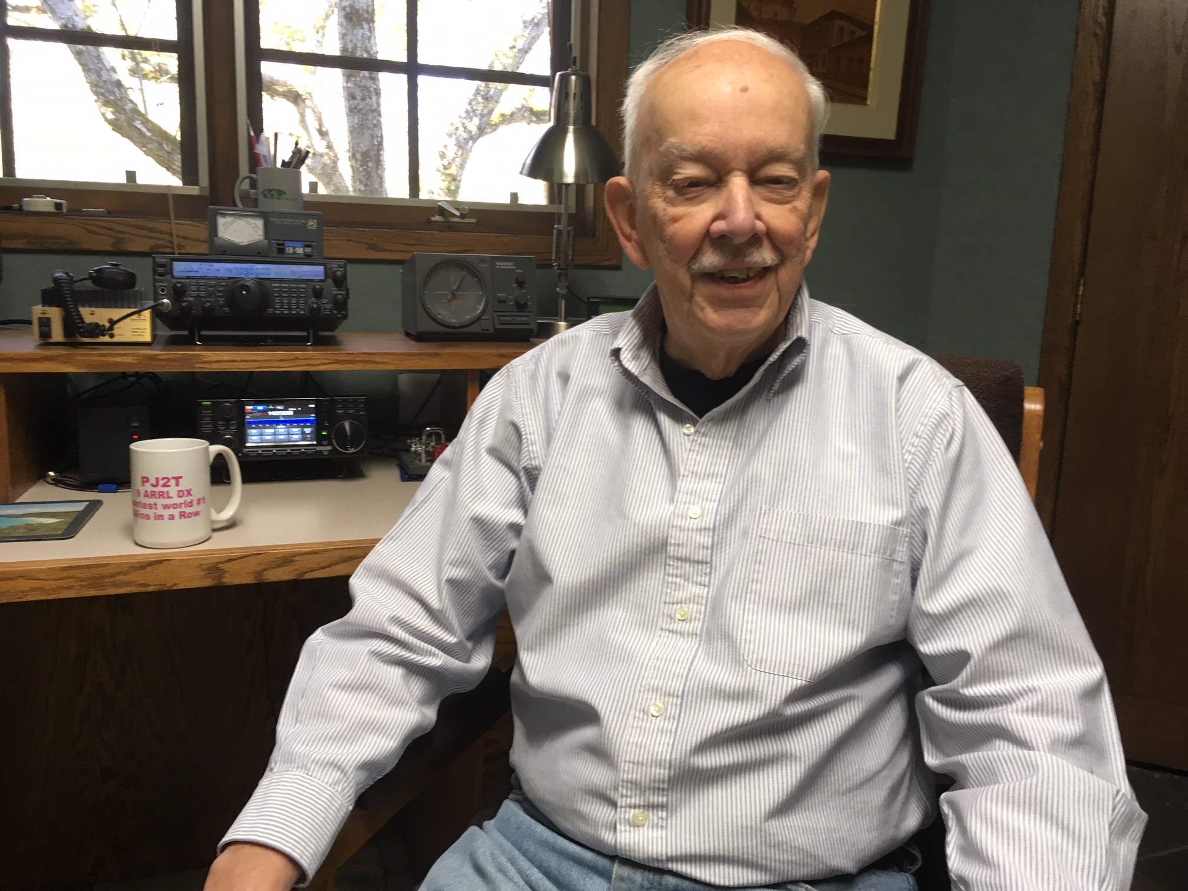

Like many from that era, I became interested in radio in high school and was licensed in 1952 at age 15. A friend helped get an antenna on the roof of our apartment building, and I was on the way. My first DX was a KL7 on 40 followed by such memorable calls as KV4AA and KH6IJ. I dragged a radio to college – Miami University in Oxford, Ohio. A previous guy in my fraternity had established a ham shack on the top floor of the fraternity house – very convenient for me to move in. This was during the peak of sunspot cycle 19 – the best ever – and DX was so easy. Later on, got married, bought a house, and moved on to some good equipment and contesting.

The serious contesting from the DX side began in 1980 – the first business trip to Brazil – meeting the Rio contesting and DX group, including Hal Harris PY1ZAE (SK), Rolf Rasp PY1RO (SK), and others. I was invited to a nice contest station about 25 miles out in the country. Hal really helped me learn contesting from the DX side. I did quite well in various contests using my first Brazilian call – PY1ZFO. Through Rolf I met Andre Sampaio PY0FF. I visited Andre on the island of Fernando de Noronha in March 1988. I happened to be there for the ARRL phone DX contest. Keeping in mind that Noronha is a separate country from Brazil for DX and contesting, and having very limited activity, I got my first real exposure to huge pile-ups. But once experienced, the pile-up hunger is never satisfied. I went back to Noronha 11 times, mostly in February for the ARRL CW contest. In February 2003 fortunate enough to win the Single Band 10 plaque and set a new continental record for South America. A 7 over 7 and Alpha does wonders. The last time to Noronha was 2009 – a multi-op venture in the ARRL phone DX contest. Unfortunately Andre has moved off the island and that opportunity is no longer available.

But before that window closed another opened. Geoff was looking for operators for the 1999 ARRL CW contest from Providenciales – and I was quick to volunteer. Being part of the VP5CW team and meeting Geoff, Keith and others was a life changing experience. It was there that Geoff decided he had had enough of dragging stuff around, and began planning for a permanent station in the Caribbean. Not long after the John Thompson station PJ9JT on Curacao became available – the rest is history. At that time the house had been unoccupied by humans for several years. The animals and the tropics had done much damage to the house, but Geoff had the vision to see what it could become. After months of cleaning up the house became habitable – things were looking great for my first visit for ARRL CW in February 2001. Soon after I led groups for the ARRL 10 Meter contests of 2001 and 2002. Later we began a series of non-contest visits with Joe W9JUV (SK) and our wives.

But the most memorable was the 10-10-10 celebration of Curacao’s independence (sort of) from the Netherlands. In October 2010 the four Dutch Caribbean island groups were added to the ARRL DXCC countries list – probably the first time ever that DX’ers throughout the world had a shot at four ATNO’s (All Time New One) at the same time. Groups went to Bonaire, Dutch St Martin, and Saba to satisfy the demand. Jeff K8ND and I catered to the multitude from Signal Point – I had been on the receiving end of some humongous pile-ups, but nothing quite like that one. Our friend Bob Allphin K4UEE actually came up with a 10-10-10 band plan so the four simultaneous pile-ups would not overlap. I wrote an article about it that appeared in the March/April 2011 issue of The DX Magazine. Now in my twilight years of contesting, I love the annual February visit to PJ2T for the ARRL CW contest. Looks like another M/M win for 2019. Living in Illinois, just being somewhere warm in February is most welcome, but the friendships and camaraderie at Signal Point are very special.

Another good experience was the opportunity to be Chairman over a ten year period of the W9DXCC convention. This is an annual event held near Chicago going back to 1953. A great opportunity to meet the “Movers and Shakers” in the DX and Contesting community, which of course included our own Geoff Howard, who told the PJ2T story at W9DXCC 2005.

I also have a life outside of amateur radio. My business career spanned forty years and included some interesting assignments. I spent a few years in nuclear insurance - which brought the dubious honor of being one of the first at Three Mile Island following the “incident” of March 28, 1979. Several international assignments – in addition to Brazil – work in Canada, Bermuda, Belgium, and Puerto Rico. The Belgium trip allowed a day with ON4UN in Ghent and ON4DE in Antwerp. In San Juan, our base was the Caribe Hilton Hotel. Security not so tight then in the 70’s – ask me about putting up dipoles on the roof of the hotel. Since retirement, I have been active in the National Stuttering Association, doing financial work for our church, and playing bridge.

None of the above would have been possible without the support and encouragement of my wife Jane. As mentioned above, Jane has been to Signal Point several times. College sweethearts - next year will be our 60th anniversary – been a wonderful journey.

