Member Spotlight

Dave Shipman, VA7AM
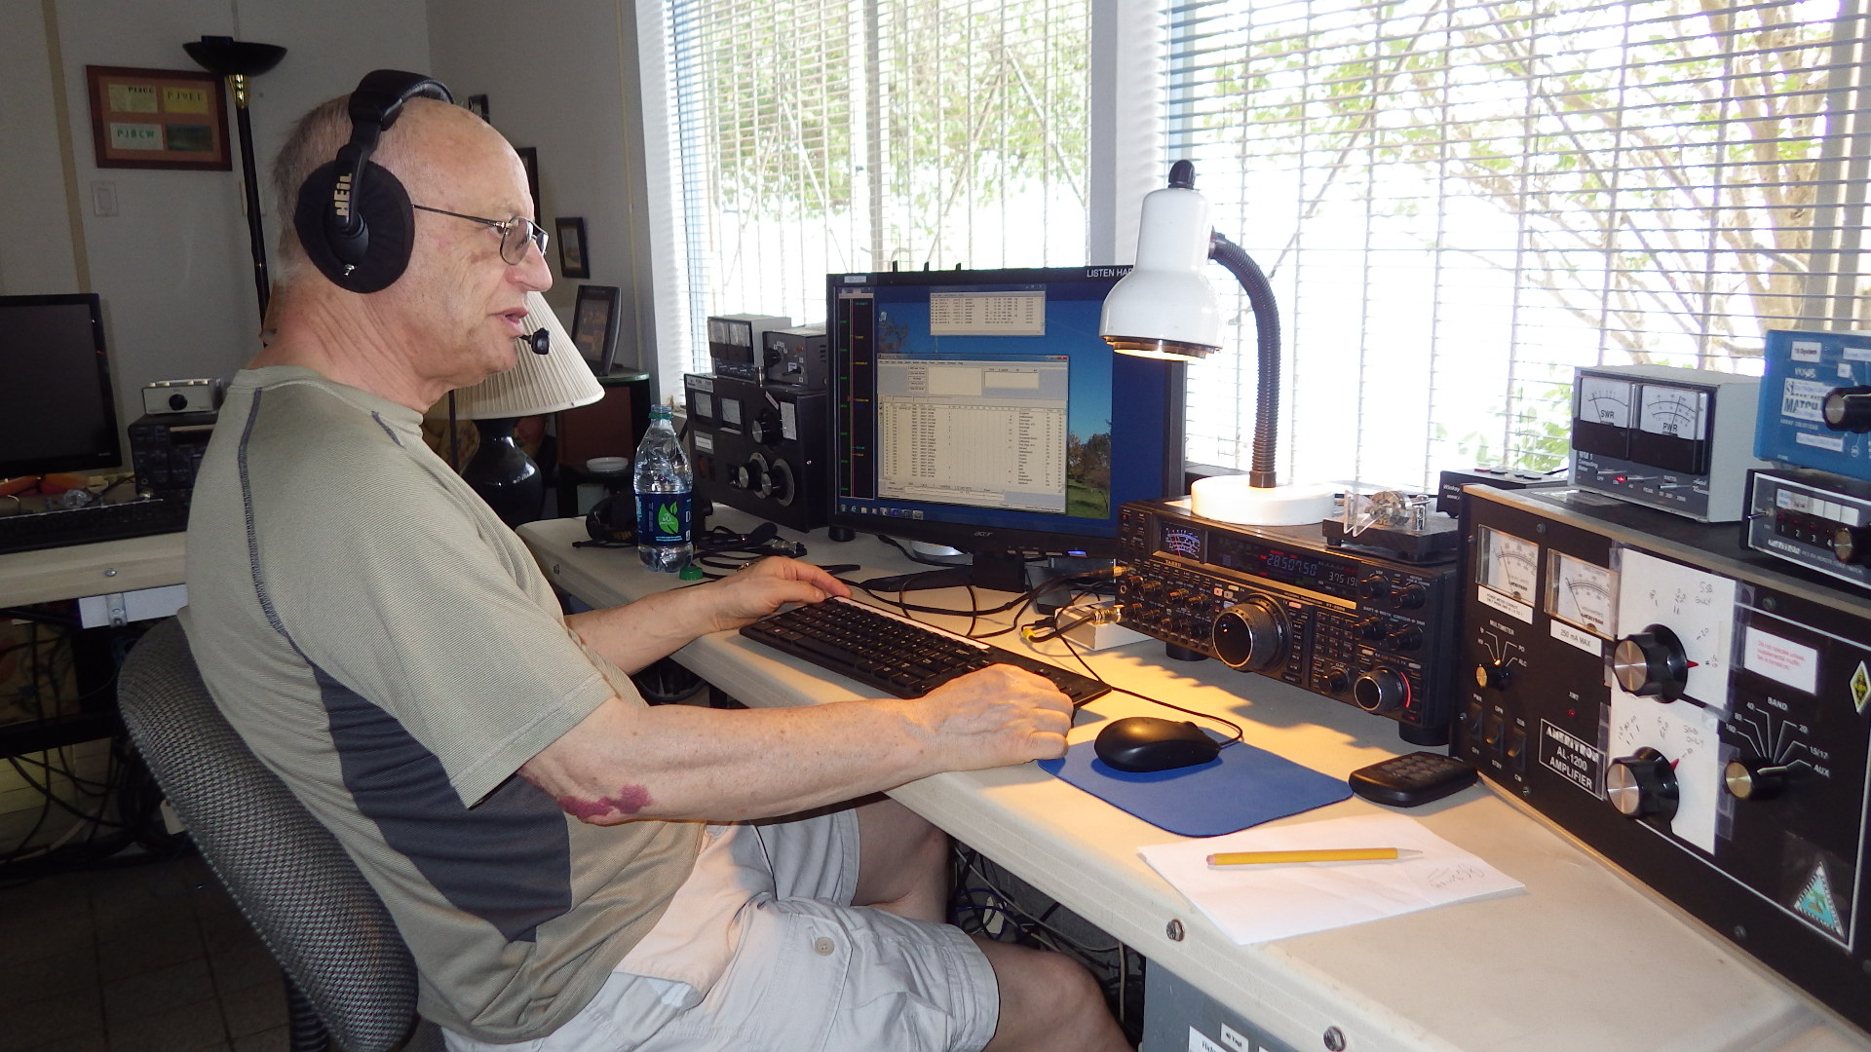

Dave was born in the UK in 1944 but emigrated to Toronto, Canada in 1968 with his wife Gill. Two winters were enough and they moved to Vancouver where they have been for the past 50 years. Career wise he started with IBM in the UK and also worked for them in Toronto. On moving to Vancouver, he joined BC Hydro where he worked in IT and General Management until retirement.

His interest in Amateur Radio started when he was 18. However, on meeting Gill other considerations took place and he did not get his license until he was 39! They have a son and daughter and two granddaughters.
Dave’s interests in Amateur Radio are software, contesting and DX. Each year he tries to get to PJ2T for the CQWPX SSB contest. He is also treasurer of two local clubs – North Shore Amateur Radio Club and the ORCA DX and Contest Club.

