Member Spotlight

Egon Behle, KF4DX and DK8FZ
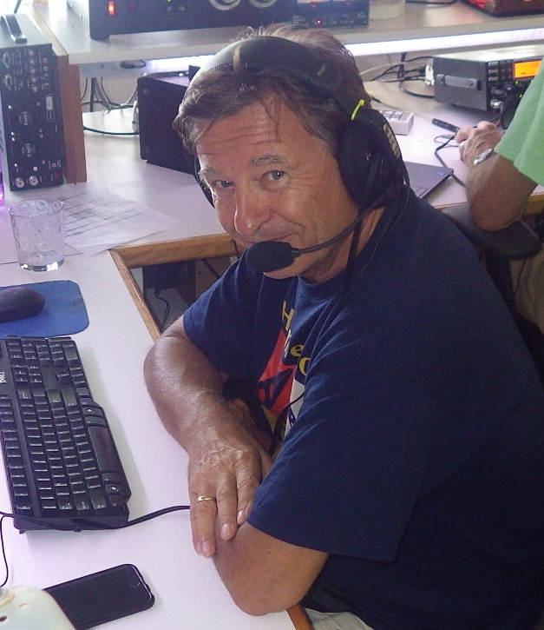

I was born and raised in a small town close to Frankfurt, Germany, as the eldest of three sons living in a nicely uphill located single family house my parents had built and from which they never moved away again. It was a great radio location! I got my ham radio license at the age of 15 and hold my German call sign DK8FZ since then. It was my dad, DK3FQ, who supported me in the licensing preparation after I had been an active SWL for some 3 years. I was thrilled to then be able to use our Mosley MP33 at 55ft and the Drake TR4 which my dad from that day on had little chance to operate.

Soon I started pushing for an amplifier and we built one together using two 813s grounded grid. My focus ever since was 80-10m sideband only and I started working contests. With band conditions in those days and my setup I was competitive and I ended up with a number of 1st in Germany and among top 10 in Europe. I worked my 5 band DXCC within 2 years but never did the paperwork to apply for the award. Making friends around the world and looking for Caribbean Islands on 20 m into the early morning hours was fascinating for me. Once in my life I wanted to visit these places and PJ9JT’s QSL card was on my wall.

Even prior to ham radio I started flying gliders and did my first solo still at the age of 14 receiving top honors as one of the youngest glider pilots in Germany. I added my powered gliders rating when I turned 18 and finally also had my driver’s license (earliest in Germany at that time). I worked on collecting my first flying awards on gliders for distance and duration of flight. Flying and ham radio were filling my free time to the largest extent. Instead of serving in the military I took the more demanding alternative and joined the border police for 2 years. For the second year after going through all trainings I successfully applied for a position as bodyguard for a German politician and top manager. (In those days there still were people in politics in Germany who knew how to make money).

This was a very exciting period of my life that largely shaped my professional goals. When turning 21 I started my studies as engineer for aviation and space technology at the University of Stuttgart after I had given up on any career as commercial pilot with Lufthansa or any other airline following some long discussions with my parents and others. Still today I am happy for that decision. I upgraded my pilot’s license to single engined aircraft and enjoy powered flying since then.

Real life finally hit me after graduating as Dipl.- Engineer and getting my first job at Bosch in Stuttgart. Ham radio was pushed into the background of my life as I continued to have no space or permission to install any antenna. My time window for flying was limited to the weekends and my fiance, Gabi, was not interested in any of my technical hobbies. However she was thrilled by my proposal to do our first trip to the United States. It was in November 1984 that we landed in Tampa FL and took a rental car south. I had FAA-validated my German pilot license in Frankfurt and read a lot about flying in Florida so I was well prepared. We ended up in Naples, and I could easily rent a Cessna 150, did a checkflight, and the aircraft was mine for the next week. We explored Florida by air from Key West to Jacksonville, visited the Space Center and did some boating in the Naples canals. I did not know at that time how much this experience seeing Florida has turned a page in my life.

Fate hit us a year later when Gabi got the diagnosis of cancer at the age of 25. She passed away 3 months later and I had to learn how fragile life can be. At the same time I took a new job as sales director at Dornier, a company in aviation and space technology. I deeply dived into this job which made me travel a lot to the USA and distracted me from my private disaster. About a year later I realized that life had to go on and happened to meet Simone. We married and my son Patrick was born.

Meantime we had moved to Augsburg in Bavaria as I took a new position with Renk AG, a company in the MAN group. As the new Vice President I was supposed to build up a new business for test systems and using my background we expanded into automotive and aviation. After taking a turnaround job as CEO in Stuttgart for 2 years, ZF Friedrichshafen at Lake Constance called me and I could not resist this new challenge at my most desirable place to live. I bought our first house in 1998 at a beautiful uphill location overlooking the lake, put up an antenna and was back on the air after many years of QRT. I also joined the local flying club having Cessna 172, Piper PA 28, Mooney and Robin aircraft available. Life was great and I was traveling the world for business from the US to Asia.

In 2002 ZF promoted me to become the CEO of the 50/50 joint venture they had with Bosch for steering systems. This multi billion dollar company with some 10,000 people around the world was at a 10% loss situation, and I was supposed to fix that. I was extremely excited about this big opportunity and the trust Bosch and ZF had put into me but had to learn from day one that this was a really tough job ahead. At the same time Simone disclosed that she wanted a divorce. She had met someone she thought to better get along with. Obviously I was away too much and did not realize what happened between us. One of the most difficult periods of my life started and ham radio and flying were switched off. Instead I was creating new daughter companies in China and the USA, pushed my people for process improvements and used our huge growth to return the company to profitability.

A year later I met Elke, a famous dentist in Stuttgart. She had gone through a divorce like me and had a daughter same age as my son. We started building up a new family and some time later we found out that we both love Naples. What a coincidence! We spent one of the first family holidays in Naples and agreed that this is our place to be. Being afraid of marriage we both had postponed it from year to year but finally took the decision in 2007. We married on the island of Santorini as Elke wanted a romantic very special marriage. At the same time I was offered the CEO position at MTU Aero Engines AG in Munich, a company listed on the stock market for just 3 years. ZF steering was back to a good profit margin and I was again excited for a new challenge. The family moved to Munich and Elke commuted to her dental practice in Stuttgart daily. My international travels got even more intense, and flying in a club was no option anymore. In 2008 I bought my first aircraft, a Cirrus SR20 and Elke loved to join me for weekend trips if we did not go to Lake Constance where a 40ft Flybridge Yacht was my toy on the water. MTU was developing great and my business connections to GE had paid off. The stock price was increasing from year to year and the market and the media were excited about this new pearl of German technology. MTU and the CEO were honored as the most innovative company and management.

In 2012 we took advantage of the real estate crash in the US and bought our first house in Naples. It was supposed to be a holiday home, but whenever we had to leave back to Germany we almost cried and we decided that longer stays have to be the future. We thought about a visa for 6 months and to spend the German winter in Florida after retirement. 2013 then was the turning point for Elke and myself. Elke was fed up by the increasing regulation in Germany and so was I in my business. I denied another 5 year contract as CEO and as the stock price had increased from 12Euro when I took over to 75Euro I decided it is time to sell and retire.

Leaving to Naples forever came into our mind and we explored our options. With my business background our US lawyer saw good chances for a Green Card and we put the application on the way in 2014. I restarted ham radio as W4/DK8FZ but finally got my Extra Class license and my KF4DX callsign. RexAir in Naples had Cirrus aircraft for rent and I had bought a boat plus boat dock. What a great life away from Germany. It took until spring 2017 to finally get the Green Card approval and we immediately sold everything in Germany, the real estate, the Cirrus, the yacht and all cars. On July 1st 2017 we left the country and arrived in Naples with big relief. When the German government had opened the borders for unlimited immigration of millions of Muslim economic refugees from Middle East and Africa into the German social welfare system in 2015, I knew this will kill the country in some years time. I bought a place in Austria where we put the remaining stuff from Germany and where we may spend one or two months in summer and meet family and friends in Europe.

Not a single day did we ever regret our decision and we look forward to applying for US citizenship in 2 years time. I am still on some boards and do some consulting to private equity and M&A. As a member of Naples Greater Leadership I am happy to support some nonprofit organizations with my know-how bettering Collier County and giving back to the country that has become our new home. Joining CCC was another of my boy’s dreams to come true: operating ham radio from the Caribbean and contesting. I love to be a part of it.

