Signals from the Point

QUARTERLY NEWSLETTER OF THE CARIBBEAN CONTESTING CONSORTIUM
MAY 2007 VOL. III Issue 1

PRESIDENTIAL POINTS
Comments from CCC President, Jeff Maas (K8ND)

Another year has come and gone (between Dayton Annual Meetings), with the usual array of maintenance and upgrade needs accomplished and new ones facing us. But I’d like to talk briefly about our place as a part of the Curacao community, and once again touch on the subject of moving PJ2T forward so we don’t fall further behind.

******************************

Knowing Curacao

We are guests of Curacao, and of its Amateur Radio community, whenever we are on the island. When we are on the air, we project an image of Curacao around the World. When we are on the island, we represent Amateur Radio to the non-Amateur people of Curacao.

How much do you know about the history of Curacao? Have you learned any Papiamento? Have you visited some of the museums, historic sites, or visited a national park (Willemstad is not just for shopping!)? Visited an authentic Curacao restaurant? Talked about Amateur Radio with a Curacao resident?

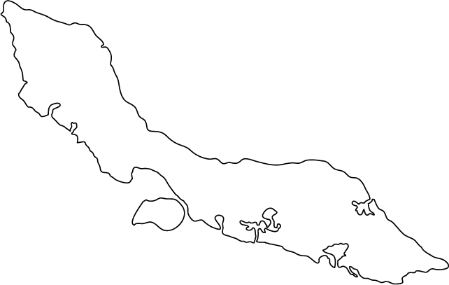
We have a fantastic opportunity when on the island to learn and grow, and to promote Amateur Radio. I know that I, personally, have fallen short on taking advantages of the opportunities outside of the Santa Martabaii area, and pledge to change that on future trips!
******************************

Overcoming Club Inertia

Improvements in the station’s contesting capabilities (beyond maintaining what is there now) are limited by (at least) 7 factors:

- Desire to Perform Better In Contests.
- Previous Decisions/Infrastructure;
- Available Workers/Skills;
- Physical Space Available;
- Time, Especially Time On-Site;
- Money;
- Political / Neighborhood Concerns.

If we have the will to overcome inertia, we will need to improve our ability to overcome as many of these limitations at possible.

******************************

Curacao Callsign Wishes

We pay a $60 (USD) fee to Curacao’s Bureau Telecommunicatie per contest for the privilege of using the PJ2T callsign in contests. I think, having established ourselves as a long-term presence in Curacao’s Amateur Radio community, we should work towards having that call assigned to our club station on a permanent (or, at least, annual) basis, similar to PJ2A (VERONA – Curacao ham club).

I, for one, would very much like to see us working, with VERONA, towards a modification in the requirements for obtaining an annual “PJ2xx” callsign. As we know, most countries make it relatively easy for someone to obtain a non-CEPT callsign (e.g. “PJ2/K8ND”) when operating from that country. Curacao does not, except for short contest periods. I would really like to have “PJ2T” permanently assigned to our club station on an annual basis, and to operate as “PJ2ND”!

Curacao requires the Amateur to have residency, a long and expensive process, to have a fixed “PJ2xx” callsign. Aruba (P4) does not. Sint Maarten (PJ7) does not. Essentially, none of the Caribbean islands limit the ability to get a primary callsign by visitors. I’d
like to have us play a part in changing this situation on Curacao.
(Presidential Points, cont.)
Key in making this happen would be convincing the Curacao licensing authority that such a change 1) is legal and proper; 2) could be done without significantly increasing their work load; and 3) could provide them with some additional Bureau income in the form of annual fees.

My suggestion is that Curacao adopt a process that requires 1) Personal appearance at the Bureau Telecommunicatie to apply; 2) Presentation of a valid Amateur Radio license from their home country; 3) Payment of an annual fee, with expiration after one year; 4) Membership in VERONA. Perhaps this would be sufficient for a “PJ2xxx” callsign. To be eligible for a “PJ2xx” callsign, add: 5) Demonstration of continued interest in the island through multiple visits in a set period (e.g. perhaps eligible after three visits in a 3-year period).

These requirements would prevent everyone scheduled for a six-hour cruise ship stopover from obtaining a local PJ2 callsign, but would allow those visiting Amateurs with an ongoing relationship with the island to build their identity as a PJ2 licensee and further promote Amateur Radio on Curacao.

06-07 Antenna/Tower Renovation Status
Triggered by the broken 15-meter boom on the Europe antenna, a need to renovate towers and antennas became an important part of the CCC vision for Signal Point. In the 2001 installation we got 90% of the job correct, but the 10% that was done improperly for such severe salt-spray conditions had caught up with us.

Examples of the problem include the steel U-bolts on aluminum beams, unprotected galvanized parts, substandard grades of stainless steel and exposed steel guy wire tails.

Experience has taught us how to properly protect and repair everything for likely 10-year+ survivability. The 17-page renovation plan and budget for $4500 worth of parts has us well on the way to recovery. N8LGP fabricated custom hardware and new boom sections were donated by N8NR. 14 of the 17 pages of the plan have been accomplished. All that remains is to install the last four new guy wires and to rebuild the US 15 and 20 meter Yagis.

The question now is - - when do we do it???

When this renovation plan is complete, regular maintenance of the towers and antennas will have been greatly minimized, leaving only routine tower scraping and painting on the work list. (See article on tower painting schedule on the next page.)

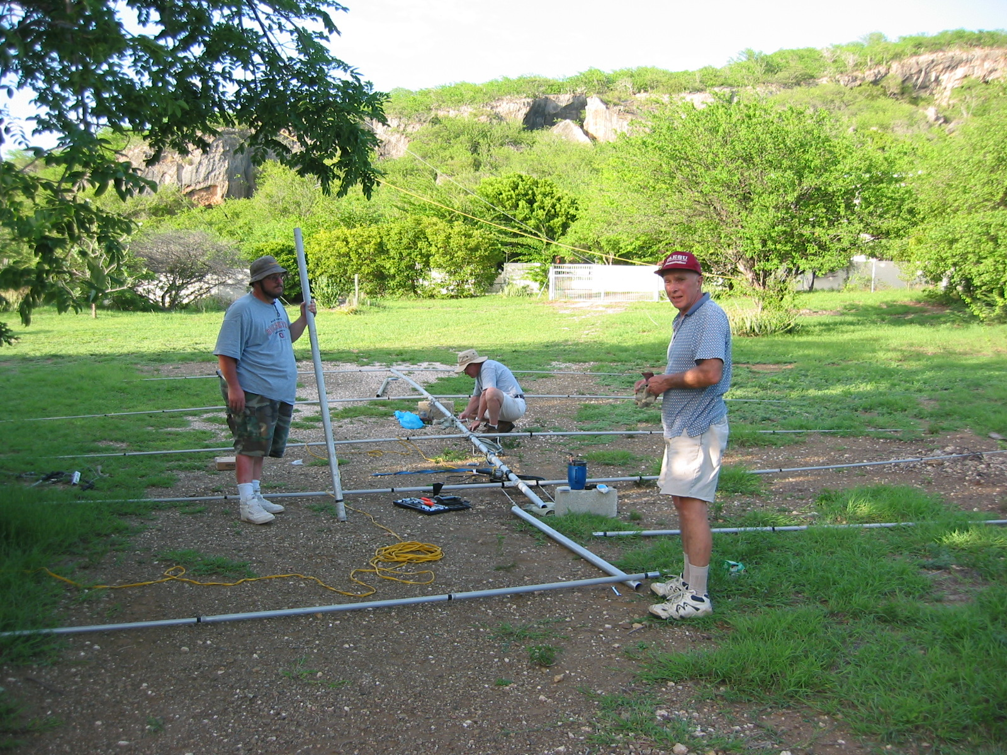

K8ND, WONB, N1ZZ working on antenna repair: Dec. 2006

Curacao Country Status
With the April 2005 referendum calling for Curacao to hold “Status Aparte” or to become an autonomous state, there is much discussion and confusion on Curacao and throughout the former Netherlands Antilles as to what changes will occur and when. In reports at the VERONA radio club meetings it is clear that changes will be coming – but not in the immediate future. Call signs currently issued on Curacao (including the club call PJ2T) will most likely be in effect for at least five more years. Other islands, such as St. Maarten, have much more re-organizing to do and it will take some length of time to be able to coordinate the changing of country codes that also affect air traffic.

Updates from VERONA and Radio Bureau officials will be passed on to CCC members as information is available.

Yellow Tours – Jeep Safaris
Need a new diversion on your next trip to the island? Local ham, Mark DeHoo, (PJ2GT) is part owner and operator of a new tour company that provides a myriad of island tours for cruise ship and hotel visitors.
They provide everything from walking tours of the UNESCO sites to beach trips and jeep tours of the National Park.

Check out the website:
http://www.city-discovery.com/curacao/tour.php?id=2070

You may wish to sign on for a tour – or a group of hams can certainly contact Mark as to when they’ll be on the island and he’ll arrange a deal for you!

New Tower Painting Scheme
Geoff (W0CG), Jerry (WB9Z), and Bob (N8NR) have been keeping the towers scraped and painted with epoxy paint and need some help! Here’s the deal:

Both towers need re-coated every six months - in May and November. A local professional tower contractor (Herko) is interested in the job and will be used mostly in May. Jerry and Geoff will continue to climb and paint but will each do only 2 sections per trip. Non-climbing CCC-ers are asked to do the bottom 20 feet of each tower.

The contractor charges $61/hour. Total amount of this cost will be covered by the $25 annual dues increase and the additional $175 outside maintenance surcharge added to the cost of each rental week.

Transceiver Rotation Proposal
W0CG, CCC Maintenance Guy, suggests the following proposal for the membership to consider:

The FT-1000s have been by far the most reliable transceivers of everything tried throughout the past 7 years. But – a clear pattern is emerging. At about a 3-year period the transceivers fail, are sent for repair, then returned to service after which they fail again.

The proposal is that we keep Signal Point supplied with these transceivers aged 0-3 years and sell off the older ones (which are probably still good for years of service back in the U.S.)

FT-1000s are out of production. We would need to move fast on acquisition because all of the next generation of transceivers are prohibitively expensive. Thoughts????

Plugging PJ2T Weak Spots
In general, things are going great! The station is scoring fabulously in contests and working pretty seamlessly. But…there is always room for improvement. There are two glaring shortcomings at Signal Point.

1) As much as 90 minutes is lost to Europe on 10
meters at both the band opening and closing times
compared to Aruba and Bonaire due to the infamous
HILL. Once the bands are fully open then the station
is fully competitive. Hypothesis: the only way to
catch the low arrival-angle signals is for an antenna to
be put on the ridge.

To validate this, an experiment is needed. Who can bring a battery-operated transceiver so that someone can climb up on the ridge with an HT and make direct comparisons to signals as heard in the shack on the primary antennas? If the difference is dramatic, then the next step would be a prototype installation on the ridge.

W0CG proposes a 20’ Rohn 25 tower and a TA33 Tribander - both already on site at Signal Point. Feed line length would be about 1600 feet. We have 400’ of Heliax at SP. Who has coax or hardline? We could do an ocean shipment. The tower would be set on rock and guyed to trees – no rotator needed. Then would come the wait to see if any vandalism occurs. Geoff estimates that this project would require 2 people and 4 days to complete – with the feed line not buried.

2) We badly need a gain antenna into the U.S. on 80 meters. The first thing to try is colinear verticals. We need to explore short verticals – possibly from DX Engineering – and quick deploy radial kits so that everything is easily erectable for each contest weekend. Who would be willing to take responsibility and create the design???

Pitching in for CCC:
More Than Meets the Eye
Not everyone can afford large monetary gifts to the club. Not everyone has a flexible schedule that allows vacation days to be used to build or repair things for the station. Not everyone climbs towers.

But everyone CAN do something! There are many (sometimes non-obvious) ways that all CCC members can contribute to the club.

- Recruit new members. Ideally the group could use 5 new members with possible focus on excellence as SSB operators or tower climbing. Time and resources to make good use of the station and a wish to help preserve Curacao contesting history are also positive components for club membership.
- Present the PJ2T story at local ham club meetings.
- USE THE STATION! Your presence at Signal Point keeps things going and provides a PJ2T presence on the air throughout the year, contest or non-contest. And, while you’re at SP, there’s always a list of jobs that need done – some as simple as cleaning computer keyboards, others as taxing as digging radials – and your help is needed and appreciated.

Here are some specific jobs that still need to be done on an on-going basis. Any volunteers?

- Club Historian: Obtain, catalog and protect all logs, scores, and op lists from all operations. Catalog annual meeting minutes, station manager reports, and all correspondence. Keep track of published rankings of all PJ2T operations. Cont. on next page…
- Photo Archivist: Establish a collection of all Signal Point and CCC photos, keep it updated, and keep them on file and on CDs that could be available to all members.
- Plaques Manager: Keep track (via photos and lists) of all plaques won by PJ2T operations, take orders for plaques for station contests and aggressively place plaque sponsorships on behalf of CCC.
- Publicity Manager: Write or solicit articles from members to be placed in a variety of publications. Create a publicity plan. Post photos on QRZ.com frequently. Write letters to vendors and suppliers summarizing PJ2T accomplishments. Push for presentations at stateside ham club meetings.

CCC MEMBER SPOTLIGHTS
(Each edition of SIGNALS from the POINT will provide you with several short bios of club members – share your story and learn more about your fellow CCCers!)

W8AV – GOOSE (ELMER STEINGASS)
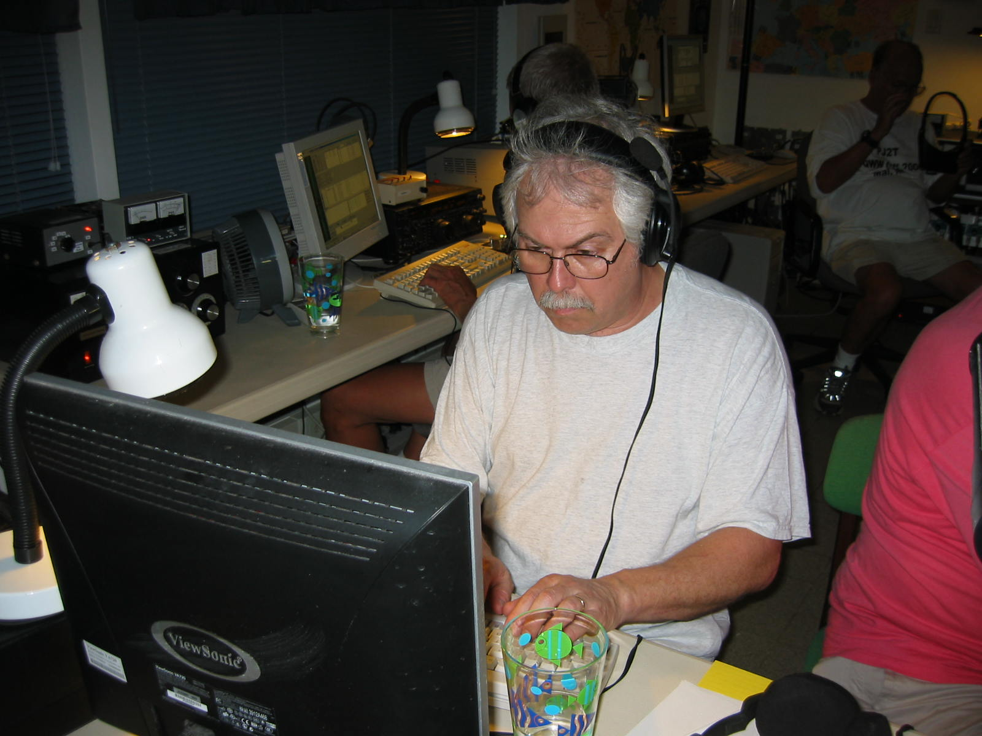

A 1974 graduate of the College of Wooster with a BA in Chemistry, Goose worked as a newspaper and wedding photographer in the city of Wooster for about seven years after graduating. He has worked as a radio and TV consulting engineer for the past 26 years.

Goose found out about ham radio in elementary school but never did anything about it until a fraternity brother got him interested in the mid 1970s. He was licensed in 1977.

DXing and contesting are his favorite things about being a ham. Goose says “Achieving Honor Roll status is the pinnacle of ham radio and contesting competition is a great operating skill builder.”

His favorite thing about CCC/Signal Point is finally achieving a dream to be part of a top-level contest station in the Caribbean! One of the founding members of CCC, he still remembers the post-contest dinner in VP5 when the plan to build a station was launched. He looks back fondly on how it grew exponentially from there to what the club has today.

In reply to a question about who has most influenced his ham radio experience, Goose replied, “The ham that influenced me the most is Don, K8MFO. Don is a top tier operator who is a walking encyclopedia on all aspects of ham radio and I am proud to have been associated with him over the years. Next on the list is Doug, K4LT who helped me build the W8AV station. Doug has been a loyal operator and friend over the years and has really helped me hone contesting skills in the early years and still does so today.”

One of Goose’s memorable adventures in ham radio was operating as 6Y5L with Doug (K4LT) on their first DXpedition in 1979, when they won the ARRL CW Contest for the first time and had a blast. That was his first time experiencing pileups from the other end and it is a special, never-to-be-forgotten event.

In addition to playing radio Goose finds time for several other hobbies. He is an avid Amateur Astronomer and is a brewmeister, making some incredible homemade beers! He’s also been active in area radio clubs and has worked hard to train new hams.

Goose has been happily married to Sue for 21 years this September and has two wonderful grown stepchildren, Matt and Dan, who are both hams, although inactive.

Retirement VERY SOON will allow Goose more time to come to Signal Point for operating events as well as allow him and Sue to travel to see more sites in the U.S. that are on their list.

W8TK – TOM (DR. TOM KRAVEC)

Born in Cleveland in 1945, Tom was raised in Youngstown, Ohio until 1963 when he moved to Chicago for college and medical school at Northwestern. He did his internship at Parkland Memorial Hospital in Dallas, Texas – the place where JFK died. Northwestern and Chicago were home once again when he did his surgery residency and later anesthesiology there. He met Lora when he was a surgery resident and she was a medical student. They’ll celebrate 35 years of married life on June 3rd! Their two kids, Ann and David are both graduates of
Cont. on next page…
Miami University of Ohio. David is an accountant in
Tucson and Ann is working at the University of Oregon in Eugene.

Tom built a Knight-kit receiver kit at age 12. He was first licensed (KN8PBZ) in 1959 at age 13. He had a crazy Uncle Joe, the black sheep of the family, who had been W7ITE back in the ‘30s. Uncle Joe got re-licensed as K8QAT at about the same time Tom got his license, so they hung around radio emporiums and clubs together. Tom upgraded to General a year later, then to Extra some time in the ‘60s. (Tom remembers that there was no need to do so until some privileges were reserved to higher class licensees.)

While living in Chicago, Tom was issued the call WB9HIB. He still held K8PBZ in Ohio and changed it to W8TK in 1978. He and Lora moved to Columbus, Ohio in 1974 so Lora could do her ophthalmology residency at Ohio State and they’ve been there ever since. Lora is also a ham. She passed her advanced test at the FCC office in Detroit in 1981 – she is K8LJK.

Tom’s first contest was Field Day in 1960 at age 14. By that time he had a general class license and was proficient in Morse at high speeds. He operated CW for 24 hours straight (a Heath DX-100 and Hallicrafters SX-101 - - Tom really does remember it like it was yesterday!) On the way home from Field Day he could copy CW coming from the hum of tires on asphalt! He woke up on the couch the next morning with a mouthful of peanut butter sandwich that he was too tired to swallow the previous night!

Field Day has always been Tom’s favorite contest and he hasn’t missed many since that first one. In college he convinced a couple members (now K9MM and AD6C) of the Northwestern radio club (W9BGX) to operate FD from the roof of the engineering building on the shore of Lake Michigan. He was sorely disappointed when the old generator died in the parking lot 5 stories below in the middle of the night, bringing that FD to a premature end. The other guys thought he was nuts!

For the past 30 years Tom has operated FD with Doug, K4LT. They operated for many years at Tom’s farm in Delaware County – purchased because it was the highest spot in the county! Tom and Doug mostly operate class 1-B, just the two of them, and win the category almost every year. The past several years they’ve done it from Tom’s garage in suburban Columbus. Tom’s reasoning is “you can’t beat the proximity of a swimming pool, refrigerator, and a real bed. I’m too old to sleep on the ground.”

Tom’s first experience with the CCC group was at VP5FXB in ARRL CW in 1997. He had just survived a coronary artery bypass a few months before and was eager to get back in the saddle. Another founding member of the club, and its current Treasurer, Tom was one of the first to check out the PJ9JT house (declaring it a total loss!) and notes that “things just got out of hand after that!” He hopes to operate ARRL CW from there as long as he’s still breathing!

Final words from W8TK: “Serious health threats tend to focus one on the present. I’m still thrilled to hit the paddle and find that somebody somewhere else on earth is listening. It’s as big a kick today as it was 50 years ago, and I try never to let a day go by without experiencing it.”
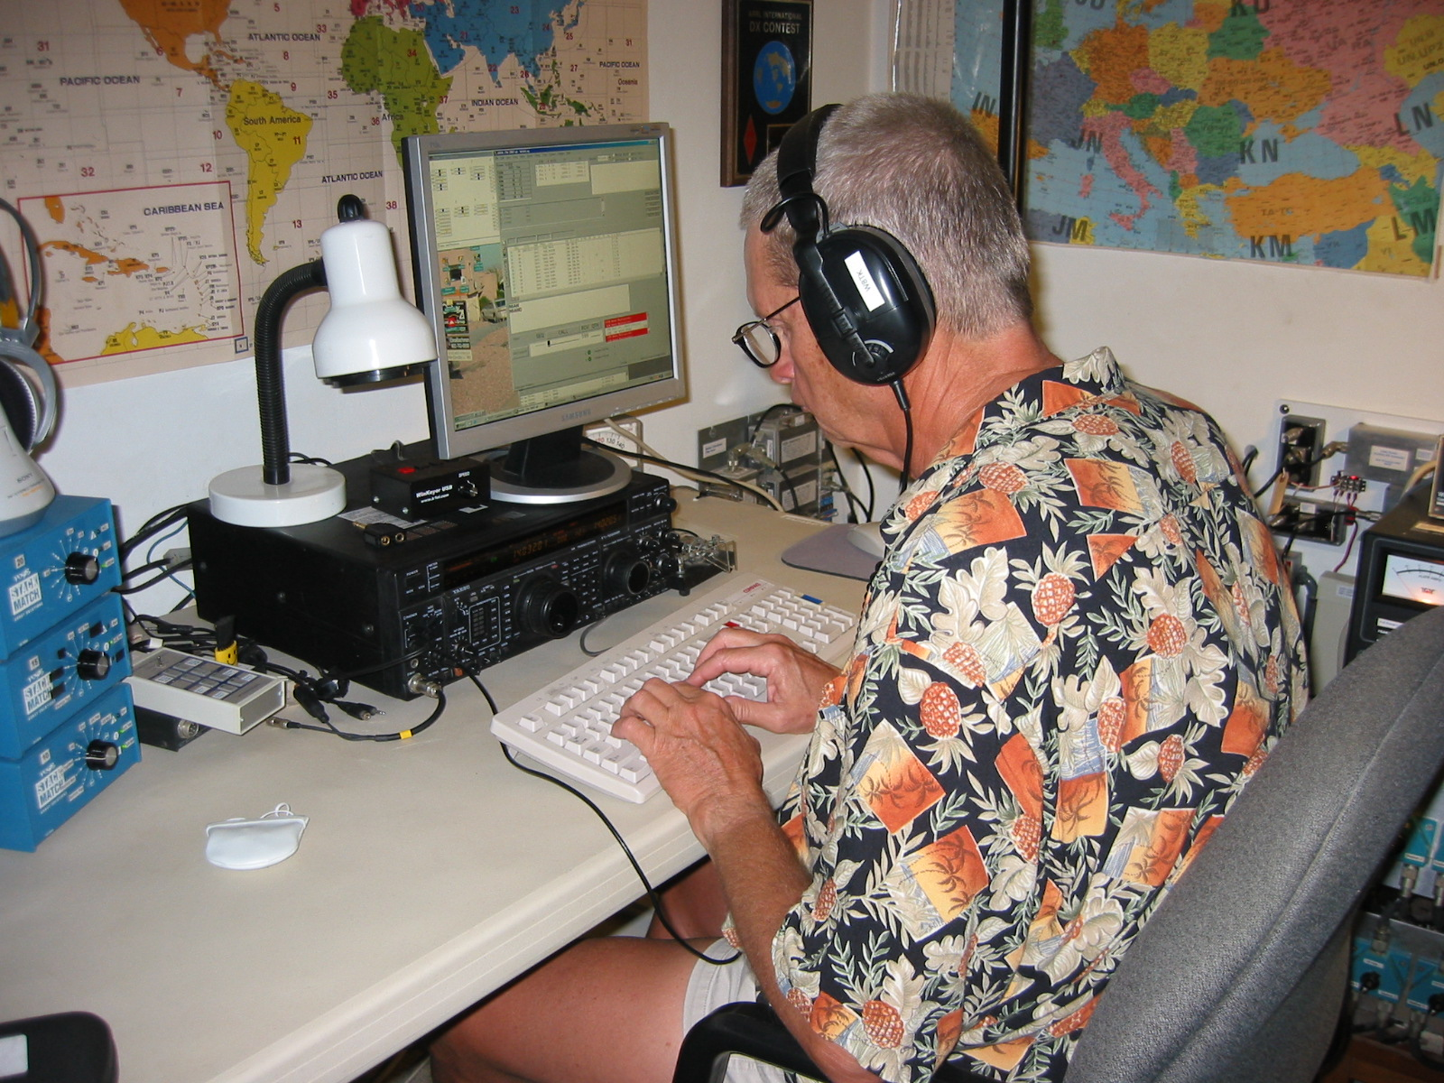
W8TK – TOM KRAVEC

SIGNAL POINT – Behind the Scenes

Facility maintenance update:
Recent chores completed:
√ Front picture window bars were scraped of their rust, primed and painted with epoxy paint and re-installed after painting and patching the window frame. The lignum vitae tree in front of the window was also trimmed, increasing the view AND the shade!
√ All door locks were oiled and sliding glass door tracks cleared and WD40d. They should work smoothly for another year!
√ Mildew was scrubbed from the concrete – the long rainy season turned things black and icky.
√ Flowers were planted in all the new beds and planters, plants and trees fertilized and trees trimmed, especially the ones that allow critters access to the roof.
√ The faucet in the east bathtub had the old dried out washers replaced and in the process, one of the 38-year-old brass fittings cracked! A new shower control will be installed next trip IF W0CG can figure out how to chip a hole through the 8” concrete wall…
(Behind the scenes…cont.)
Station maintenance update:
- All 12 plastic trap caps on the South American Yagi cracked and fell off – nearly simultaneously! We can expect the WARC Yagi to do the same soon. Repair will involve taking down both antennas.
- Retuned the 30m V – finally got 2.5:1 SWR back to perfect!
- Finally got the 80 m European array working perfectly on CW after lots of maintenance on the switches and retuning the driven element’s capacitor wire.
Equipment repair update:
- FT-1000 (#4) is back at W0CG’s from servicing on 1 May. It is on the air at his station in OH and performing perfectly.
- FT-1000 (#3) is at CG’s for evaluation and will soon be shipped to South Carolina (W6XA’s factory service) for service.
- Titan II has been at TenTec about a month – still no word on that repair.
- Titan 425 is still at Signal Point with a raspy CW note – still hoping to fix that on site.
- Serious telephone interference with the house across the street has cropped up recently. It only happens in connection with the 20 meter European Yagi.
- Power line noise problem is slowly growing – we need to buy and take a noise-sniffing receiver to track down the source of the noise.
- The rough design for the new AC power console that will contain the new transformers is complete. The finished unit may not be on site for as long as another year.

STORY TIME:

Geo-caching on Curacao
OR

Why it’s always a good thing to carry needle-nose
pliers in your pocket.
C. Howard
So N8LGP says to CG and Cindy - “Let’s go geo-caching! There are a couple sites on the island that I’d love to find.” So – off we went – following clues from an internet site and with all the coordinates plugged in Steve’s GPS system. We set off prepared to hack our way into the wilderness if necessary – bottles of water, hedge trimmers, pliers, and other tools, along with hats and sunscreen. Fortunately it was a rare overcast day which made the hikes much more enjoyable!

We found the first two sites off a well-marked and easy-to-navigate bike/hike trail out near Jan Kok plantation house – a neat place for a great walk and some incredible views. Steve found the caches and deposited his favorite small items (rubber snakes!) while removing stickers from one and checking out a Cleveland Cavalier figure in another!

Then it was on to the third spot – somewhere out near an old quarantine hospital for sailors and anyone else with communicable diseases. Set right up above the bay, the building is in ruins but was once an incredible place with magnificent views of the water.

The clue said “just below the rock outcropping.” Well – the whole doggoned cliff is a series of rock out-croppings! (At this point, Cindy made everybody stop and read the directions! It’s a woman thing!!!)

Geoff and Steve began their descent, after much putzing around due to a torrential downpour and the building being in the way of the coordinates - - - but not before Steve did battle with several prickly pears and ended up with three clumps of cactus imbedded in his arm! No complaints, though, even when CG was removing the spines with the pliers – the hunt must go on! The cache was discovered (under one of MANY outcroppings) and the end result was that we got to see a number of places we’d not yet experienced on the island. !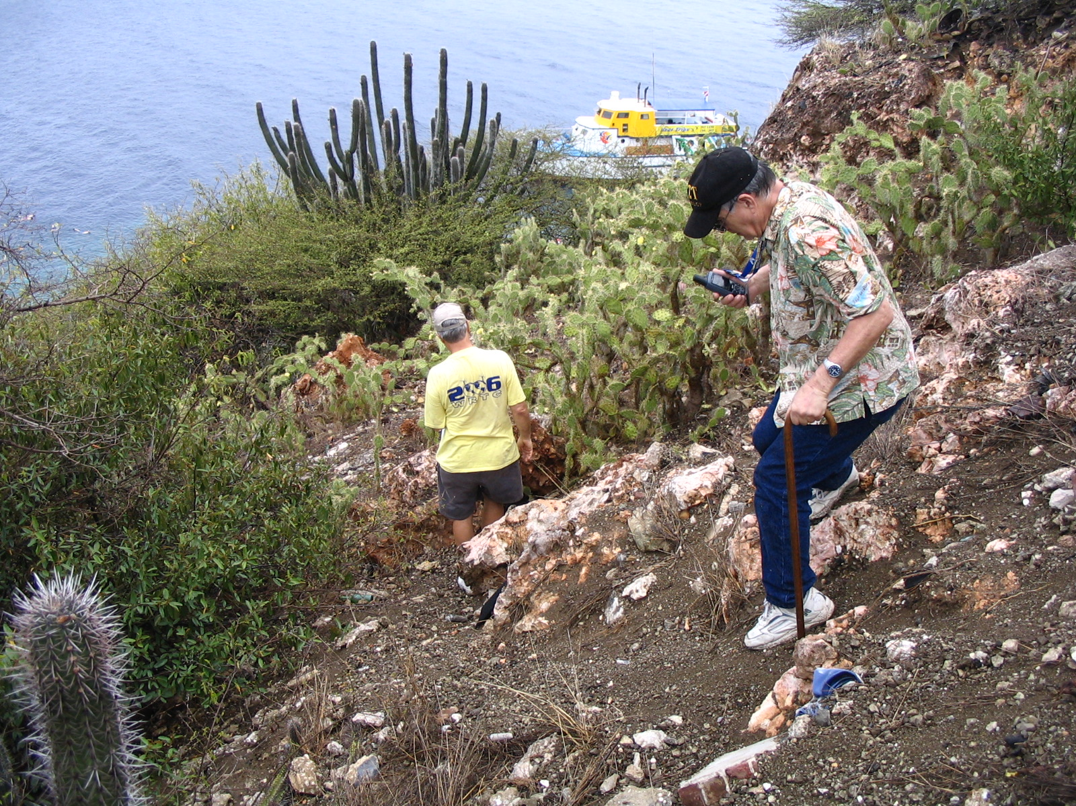

W0CG and N8LGP “on the rocks”

TREASURER’S REPORT and $$$ UPDATE

[Deleted from web-based version of newsletter.]

