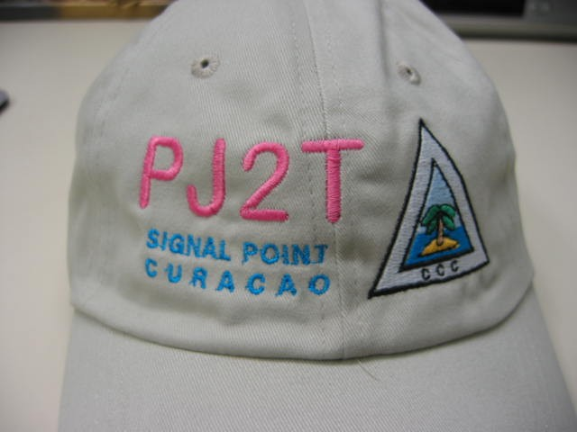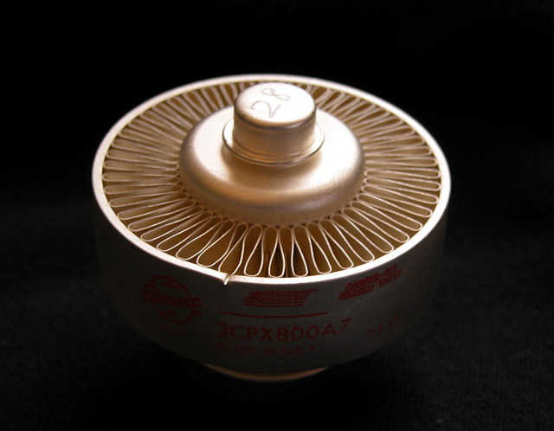

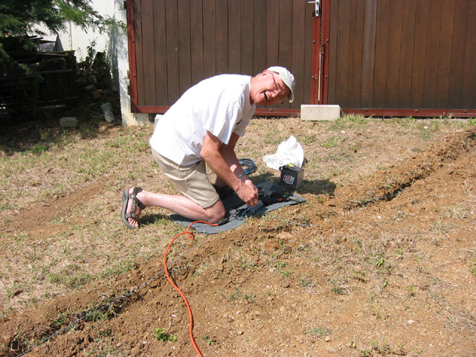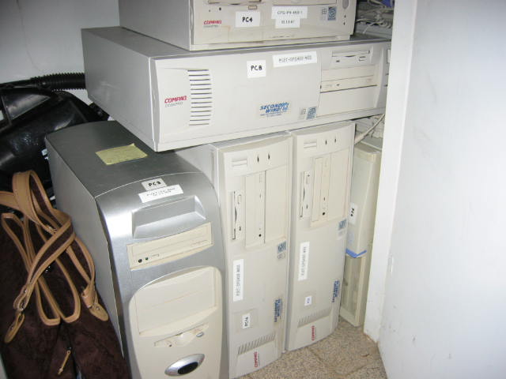

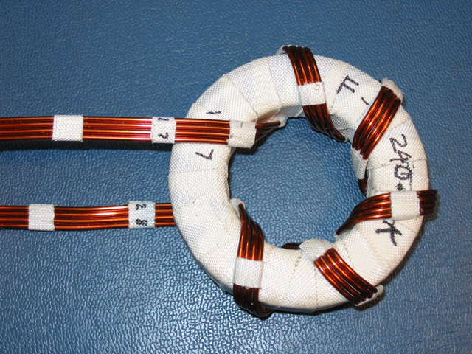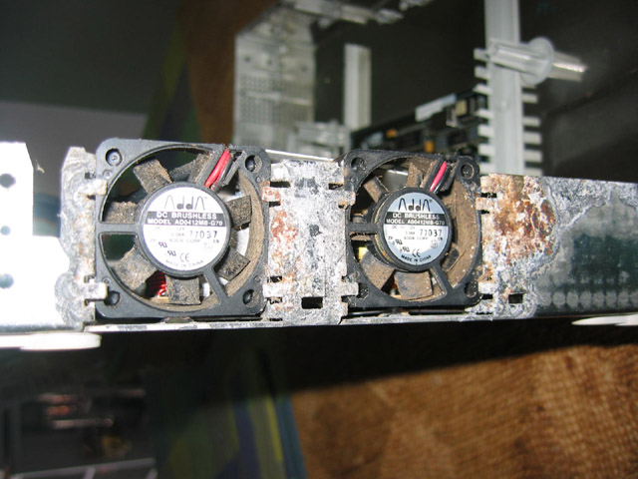

PJ2T Station Status Overview

The 2005-06 year at Signal Point was characterized by stability – a comfortable steady-state of maintenance, spares acquisition, and contest operations.

Once again, failures affecting contest operations were rare, although we needed to call upon the depth of our spares to prevent impact in a couple of cases. The alpha amplifiers, in particular, seemed to suffer a series of control circuit failures. Geoff W0CG/PJ2DX has become our expert at repairing these rugged amplifiers, and we have established a collection of repair parts for the Alpha control circuitry.

The acquisition of a Ten Tec Titan I amplifier from the VERONA club continues our trend toward a collection of amplifiers capable of reliable operation at higher power. This year, we gained authorization to operate with 1500W output during contests, putting us more on-par with our competition. Our Alpha 76 and 78 amplifiers, even with a trio of 8874 tubes, are rated for the old 1 KW input US power limit from the 1970s. All new amplifier purchases will be capable of sustained reliable operation at 1.5 KW output for a contest weekend. We currently have three amplifiers that meet this requirement: Ten Tec Titan I, Ten Tec Titan II, and Cary LK-800. The AL-1200 is marginal in this regard.

We have been incredibly lucky with the survivability of our yagis, with only a few maintenance issues over the past five years. This year, we suffered trap problems on the CL-33 tribander, since repaired. We have now reached a point where time and effort needs to be spent in taking the monoband yagis down for re-building and weatherization to guarantee their reliability for the next several years. This is going to require a great deal of effort!

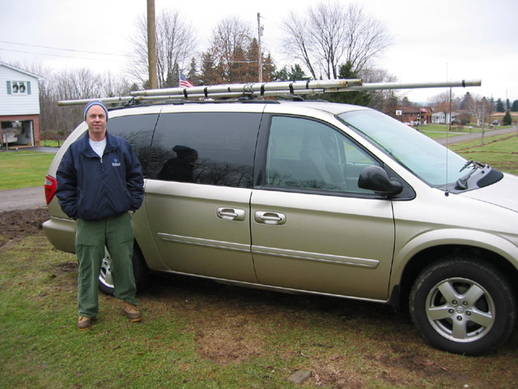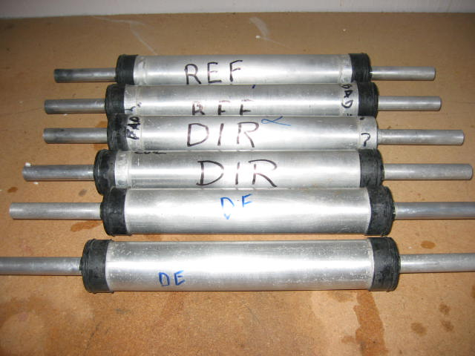
Geoff and Cindy have been very busy indeed, with construction projects, renovations, and maintenance of the house at Signal Point. In addition to the major effort and expense of the newly-built “sun room’ (providing a ‘radio-free’ relaxation area) and “observation platform” on the roof (with new telescope) which are still under construction as this is written, they have painted the West Bedroom and re-organized the storage in labeled bins (as shown in the photo below).

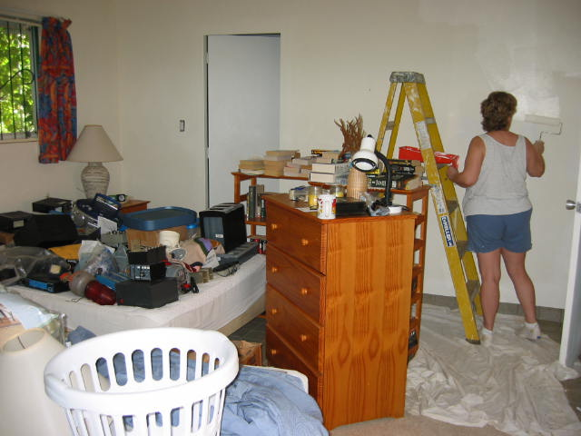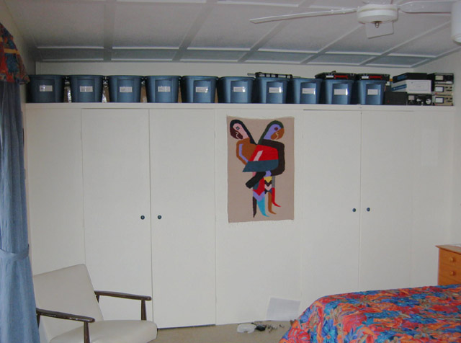

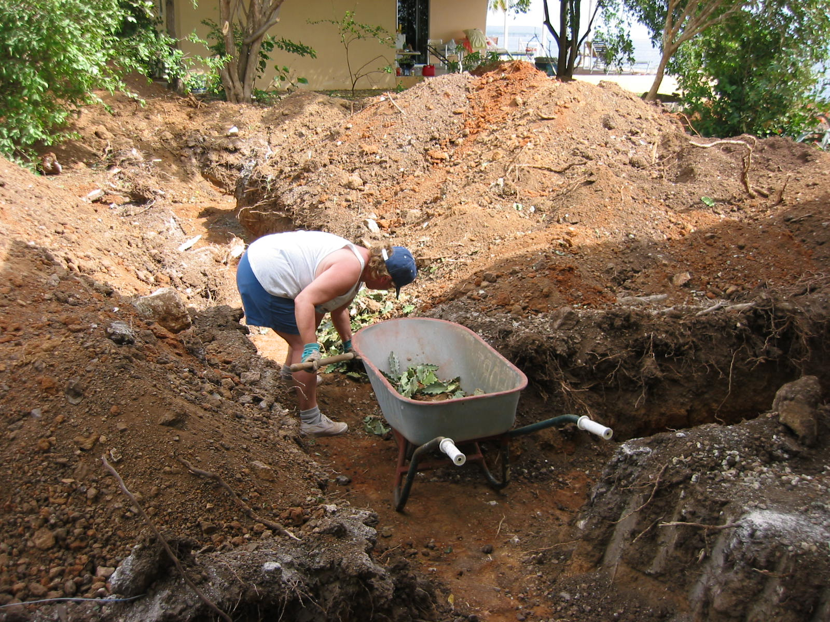

More renovations of the house are planned, including new kitchen cabinets. This will wait until a cargo container shipment can be made from the US, This same shipment will allow us to ship other larger station-related items that cannot be carried in luggage.

One of the problems of building Signal Point is the accumulation of “stuff” in the closets. This year, some of the old “stuff” that was no longer needed - broken computers, excess CRT displays, some radio parts – were either discarded, donated, or sold locally. It’s hard to “cull the herd”, but it’s a necessary ongoing endeavor.

As in previous years, the donations of parts and labor from our membership has helped to reduce the strain on the station budget. Unlike previous years, when acquisition of spare tubes, amplifiers, and other major hardware was underway, we end this year with a bit of money in the station account, around $1300.

PJ2T Station Changes and Improvements

- Half of the 30-meter inv-V disappeared, and was replaced.

- All FT-1000MP transceivers have been equipped with the INRAD roofing filters.

- When Svetlana 4CX1600B tubes once again became available, we purchased one (for $590), and W8TK purchased a second and donated it to the Club. W4PA tested the two tubes at Ten Tec, and they were full-powered. We are now well-prepared with spare tubes for the Titan II amplifier.

- W8TK donated $100 to the “tape fund” to purchase Scotch 33 tape for Geoff’s Summer maintenance trip.

- W4PA obtained and donated $800 worth of hard-to-obtain spare boards and components for the Titan II amplifier.

- Obtained sets of 9-pin Cannon-type connectors to allow connectorization of rotor control boxes and antenna switch controls. N8BJQ and K8ND donated some control cable for this project.

- Purchased eight (8) electrolytic capacitors for the Titan I amplifier. The raspy signal of this amplifier is still to be repaired.
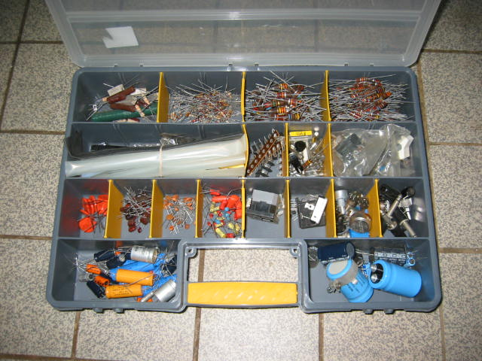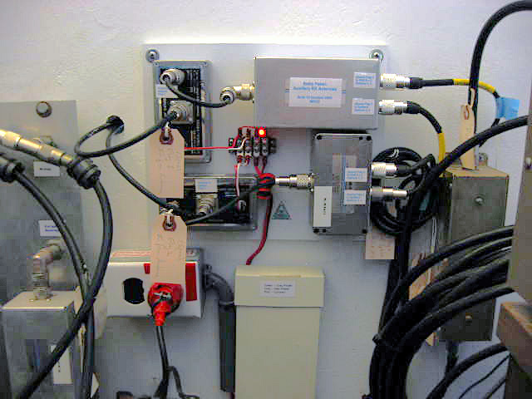

- N1ZZ donated a nice collection of spare component parts in a compartmentalized container.

- Availability of all the receiving antennas was provided at all four stations, with the addition of a K9AY RAS-2x8 switch and some magic-T splitters. Geoff W0CG assembled a panel to extend the switching system. Required connectors, cables, and adapters were donated by K8ND, W9JUV, and N4RV.

- NW0L located several new power supply assemblies for the Compaq computers, and purchased them on behalf of the Club.

- Bought three (3) new 3CPX800A7 pulse-rated tubes for the Cary LK-800 amplifier.

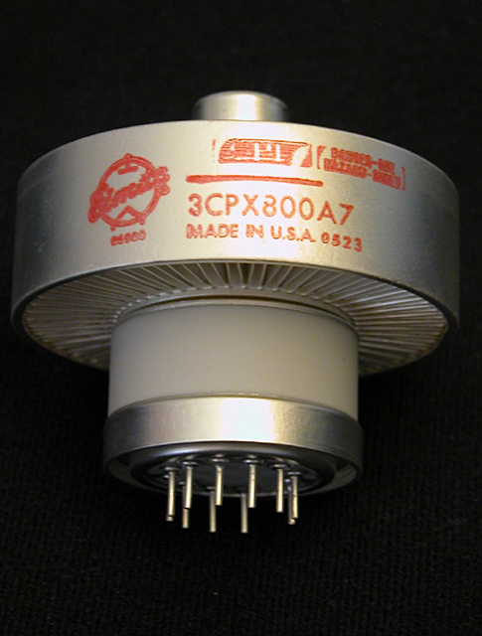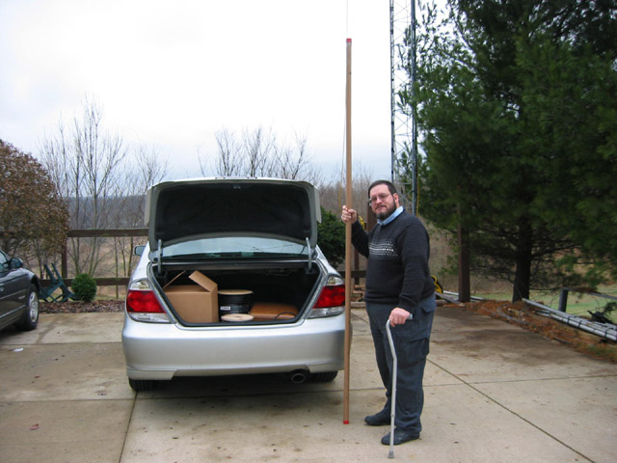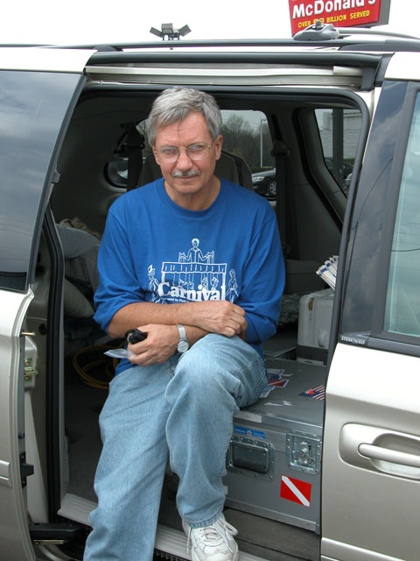

- Located and purchased LTA 7-element long-boom 10-meer yagi to replace one of the short-boom antennas now at Signal Point.

- K9SG and K8ND purchased and donated a DX Engineering 4-Square low-band receiving antenna system. Still to be determined is how to best deploy it for temporary contest use at Signal Point.

- Located and purchased a spare FT-1000MP blower assembly.

- N8BJQ donated a power-signal box for the Lance Johnson ECP-1 lowband preamplifier.

- W8TK donated Astron RS-35M 12V power supply.

- W9JUV and W8TK donated antenna insulators.

- W8TK donated a dipole center insulator, many more rolls of Scotch 33 tape, and some beautiful new reading material for the house.

- Several relays were purchased for the Alpha amplifiers, including enough to repair the current failures and retain multiples of each on the spares shelf.

- The storage in the West Bedroom was reorganized, with the addition of numbered plastic bins.

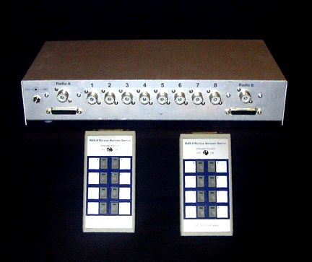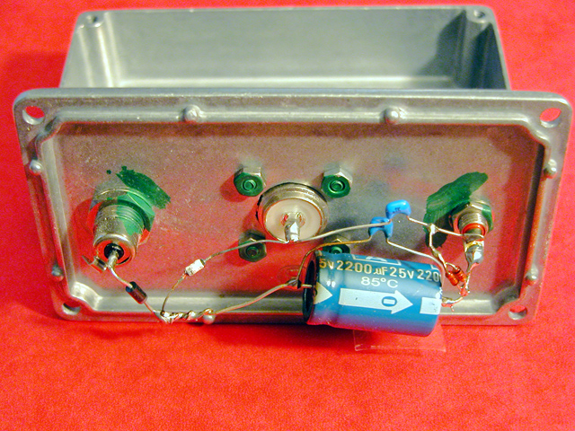

- N1ZZ and NP2L repaired the Aston RS50A 12V supply at the station.

- The Club purchased an additional five (5) 3CPX800A7 tubes for the Cary LK-800 and Titan I amplifier. W8TK donated another one.

- ADSL high-speed internet service and cable TV were added at Signal Point.

- A web camera was installed at Signal Point!

- NW0L and W0CG installed a wireless router to allow wireless browsing from laptops.

- Replacement fans for the 3COM network switch and hub were purchased.

- The Tailtwister rotor on the European tower failed after five years use turning the 40 meter yagi! It was replaced with a spare from the spares shelf.

- The failed rotor sent to The Rotor Doc, and became the last of our rotors to be rebuilt and battle-hardened by Craig.

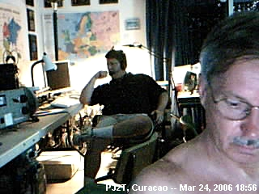

Known Repairs Required / To Be Done Projects

- Repair VERONA Titan I amplifier (hum).

- Re-work all yagis with signs of corrosion.

- Repair 160 meter chirp problem in Ten Tec Omni VI.

- Define / Fix rotor control problem on WARC tower.

Ongoing Maintenance/Projects

- Painting towers, guys, guying hardware.

- Improve organization of equipment documentation at Signal Point.

- Increased Member Task Specialization program: more volunteers needed.

- Inv-L radial repair and burying.

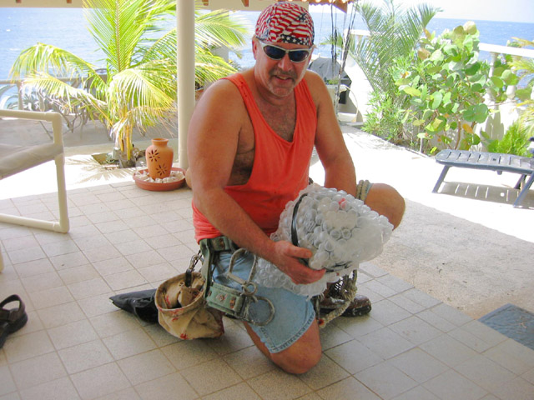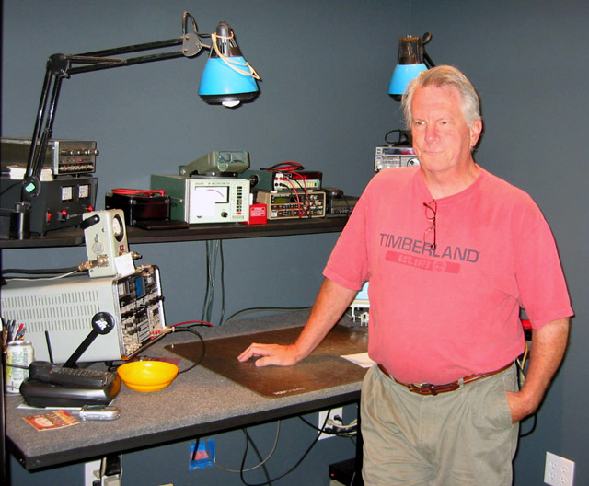

Station Enhancement Ideas for 2006-07

- We need to enhance our supply of small parts and components – new resistors, capacitors, etc. The kit provided by N1ZZ is a great start: now we need to lay in additional supplies for repairs.

- Auxiliary fans on all amplifiers should be switched on automatically with the amplifier, to prevent operation without proper cooling.

- The WARC tower is wasted during contests: how can we add contest-band antennas on that tower?

- Obtain additional 3CPX800A7 spare tubes.

- Repair Cary LK-800 3rd tube socket.

- Connectorization of accessories (rotor boxes, Stackmatch controllers, etc.) to allow them to be easily replaced and moved around station positions.

- Obtain additional 17-inch LCD displays, to provide one at each station, plus spare. Discard all CRT displays for space.

- Networked webcam(s)?

- The 80 Meter signal continue to be our weak point. Possible solutions:
  - Rotatable dipole @ 107’ on Europe Tower?
  - Vertical on cliff top?
  - Temporarily-deployable vertical(s) in the “flats”?

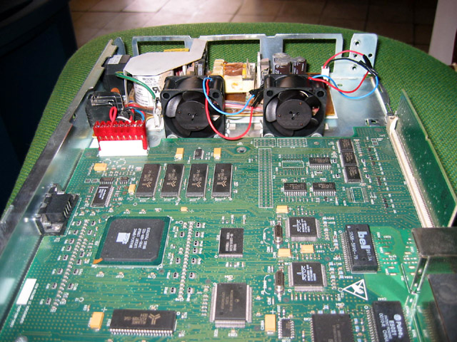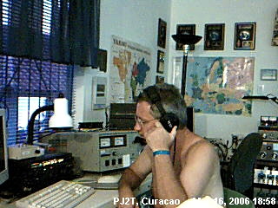
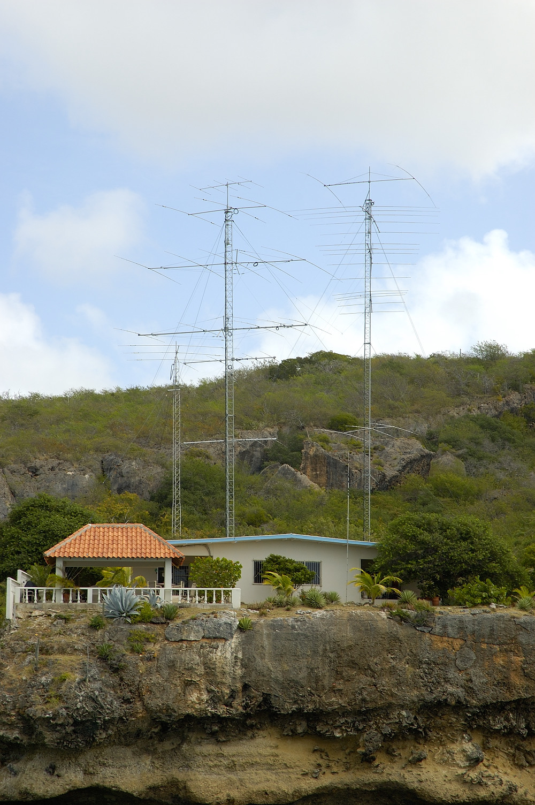
Your Station – PJ2T

